|  |
| --- |
|  |

|  |
| --- |
| © Ericsson AB 2013  All rights reserved. The information in this document is the property of Ericsson. Except as specifically authorized in writing by Ericsson, the receiver of this document shall keep the information contained herein confidential and shall protect the same in whole or in part from disclosure and dissemination to third parties. Disclosure and disseminations to the receiver's employees shall only be made on a strict need to know basis. |

Contents

1 Product Description 6

1.1 Overview of Ericsson Order Care Key Product Modules 7

1.2 Overview of Ericsson Order Care Optional Modules 8

2 Order Negotiations 10

2.1 Customer-Specific Information 11

2.2 Order Capture 12

3 Order Management / Project Management 18

3.1 Order Management Capabilities 18

3.2 Order Tracking 19

3.3 Manual Work Items 24

3.4 Jeopardy and Exception Handling 27

3.5 Rollback and Compensations 29

4 Order Analytics 32

4.1 Order Analytics (OA) Key Features 32

4.2 Order Analytics in Detail 33

4.3 Third Party Reporting Tools 33

4.4 Creating Reports 33

4.5 Order Analytics Capabilities 34

5 Service Designer (SD) and Velocity Studio (VS) 38

5.1 Service Designer 38

5.2 The Form Designer 39

5.3 Enhanced Features of Velocity Studio Designer (VS) 40

6 Application Virtual Machine (AVM) 40

6.1 AVM Cache 40

6.2 AVM Cache Types 41

7 Orchestration Framework 42

7.1 Implementation 42

7.2 Fulfillment Plans 47

7.3 Orchestration Framework Tables 49

8 Customer Information Management (CIM) 50

8.1 Overview of the CIM User Interface 50

8.2 Code Tables 53

8.3 Using CIM – Customer Management 54

8.4 Finder Menu Options 63

8.5 Using CIM – Customer 360° 64

8.6 Customer Information Management and SID 77

9 Service Registry 78

9.1 Logical Model 78

9.2 Active Data in Service Registry 79

10 Unified Workstation 80

10.1 Overview 80

10.2 Key Features 80

10.3 Plug-Ins 81

10.4 UWS in the Ericsson Product Suite 82

11 Enterprise Self-Care 82

11.1 Customization 82

11.2 Registration and Authentication 84

11.3 Non-Ordering Pages 85

11.4 Ordering 88

12 Buy-Flow Manager 97

12.1 Overview 97

12.2 Key Benefits 98

12.3 Functionalities 98

12.4 Services 99

12.5 Buy-Flow Manager Related Modules 101

13 Common Platform Capabilities 101

13.1 Business, Validation and Integrity Rules 101

13.2 Integration 105

13.3 Language Customization 108

13.4 Change Management 110

13.5 Migration Considerations 116

13.6 Migration Sizing 118

13.7 Certified Environments 120

13.8 High Availability Deployment Architecture 121

13.9 Deployment Sizing 125

13.10 Performance Management and Monitoring 130

13.11 Auditing And Event Logs 135

13.12 Archiving 137

14 Single Sign-On, Authentication and Password Management 138

14.1 Authentication and Password Management 138

14.2 User Privilege Management 141

15 Adapters 145

15.1 Competitive Advantage 145

15.2 Orga OPSC Gold Adapter 146

15.3 CSG Billing Adapter 149

16 Standards Adoption and Adherence 151

16.1 Solution Architecture 151

16.2 J2EE Architecture 152

16.3 Service Oriented Architecture 153

16.4 Web Services and Integration 154

16.5 BPM/Workflow 154

16.6 TeleManagement Forum: NGOSS, eTOM, TAM and SID 155

16.7 Frameworx Compliance 155

17 Product Management 163

17.1 Software Release Strategy 163

17.2 End-Of-Life Policy 163

17.3 Documentation 164

18 Software Support Services 165

18.1 Introduction 165

18.2 Scope of Services 165

18.3 Software Warranty 166

18.4 Software Support Services 166

18.5 Terms 167

19 ConceptWave Integration with Ericsson: New Product Names 167

20 Trademarks 168

21 Disclaimer 168

# Product Description

The Ericsson Order Care product portfolio is positioned as a set of enabling tools to help Communication Service Providers (CSP) manage their quote-cash supply chain whilst maximizing operational efficiency. Ericsson Order Care’s product comprises a set of pre-built software modules, which can operate independently or in combination with one other.

Ericsson Order Care (formerly ConceptWave Order Care®) is a centralized system that captures orders, and coordinates automated workflows and manual work activities across services, systems, and groups. It automates product and service order management through validation, decomposition, routing, and status tracking. It also provides fallout management, which can handle exceptions and notifications. As a result, you will know quickly whether customer requests can be supported.

Ericsson Order Care comprises the following key modules:

* Order Negotiations (ON)
* Order Management (OM)
* Order Analytics (OA)
* Service Designer (SD)
* Application Virtual Machine (AVM)

The following options are available:

* Orchestration Framework (OF)
* Customer Information Management (CIM)
* Service Registry (SR)
* Unified Workstation
* Enterprise Self-Care (SC)
* Velocity Studio (VS)
* Workflow Director
* Buy-Flow Manager(BFM)

With shorter product lifetimes, shrinking ARPU, competition from new, non-traditional entrants, and multiple sales channels to market, traditional B/OSS systems are insufficient. The Ericsson Order Care suite fulfills that critical need with highly agile and complete handling of order — from entry to delivery. From inception to retirement, our proven end-to-end catalog-driven order management solutions enable the creation of products and offers that customer demand with pre-configured Libraries and rules to quickly get started then easily customized to target specific needs — launching in record time.

## Overview of Ericsson Order Care Key Product Modules

### Order Negotiations (ON)

Order Negotiations (ON) provides the capability for users to input data into Ericsson Web forms during the selling process (for example, quote, selling, ordering, credit approval, etc.). The Web forms are a representation of CSP’s requirements to capture data for any products/service (including bundles/offers), any order type (including New, Add, Move, Supplement, Cancel, Suspend, Disconnect, etc.), any channel (internal CSR’s, customers, channel partners, suppliers, etc.) and enables the creation/modification of associated customer profiles and invocation of the required business/validation rules necessary to ensure an order is captured completely and accurately prior to distribution to Order Management.

### Order Management (OM)

Order Management (OM) inherits orders from Order Negotiations (ON) or the CSP’s alternative order capture system and orchestrates the order fulfillment lifecycle with a view to successful orders flow and minimization of fallout/exceptions. Order Management is capable of reducing OPEX (associated with activity-based costs) in the order fulfillment process through mechanization and is based upon a combination of template best practices and the leading edge Business Process Modeling Language (BPML).

### Order Analytics (OA)

Order Analytics (OA) provides real-time operational reporting (statistics and measurements) to address all aspects of the end-to-end order fulfillment lifecycle. All data is collected during the order lifecycle and parsed/assembled into management reports and/or live dashboards. From the users who touch the orders to the milestones that are completed, timestamps of all activities are stored in our database for immediate retrieval through the configuration of Order Finders and any field within the order that can be used as search criteria. In addition, timelines around each activity of the ordering process can be defined from minutes to hours and days, with resultant notification and reporting of those activities in jeopardy or escalated states. With a 360 degree view of the order lifecycle, Order Analytics ensures that possible order jeopardy conditions are identified and actioned before they become customer impacting (e.g. missed due date).

### Service Designer (SD)

Service Designer (SD) is a design tool for the design, implementation and ongoing modifications of Ericsson modules. Service Designer is used to model the workflow activities, establish systems interfaces and business rules, and generate certain form-based screens required by participants in the order fulfillment process.

### Application Virtual Machine (AVM)

Application Virtual Machine (AVM) is Ericsson’s runtime engine for all metadata (Ericsson’s Application Markup Language (AML)). The AVM provides common services to metadata-based modules including a UI server, workflow engine, integration framework, rules engine, user authentication and authorization, and data persistence services. The AVM is the runtime framework of Ericsson Order Care and Ericsson Catalog Manager applications.

## Overview of Ericsson Order Care Optional Modules

You can customize Ericsson Order Care to suit your needs by adding the following options.

### Orchestration Framework (OF)

Orchestration Framework (OF) allows the ability to orchestrate and assemble dynamic process flows with little or no coding. The framework contains functionality related to workgroup tasks, task orchestration, and task management that can be used by a non-IT user to define and configure micro-flows, Technical Action Specifications (TAS), and fulfillment plans.

### Customer Information Management (CIM)

Customer Information Management (CIM) manages customer information within the Ericsson Order Care suite. CIM has been designed to allow Customer Service Representatives to quickly and efficiently associate customer information in a single centralized interface. The philosophy is to create a 360° degree view of all the necessary information to “connect” the customer and the associated services, work orders, and contact events.

CSR’s have an accurate 360° view of customer information, correlated with associated work activities on a real-time basis. CIM contains all the needed elements to effectively support and manage CSR work efforts and at the same time allows for a better overall user experience due to the intuitive Web browser-based interface.

### Service Registry (SR)

Ericsson Order Care Service Registry module provides a repository for the subscription inventory (offers, products, services and resources sold to customer) that provides:

* A SID based data model for the management of the Service Inventory
* Support for the management of Offers, Products, Services and Resources
* Support for the management of the relationships between these items
* Full versioning
* Integration with the Catalog Manager enabling the service specifications to be retained within the Catalog Manager and simply referenced in the Service Registry
* A user interface for the inquiry of the service inventory
* Links enabling the Customer Management module to provide a 360° view across a customer, account status, services held, active orders, contract status and contact history
* A full Web-services based API enabling the creation, update and inquiry of Service Inventory data by external systems

As with all Ericsson Order Care modules, all service inventory data is accessible via the Web browser in the integrated Ericsson Order Care application. The data is fully available to other Ericsson Order Care modules including Order Negotiations and Order Management.

### Unified Workstation

Unified Workstation (UWS) provides a unified customer service desktop solution that directly integrates with product, order, billing, workforce, and customer service information. UWS functions in real-time without its own repository for third-party systems. Key functionality includes: add, search and display customer account information; view all offers and bundles available to the customer; use desktop messages to communicate with other CSRs and to share knowledge; access and edit customer billing information; view any notes that pertain to the customer’s account, such as trouble tickets; add, edit, and view services for a customer.

### Enterprise Self-Care (SC)

Ericsson Self-Care exposes self-care functionality through the CSP’s existing Web portal. The self-care module provides the user interface to expose the following back-office functions (where available) to the end client via the Web:

* Customer profile inquiry / update
* Product / Offer presentation and inquiry
* Quotation
* Ordering
* Order Status inquiry
* Account / Payment Status inquiry
* Billing Inquiry (PDF invoice retrieval)

The style sheet-based user interface provides a seamless integration with the CSPs existing Web portal.

### Velocity Studio Designer (VS)

Velocity Studio Designer (VS) provides all of the functionality of Service Designer, as well as advanced UI form modeling that enables next-generation application design. VS is a critical enabler for end-user facing applications requiring an enhanced user experience, ease of navigation, etc.

### Workflow Director

A work order and task management module used for handling automated workflows and manual work activities across services, systems and groups.

It handles exceptions (errors), manual work items and notifications that occur during automated processing of service orders and planned manual work. Designed to fill any gaps in your current operational environment, using intelligent prioritization, work assignment, and data enrichment, along with a mix of work handling approaches. With it, you’ll be able to coordinate and track the status of work items across disparate services, systems and groups, and ensure that the right people get the right work at the right time.

### Buy-Flow Manager (BFM)

Buy-Flow Manager (BFM) streamlines the order flow-through and exception management across sales channels to improve the customer experience and reduce order fallout. It manages the shop experience by providing business services that connect and enrich existing fine grain services. The goal of this composite layer is to orchestrate the fine grain services and direct legacy calls to provide simple business-level services to be consistently used across channels. The channel interface may be either an indirect automated interface, or an internal or external user interface.

# Order Negotiations

Order Negotiations is a fully customizable order entry system that validates every order prior to provisioning and enables CSRs (customer service representatives) to offer pricing, availability, multi-featured bundles and discounts.

Order Negotiations provides a wizard-driven graphical user interface that guides the user through various screens during the order capture process (including quote, selling, ordering, and credit approval). These screens can capture data for any product or service (including bundles and offers); and any order type (including new, Add, Move, Supplement, Cancel, Suspend, and disconnect); across any channel.

## Customer-Specific Information

Using the Order Negotiations module, the CSR has the ability to search and view customer information and their existing orders and products/services.

### Customer Identification

* Customer identification (self-care mode) is performed either via an explicit login with an ID and password, or via a Q&A challenge where the client is expected to supply the correct answers to a series of questions (birth date, mother’s maiden name, last invoice amount, etc.).
* Customer identification in a CSR mode is performed via a complex search (search by phone, contact name, postal code, account number, email address, etc.). The identity of the calling party is confirmed as in self-care, via a series of questions posed by the CSR, aided by the system.
* A customer’s identification can be determined through an Interactive Voice Response (IVR) system by searching on the customer data provided (e.g. caller’s phone number). A list of matching clients is presented and the customer can be authenticated via a series of challenge/response questions.
* This information is obtained from the Customer Master. The inventory may be provided by Ericsson but may also be provided by a CRM, Billing System, Data Warehouse, or other third-party system.

### Existing Products/Services

Once the customer is identified, the existing Products and Services subscribed to by the client are presented. This information is obtained from the Service Inventory. The inventory may be provided by Ericsson but may also be provided by a CRM, Billing System, Data Warehouse, or other third-party system.

### Existing Orders

The CSR has the ability to view all existing orders for a customer. Order status for any existing orders is available from Ericsson, both via the user interface and via APIs. All functions and services performed online via a Web browser may also be exposed to a third-party system via APIs. This allows for the inquiries and quote/order collection to occur either in the native browser or in a third-party application, such as a CRM, IVR, or a Web-portal.

Sample transactions include:

* Product/service inquiry
* Order status inquiry
* Service Inventory inquiry
* Order/Quote validation
* Order/Quote submission

## Order Capture

Once the customer has been identified, a new order or a new quotation can be entered for this customer.

### Order Entry Process

The CSR can enter a new order for a customer during order entry and the order is validated at three different levels:

* At the field level for data format issues, e.g. field length, numeric values, masks, etc.
* At the form (page) level for mandatory fields and “in-form” validation
* At the order level for more complex inter-page business rules

All of these rules are executed as the order is being placed. In addition:

* Mandatory fields are highlighted with a red asterisk.
* Triggers may be defined so that the form dynamically and immediately changes (fields enabled/disabled, shown/hidden/populated) based upon data as it is entered.
* Business rules that have been violated are presented in list form. Clicking on a business rule brings the user directly to the field in question.

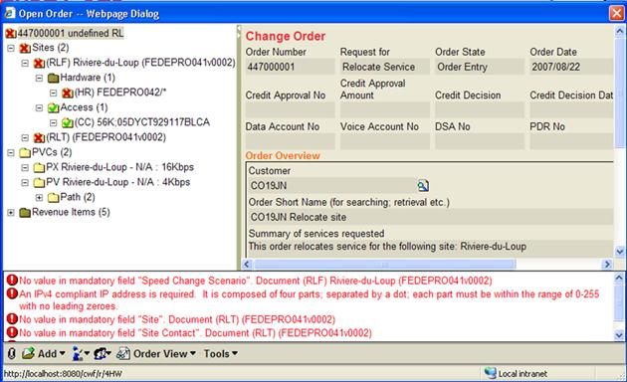

The Order Negotiations module is integrated with Ericsson’s Catalog Manager Product Catalog module to provide a listing of available services and products to be purchased. When a product is selected during the order entry process, the Product Catalog further applies business rules that ensure that all requisite components and products have been selected and configured.

While upfront order validation is the norm, Ericsson supports “minimum dataset (MDS) order capture” where an order may be accepted that does not necessarily have all requisite information. Once the MDS criteria are satisfied, the order may be submitted. In the event that the order is incomplete, an agent would be tasked to complete the order. Electronically received orders that fail the full-dataset (FDS) criteria would be similarly treated.

Where order entry is not possible, and an escalation is required, the order may be submitted for completion by an expert group using Ericsson’s Worklist management functionality.

Ericsson Order Care modules may be configured to log errors for subsequent reporting so that a continuous improvement process may be enabled. Errors encountered during order entry are not typically logged due to performance reasons but individual rules may be configured to log themselves as required.

Ericsson’s Service Designer (SD) or Velocity Studio (VS) modules are used to model the menus, screen flows, labels, selection of controls, etc. There are no hard-coded Web pages; all are generated from the definition within SD or VS. Ericsson prides itself on its ability to release functionality iteratively to enable rapid adaptation of the delivered solution to the business requirements.

Ericsson maintains a shopping cart and permits the user to browse the Catalog, and add/remove products and services, options, features, etc. Product filtering occurs when the user enters site specific information (e.g. telephone number, address) during the shopping/quote/order entry session. The shopping cart can be maintained in the native user interface (Catalog driven), through a wizard type interface, or via an API from a front-end Web portal, for example.

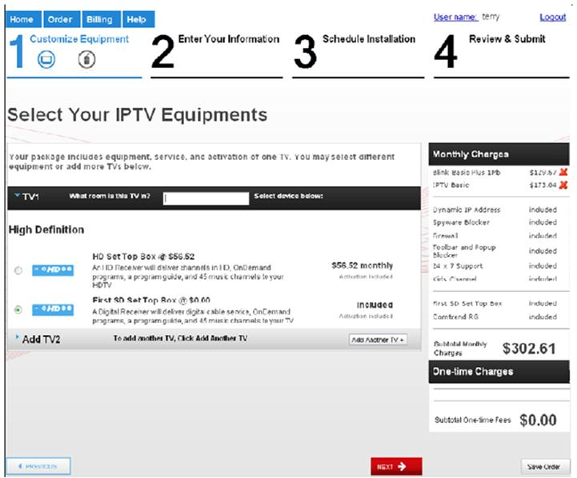

Channel specific pricing and campaigns are supported as follows:

* The channel is determined via the logged-in user (or guest).
* The channel may be used as an attribute in selecting the Pricing Version, for example a separate price list may be maintained by channel.
* Standard pricing may be marked up or down by specified percentages for a channel.
* Discounts may similarly be varied by channel.
* Discounts also carry a “Promotion Code”, for example an advertised code that when entered during order entry time will “unlock” special pricing. This is similar to the mechanism employed by car rental agencies, hotels, etc.

### Quotation Process

Quotations can be generated directly within the Order Negotiations (ON) user interface. ON can be configured to capture the required address/location and/or customer information required to query the Product or Service Catalog for eligible products/services for a specific customer location.

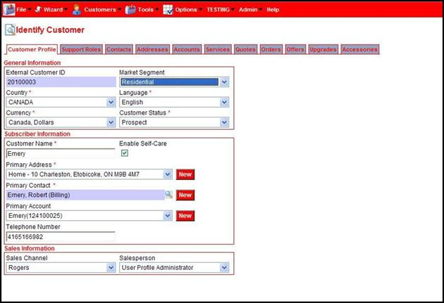

In addition, as part of the filtering process, a serviceability check can be performed against an internal or external data source to provide a list of the products and services available at a particular location. Catalog Management (CM) will then filter the returned results to only display (via Order Negotiations) those products/services available at the target location.

Optionally, a ‘Needs Assessment’ can be configured within the Order Entry page to provide a list of questions to further filter the products/services for recommendation to a customer. The responses to the questions are linked to business rules that rank the bundles and services in Catalog Management (CM) and can sort the returned results by this ranking.

The product/service details contained within Catalog Management (CM) can be displayed at any time during the quote process. This includes pictures, features and pricing details along with any required availability or eligibility rules or constraints.

Once a customer has completed their quote, a PDF version of the quote is presented. It can be downloaded, printed, or sent directly to the customer via an e-mail attachment. The PDF contains the detailed break-down of the products, services, and charges as captured in the quote. The PDF can be configured to include additional promotional material such as current offerings and related discounts.

Configuration consists of defining the quotation format, Communications Service Provider (CSP) logos, and contact information.

In addition:

* Quotes carry an expiry date and may be saved for later retrieval. A Quote is closed once the expiry date is reached.
* For Residential (or business) customers, a quote may be re-used until it expires.
* Quotes are automatically saved (not submitted). When the quote has been accepted, an order is created and the quotation information is carried forward onto the order.
* Orders may be saved for processing based upon a future event, e.g. serviceability change.
* Serviceability information may be displayed for a desired location during order entry, e.g. the planned service date may be presented and communicated.
* Any special pricing requests (PDRs) outside the authority of the order creator can be managed to grant a lower price than the authorization level of the user. A pricing approval process is initiated.

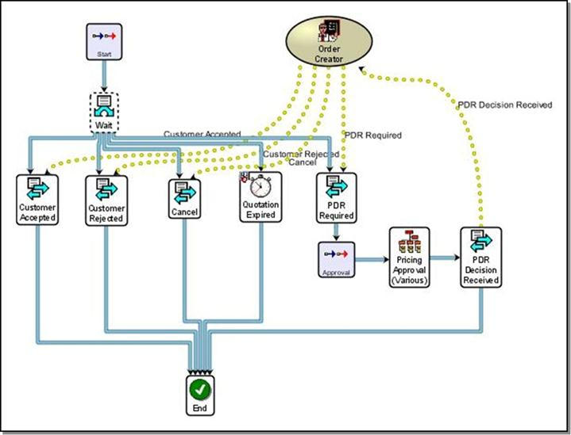

During the quote creation process, a quotation order is created in the background, and the depicted workflow (depicted above) is launched. Once the client accepts the quotation, the CSR submits the order and the quotation-workflow process ends successfully:

* A message is sent to the quotation workflow indicating Customer Acceptance.
* An order is created from the quotation, and all quotation data captured to date (client information, product selections, etc.) are carried forward onto the order.

# Order Management / Project Management

## Order Management Capabilities

Ericsson’s framework includes a rules-based workflow engine. Developed by Ericsson, the workflow engine is Business Process Modeling Language (BPML) compliant. Access to the workflow engine is through the Service Designer (SD) or Velocity Studio (VS) graphical user interface (GUI), as illustrated below.

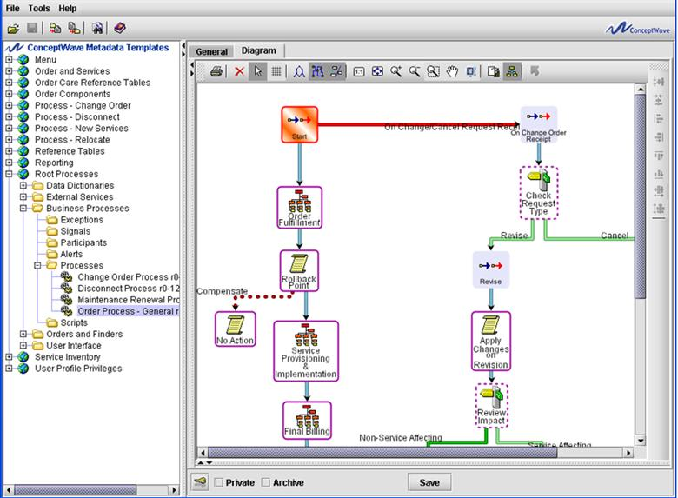

Ericsson provides the ability to graphically define and change workflows. A fully-featured workflow engine, the Ericsson Order Care solution provides support for:

* Workflow selection, and order decomposition by attributes such as service being ordered, customer type, etc…
* Definition of milestones (target) and jeopardy (escalation) dates
* Definition of manual versus automated tasks
* Task prioritization models by activity/Worklist: LIFO or FIFO within Priority
* Task distribution models by activity/Worklist: Shared (Pull - user gets next task); Manual (manager assigns tasks to users); Round Robin and Balanced (Push - system distributes tasks automatically)
* Definition of Workgroups within a particular “Participant”, i.e. Group, either by region, service type, or any other characteristics of the order.

Both atomic and complex process activities (tasks) are supported for process and workflow modeling and development through simple drop-down menus and point-and-click GUI. Atomic activities include Script, Operation, Complete, Spawn, Join, Repeat, Exception, Resume, Rollback, Synch, Signal Alert, etc. Complex activities include All, Sequence, Choice, Switch, Sub-Flow, Compensate, etc.

## Order Tracking

### Order Inquiry

Ericsson Order Care includes metadata defined “finders”. Finders provide the mechanism through which search functions, including order inquiries, are implemented. Ericsson is not restricted to pre-defined search screens, and can therefore be defined to include any specific attributes that have been implemented for your particular application. As a result, Ericsson Order Care enables you to search and report upon all the attributes within the system. The core capabilities of Finders include:

* Searches against simple or complex data structures.
* Searches against data either fully or partially located in other systems via an API.
* Searches against data either fully or partly located in non-native databases via JDBC.
* The ability to specify filter (search criteria) and result columns.
* The ability to add to, update and delete the target of the search, e.g. the ability to list all eligibility rules for a product, then add a new one from the same screen.
* The ability to drill-down into the search results by either selected row or cell. This allows, for example, the end-user to find the set of products of interest, and then drill down into the list all of the eligibility rules for the selected product(s).The ability to save searches as favorites, either globally or by user.
* The ability to set non-visible filter criteria e.g. set Domain based upon user.
* The ability to manipulate the result set, e.g. to clear the Postal Address for sensitive locations for only those users without the appropriate authorization.
* The ability to download search results in PDF, XLS, CSV and XML formats.

It is important to note that these finders are pre-built objects and do not allow the end-user to build their own reports on the fly. Integration with external data warehousing and reporting systems is recommended for advanced types of analysis.

### Order Status

Ericsson Order Care provides a Gantt based view of an order’s workflow that enables any viewer to quickly identify the status of any order.

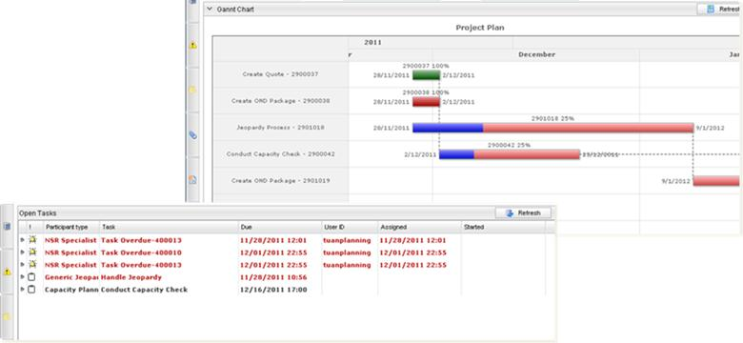

### Order Dashboard

The Order Negotiations and Order Management modules include a pre-configured dashboard that may be extended / altered to meet the needs of a client deployment. The dashboard provides a single view of the Order, the Technical Services on the Order, and of the Resources and Activities.

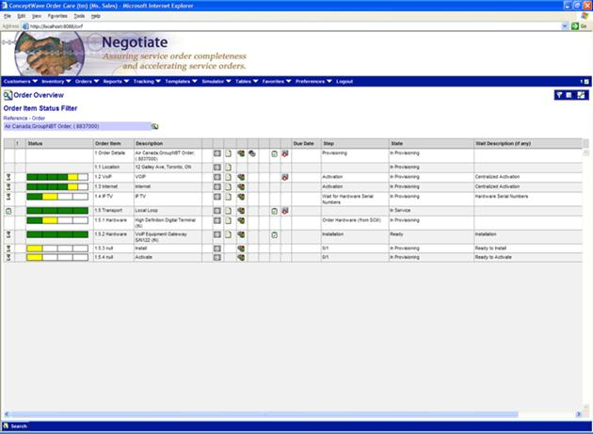

**Column 1: Status**

* Hourglass indicates process is waiting (see wait description)
* Green check indicates completion
* Red Stop Sign indicates that Process Engine is not running or Process itself has failed

**Column 2: Jeopardy or Alert**

* Double-click on cell to view Alert

**Column 3: Progress Meter**

* Green cells indicate completed progress
* The yellow cell indicates the currently active activity
* White cells indicate future steps yet to be reached

**Column 7: Order**

* Double-click on cell to open Order

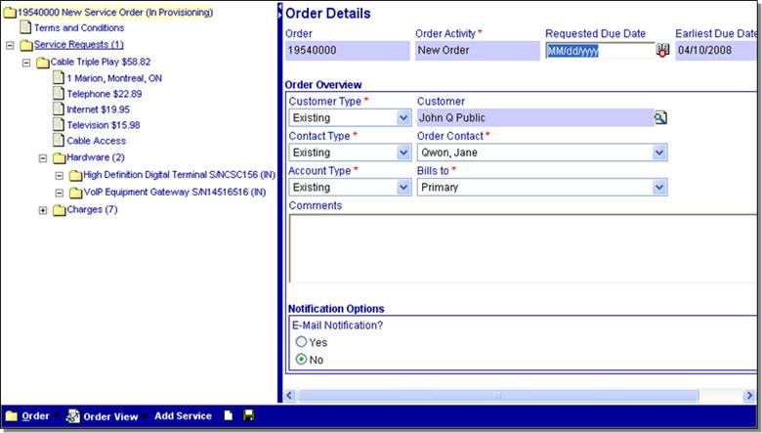

**Column 8: Document**

* Double-click on cell to open Order Page for this row/workflow
* May not be present for workflow without an order page, e.g. Install and Activation flows

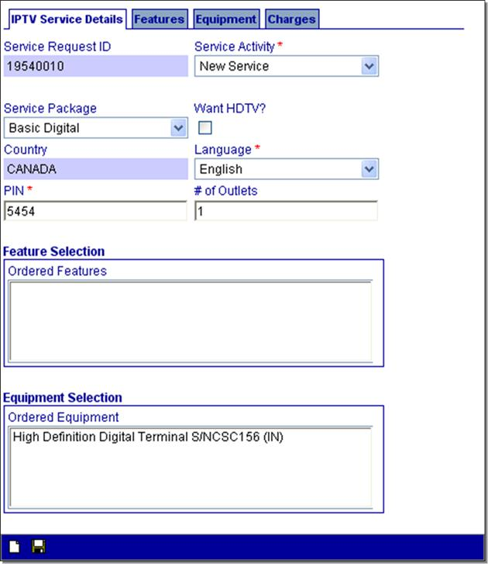

**Column 9: Process**

* Double-click on cell to open Process
* May not be present for order pages without a provisioning workflow
* You may drill down on process to view children, activities, event log, etc.

**Column 10: Sub-Processes**

* Double-click on cell to open list of Sub-Processes (children)
* May not be present for workflow without children
* You may drill down on each process to view activities, event log, etc.

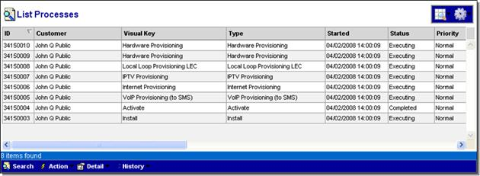

**Column 11: Open Manual Activities**

* Double-click on cell to open list of open manual activities
* May not be present

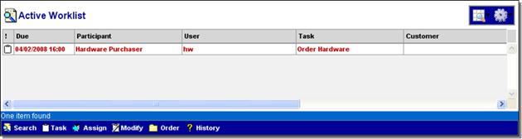

**Column 12: Completed Manual Activities**

* Double-click on cell to open list of completed manual activities
* May not be present

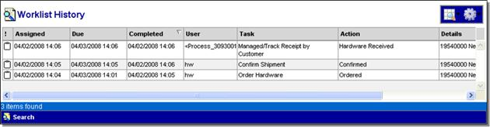

**Column 13: Milestones**

* Double-click on cell to open list of milestones
* Only present if defined in workflow

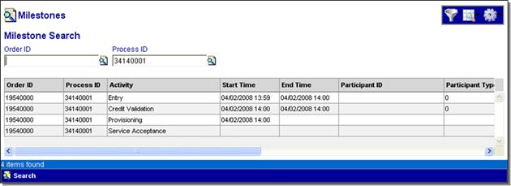

## Manual Work Items

### Delivering Tasks

The Ericsson Order Care solution delivers human tasks to a user or set of users via Web portal (desktop screen), email, mobile device or third-party workforce management system. In the latter three cases, these are really implementation of an automated interface to an external system that is presenting the user interface. This section deals with the scenario where the user is tasked through Ericsson Order Care itself.

### Skills-Based Routing and Rules-Based Work Item Assignment

Several additional capabilities are provided to enable functions such as skill based routing and rules based work item assignment:

The Worklist Distribution script may be used to “calculate” the user to which the task should be distributed. The script has full access to all the capabilities of the system including access to the order, reference data, external systems via APIs, etc. This script is most often used to request a resource assignment from an external workforce management system, or to get the manually specified assignment from the order.

The system exposes a series of runtime rules through which an end-user can configure the business rules in a more dynamic, less pre-determined, manner. These rules are defined in a user friendly graphical rule-builder environment. Rules are triggered at predetermined points/exits and include: work item creation, work item assignment, work item update and work item completion.

While the use of permissions to drive distribution is much simpler, and strongly recommended, there are situation where the desired effect is not possible. To this end, a Stored Procedure is exposed that drives the “System” distribution modes, i.e. when the system auto-distributes work. This Stored Procedure can be changed to implement routing based upon a skillset, region, or any other characteristic.

### Notification of Tasks

When a Task is assigned to a user, a Worklist icon at top right of the UI screen appears and shows a count of the number of Worklist items in the user’s queue. Unopened tasks are bolded, opened tasks are normal font and overdue tasks can be a different font color such as Red shown in the screenshot below.

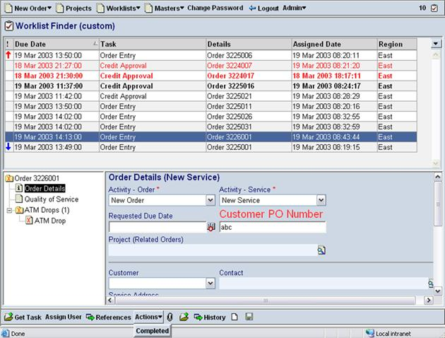

### Task Delegation and Routing

Task delegation and routing within a process is supported at various levels. The delegation of a particular task within a process may be pre-defined and user access levels as well as administrative controls may be applied. For example, if a task was delegated to a particular group the task may be sent to the manager of the group or maybe routed to a group member. Similarly, a group member may be allowed to re-allocate a task to the queue for distribution to another group member or may re-assign the task to a group with the same function in a different geographic area based on time zone, work function, etc.

With the work queue UI, certain conditions may be allowed to the user (granted by System administrator and pre-defined with the process flow). These conditions may allow a user the privileges needed to release the task back into the general queue. When this action is processed the Ericsson Order Care solution will track via electronic signature this action and any changes made within the task. In addition any jeopardy management parameters and other notifications will not change.

Example of selected privileges that alter how a task may be assigned / worked:

* **Get Available:** Permits holder to get the next shared task. Without this privilege the user will not be able to get shared tasks from the unassigned tasks queue and will need to wait for the system to push tasks into the Worklist.
* **Select Task:** Permits holder to select from available tasks rather than receiving next task in priority sequence.
* **Group Manager:** Permits holder to act as a manager and distribute unassigned tasks.
* **Delegate Task:** Permits holder to delegate assigned tasks to other users.
* **Return Task:** Permits holder to return a task to the shared queue (sets task to unassigned).
* **Take Task:** Permits holder to take a task away from other users.

### Automatic Routing and Distribution of Work Items

Work items arriving into Ericsson Order Care are processed and automatically routed to service provider-specified work centers. These work centers are used as physical or virtual repositories for outstanding work. Work centers and distribution rules are defined and configured by the service provider in the metadata.

Assignment of work items to a specific user can be done automatically or manually based on multiple, flexible approaches (e.g. round robin, balanced, manual, shared, or other, based upon user-defined complex business logic). Once work is assigned or packaged to a user it appears on the user’s current work list. The work item remains his/her responsibility until the work is cleared, cancelled, withdrawn or repackaged to another user.

### Automatic Removal of Resolved/Confirmed Work Items

Work items can be automatically removed from a user’s work list (or automated work list for fully automated resolution of exceptions) on item closure based upon a number of scenarios. These include:

* Manual user activities as part of a planned work flow to complete the work item/exception
* Notification of an externally generated activity required to consider the work item exception completed
* Receipt of a message from the item source (e.g. order management system) to confirm/complete the work item
* Automated flow processing defined to work/clear the item

The manner in which items are completed and removed from work lists is service provider definable based on metadata.

### Work Item Prioritization and Grouping

Work items can be prioritized by type of service, customer, geographic data, or other criteria as defined by the service provider in metadata. These priorities can then be used if necessary in determining the appropriate routing and assignment path for each item.

Priorities can also be set based on configurable business flows using information received from source/external systems or when certain conditions are met (time of day, point of time in a work week, jeopardy condition being met, etc.).

Work items can be grouped and processed at the order level, item level, or component level based on the specific business flows required for the service being provided. The desired grouping can also aid in the generation of more meaningful reports that will aid in resolution and overall work management for a service provider.

The Ericsson Order Care solution can also integrate and be directed to a third-party Workforce Management System to send orders as appropriate to user's work queue.

## Jeopardy and Exception Handling

Configurable management dashboards show managers the most critical information related to their responsibility areas and automatically escalates jeopardies via pagers or email if necessary based upon service provider-specific rules.

Ericsson Order Care can be fully customized by the service provider’s IT or administration group with business rules defining assisted and fully automated exception handling flows, including interactions with external systems to obtain data required for resolution. Using Service Designer (SD) or Velocity Studio (VS), these groups can independently customize, develop, and maintain their own flows, business logic, and system interfaces tuned for their particular services, systems, and organizational model.

Integration to Problem or Fault management systems is achievable using Ericsson Order Care’s integration framework with its out-of-box service providers such as JMS, MQSeries, Tibco, HTTP, SOAP and other common communication and integration protocols, and can assist in defining and resolving service order fallout events in an automated fashion.

### Escalation Capability

Jeopardy status may be set on an order either through the configuration of a “pending jeopardy” threshold or the actual expiration of the permitted duration for an activity or set of activities, and/or through a manual function "place in jeopardy".

Jeopardy notifications or Alerts can be automatically generated upon the assignment of an order to jeopardy status. Notifications can take the form of color changes to order status on the UI, the assignment of a task to a supervisor Worklist, a call to an external system with appropriate parameters passed on or electronic communications such as email, pagers or text messages to targeted individuals. Notifications are user-configurable in the application metadata through the Service Designer (SD) or Velocity Studio (VS) tools.

Timelines around each activity of the ordering process can defined from minutes to hours and days, with resultant alerting and reporting of those activities in jeopardy or escalated states to supervisors or stakeholders.

The types of alerts supported are:

* **Email –** This alert type will dispatch an email message to a defined email address. The system contains an SMTP server configuration that is used to define the SMTP server address.
* **Pager –** Similar to the email alert, although where the email address specified is a pager address.
* **External System –** This alert type will invoke an external service operation. The script defined in an alert definition will be invoked with document and process parameters, where the document parameter type is defined as the input of the interface operation, and a process parameter is a process that issues an alert. This method can be used to interface to an operations center management system.
* **Worklist –** This alert type will send a request (task) to the Worklist queue. The alert definition specifies the user participant type that should receive this request (alert). The label of the alert metadata element is used for the Worklist task description.

### Exception Management

Communications Service Providers often approach resolving exceptions/fallouts through manual methods. This results in inconsistent exception handling practices, difficulty in responding to high volumes, and high training costs for exception handling resources.

The Ericsson Order Care solution can be configured to manage unplanned exceptions and error messages that are created during flow through processing of service orders as well as planned activities requiring manual work efforts. Event triggers are defined and business logic is established to handle resolution and/or routing.

Configurable management dashboards show managers the most critical information related to their responsibility areas and automatically escalates jeopardies via pagers or email if necessary based upon CSP-specific rules.

Exception Event Types include:

* **Time-Out Violation.** An activity or series of activities has exceeded its specified “duration”.
* **User Defined.** A process activity explicitly “threw” an exception (internally caught business problem).
* **Interface Error.** An interface operation failed or timed-out (technical problem).
* **Interface Fault.** An interface returned an error message (externally caught business problem).

### Benefits

* Enhances user productivity by focusing them on non-repetitive work that truly requires human intervention.
* Enables work centers and/or IT resources to develop and maintain their own flows tuned for their particular services, systems and organizations.
* Provides enhanced reporting on order process fallout to drive continued operations process improvement.
* Easily integrated with existing customer systems to support consolidation of exceptions/fallout and necessary system interactions to speed resolution.

## Rollback and Compensations

The workflow can issue a rollback which can be triggered via any numbers of events, including receipt of a cancel (rollback to beginning) or change order (rollback to first affected activity), an error condition received from an external system, the rejection of an ASR, etc.

### Rollback

A Rollback activity may specify the “type of rollback” by returning a string in the activity script. The string should match one of the “Compensate Types” defined in the metadata:

* Datatype
* Base type: “Compensate (Ericsson Order Care System)”
* Overrides “All Compensates (Ericsson Order Care System)”
* Specify the types in the Restrictions/Enumeration

The following diagram illustrates a typical Rollback call:

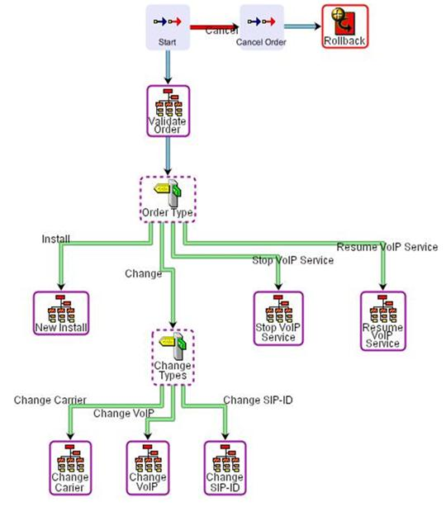

When a rollback is issued, the following occurs:

* Execution stops after the currently running activity
* All compensation activities are performed (see next section) where the type of rollback matches the compensation type specified
* The rollback completes only when all compensation activities are performed

### Compensating Activities

Since provisioning processes are often long-running affairs spanning several days if not weeks, database transaction management cannot be realistically employed. As such, a “compensating” activity is defined for each workflow step that needs to be undone:

* The compensating activity itself can be a series of activities, allowing for the ability to issue alerts, define decision nodes to determine the action to be taken, invoke asynchronous interfaces etc.
* The compensate activity will be executed only if the activity has been completed.
* Compensating activities will be executed in the reverse order to that in which they were defined.
* If a compensating activity is defined for a complex activity, it overrides any compensating activities defined for any of its sub-activities, once the complex activity has completed.

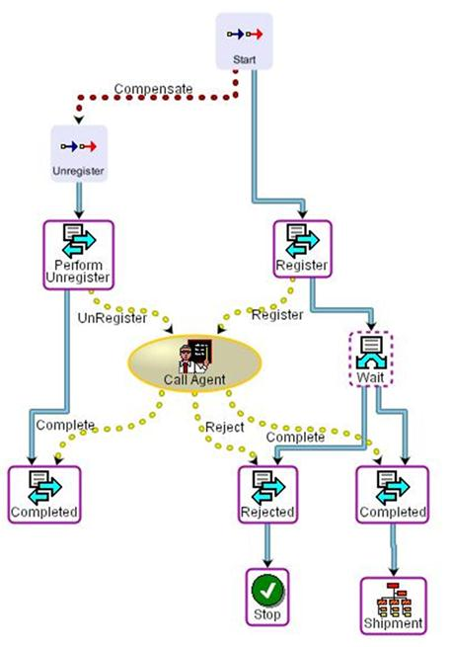

The diagram above illustrates a typical Compensating activity definition. Compensating activities have a “type”, defined by the All Compensates data type. In this manner, multiple compensate workflows may be defined to handled different types of events.

# Order Analytics

The Order Analytics (OA) module is designed for Service Providers’ real-time operational reporting requirements to address all aspects of end-to-end order management performance statistics and measurements.

As order creation is started, Ericsson Order Care audits and tracks all aspects of the order lifecycle. From the users who touch the orders to the milestones that are completed, timestamps of all activities are stored in our database for immediate retrieval through the configuration of Order Finders and any field within the order that can be used as search criteria.

In addition, timelines around each activity of the ordering process can be defined from minutes to hours and days, with resultant notification and reporting of those activities in jeopardy or escalated states.

## Order Analytics (OA) Key Features

|  |  |
| --- | --- |
| * Common search and report development infrastructure for both Order Negotiations and Order Management * All captured and managed ‘content’ is accessible for real-time operational reports, high-level management reports or historical review * Flexible configuration environment allows for efficient end user control of reports and their presentation | |
| Multiple Types of ‘Content’ Finders:   * Order finders that allow searching for specific orders stored in the Ericsson Order Care Database * SQL finders that allow database search with user specified SQL statements * Interface finders that link to external interfaces that implement the finder operations * Configurable ‘search criteria’ input document structures * Configurable ‘search result’ descriptors defined as output document structures | Many report presentation options such as:   * Display Types: Normal, Split Screen, Hierarchy, Dashboard * Maximum number of displayed rows * Configurable caching of report results to improve performance * Configurable row styles, forms and menus * Default sorting options per column * Ability to print locally or to network printers * Ability to download reports in Comma Separated Value (CSV), Excel, XML and PDF formats * User-based permissions per search option or report * Drill down capability from report to report |

## Order Analytics in Detail

Ericsson Order Care provides tools to inquire upon any information associated with the order at any point in the order lifecycle. For authorized personnel, inquiry screens are provided which can be used to inquire on orders and their workflow status, across all task levels. Ad-hoc reports can also be created using third-party reporting applications such as Crystal Reports (see below).

As order creation is started, Ericsson Order Care audits and tracks all aspects of the order lifecycle. Order IDs are generated for all orders and used for tracking and reporting purposes. Sub-orders are tracked and reported via Request IDs and are children to the master order ID.

From the users who touch the orders to the milestones that are completed, timestamps of all activities are stored in our database for immediate retrieval through the configuration of Order Finders and any field within the order that can be used as search criteria.

In addition, timelines around each activity of the ordering process can be defined from minutes to hours and days, with resultant notification and reporting of those activities in jeopardy or escalated states. Pending jeopardies can be flagged and notifications sent to the customer and your rep via UI or email alerts.

## Third Party Reporting Tools

Ericsson Order Care can also expose its order data to third party reporting tools (such as Crystal Reports) for offline analysis and consolidated enterprise reporting needs.

Ericsson Order Care supports real-time DB queries from these applications through an API through identification of order-related Oracle tables with Ericsson Order Care that would be exposed to the enterprise-based reporting applications.

## Creating Reports

Pre-defined reports can be created within Ericsson Order Care using the Service Designer (SD) or Velocity Studio (VS) tools. Adequately trained IT personnel who understand metadata development procedures using Service Designer/Velocity Studio can create reports for specific groups and users leveraging any data stored within the system.

Customers and internal end users of the application cannot create ad-hoc reports directly within Ericsson Order Care however they can select from any number of pre-defined search criteria fields for operational report purposes. The results column is also configurable in that users can select from a number of pre-defined columns those ones they are interested in.

### Report Outputs

Report output can be viewed online; printed locally or to a network printer; and saved locally in the following formats:

* PDF
* CSV and XLS
* XML

## Order Analytics Capabilities

Ericsson Order Care analytic capabilities range from reporting on the organizations responsible for certain segments of the ordering processes to volumetric reports on total orders by product, service, rejection types, etc.

Tiered drill down capability from the management layer to the individual order itself can be navigated through point-and-click access.

The system provides the capability to search and view outstanding orders in any number of search criteria. The search criteria fields are defined in the metadata and are completely customizable and support multiple views depending on the user privileges.

Pre-configured reports do come “out of the box” with the Ericsson Order Care suite. Configuration of customized reports can be performed as explained above.

**Note:** If the database load imposed by such reports and dashboards is expected to be high, running them against a replicated database should be considered. Alternatively, or in addition, some customers choose to ‘archive’ order information from Ericsson Order Care to a Data Warehouse and process reports from there.

The following screenshots illustrate examples of common reports that are generated by the Ericsson Order Care reporting tool:

#### Order Summary Report

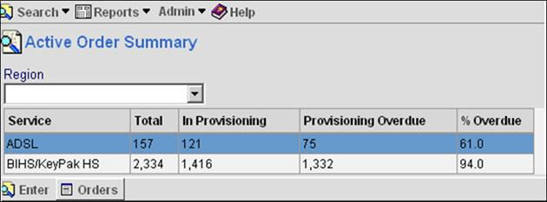

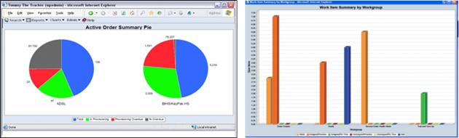

#### Summary by Milestone

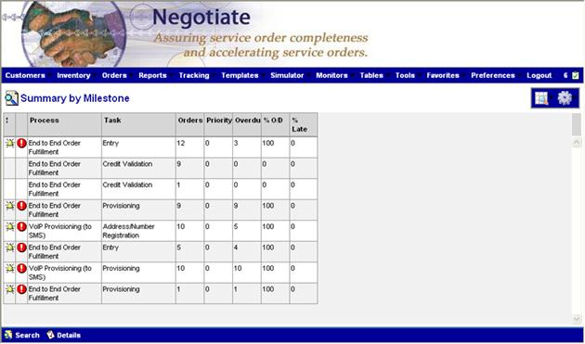

#### Workgroup Work Item Summary

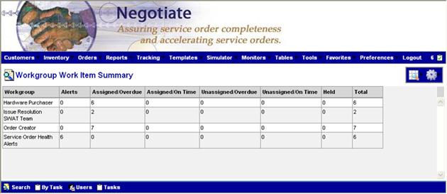

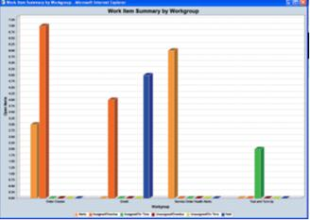

#### Active Order Summary

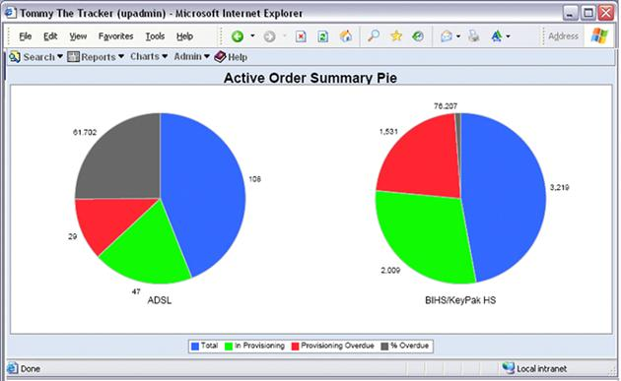

#### Dashboard: System Health

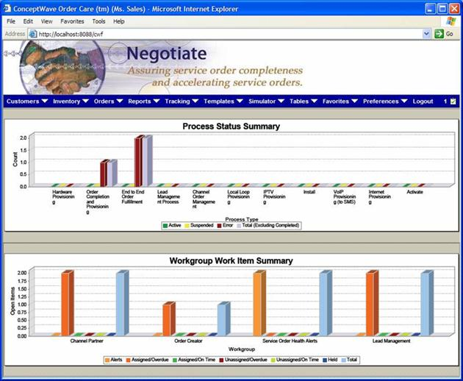

#### Dashboard: Order Health

An example of a “state of the order” dashboard. Double-click drill down on any icon to explore order status.

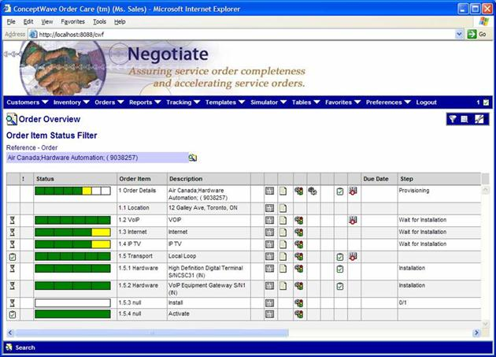

# Service Designer (SD) and Velocity Studio (VS)

## Service Designer

Ericsson Order Care provides a design tool which supports the rapid service deployment objectives of a Communications Service Provider. The tool is highly intuitive and requires only minimal IT expertise. It is used to model the workflow activities, establish systems interfaces, and generate the GUI screens required by participants in the order fulfillment process.

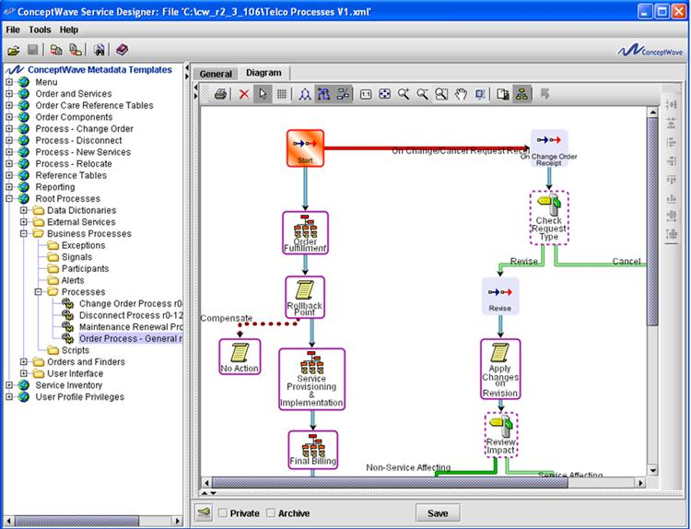

Service Designer (SD) is the only tool required when configuring:

|  |  |
| --- | --- |
| * Data model * Interfaces * Data Transformations * Business Rules * Forms * Privileges * Interfaces | * Workflow * Orders * State Machines * Search Facilities * Reports * Menus * Navigation Trees |

## The Form Designer

The Ericsson Order Care IDE (Service Designer or Velocity Studio) includes a form designer capability which provides a What-You-See-Is-What-You-Get (WYSIWYG) form design tool that allows the form designer to add, format and sequence controls:

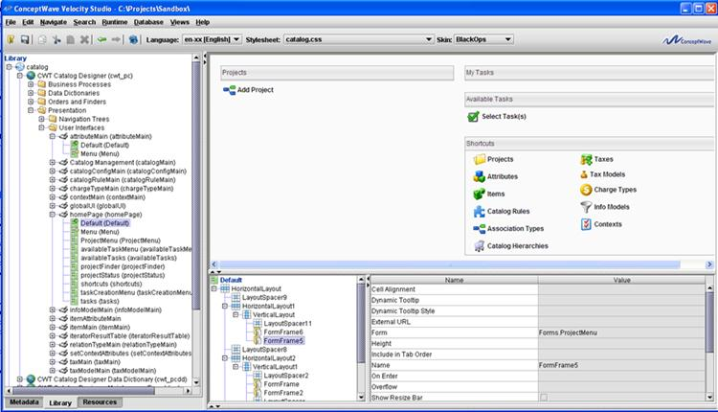

The form designer enables pixel by pixel positioning of the fields on the form, the specification of styles on each control, and the use of third-party styles. Controls supported include fields, text, buttons, lines, group boxes, buttons, images, URLs and spaces. Individual control styling options are provided, e.g. drop-down versus radio buttons.

## Enhanced Features of Velocity Studio Designer (VS)

Velocity Studio Designer (VS) provides advanced UI modeling capabilities on top of the core capabilities provided by the Service Designer, including:

|  |  |
| --- | --- |
| * Iterators * Miller tables * Fly-over and Hover binding * Data Structures User Interface * Display external URL content in Form Frame * Navigation Bar | * Customization * Ability to decouple Order Data Model from Order Tree * Table Tree * Dynamic Documents * Dynamic Tables * Skin |

**Note:** Users without a Velocity Studio Designer license can use and view solution objects at design time and runtime, but are not permitted to make any design time changes.

# Application Virtual Machine (AVM)

The Ericsson Order Care AVM is the runtime framework of Ericsson Order Care applications. Starting the AVM requires that you have your project’s metadata open and saved in Service Designer. Service Designer also allows you to stop the AVM at any time. You can also start the AVM when you are debugging your project metadata.

The following Web-based applications comprise the Ericsson Order Care AVM:

* System Administration Application, which provides detailed, real-time information about running the administration application, including the status of all AVM nodes, and defining users, groups, and privileges.
* Configuration Tool, which enables the runtime configuration of applications and allows you to configure across application nodes when applications are deployed in a J2EE cluster setting.

Applications that you have created in your project metadata are also available when the AVM is running.

## AVM Cache

The cache is a generic mechanism in the AVM that stores in memory data, which can be refreshed or recreated from disk (database or files).

You can configure the AVM cache by using the following parameters in the Configuration Tool:

* Capacity, which defines how much memory in MB the cache can take.
* Element size, which is defined in KB and is automatically set by the Configuration Tool.
* Refresh schedule, which defines one or more points in a 24-hour day when the whole cache content will be dropped. The cache will then rebuild itself dynamically as new requests come in.
* Automatic reload, which allows you to specify the percentage of an element that is reloaded.
* Interval (hours), which refers to the time in hours in which the cache writes its current content to the database.

## AVM Cache Types

AVM cache types can be configured from the Ericsson Order Care Configuration Tool. The following table describes the names and a short description of each cache role.

| **Name** | **Description** |
| --- | --- |
| CodeTable Cache | Contains code tables used mainly by the UI server. |
| Document Cache | Consists of read-only copies of documents. |
| ExternalOrderId Cache | Contains the relationship between the external order ID and order ID. This is companion cache for the order cache. |
| FinderResult Cache | Consists of data from the large finder result sets. |
| Image Cache | Contains images and is used only by the UI server. |
| InterfaceData Cache | Consists of interface data. |
| Order Cache | Contains orders. |
| Reference Cache | Consists of references and is used predominantly by the UI server. |
| Resource Cache | Contains different type of resources (mainly text), such as XSLT specs, browser JavaScript programs, etc. |
| Script Cache | Consists of metadata and catalog scripts. |
| Translation Cache | Contains the language translations of translation data types. |

# Orchestration Framework

The Ericsson Order Care Orchestration Framework (OF) module provides the ability to dynamically orchestrate and assemble processes at runtime. The framework contains functionality to define and create micro-flows, Technical Action Specifications (TAS) and Fulfillment Plans (FP) through its own UI or integration with external applications through the use of APIs. It is a flexible product that allows non-technical users to configure process flows from a defined set of micro-flows resulting in less time to market.

## Implementation

The Orchestration Framework module is implemented with Ericsson Order Care, Catalog, and Product Lifecycle Management (PLM) to allow business users the ability to change existing business process or configure new processes without having to change the metadata in Velocity Studio. Micro-flows defined in Velocity Studio can be referenced at runtime through Web UI or APIs and are easily extensible by Ericsson.

In design time, workgroup tasks are defined in Velocity Studio as a micro-flow. Each micro-flow is a unique process that includes activities such as:

* Manual operations (**Create Quote**)
* Decision operations such as Done when the Create Quote task is complete or **Jeopardy** when the Create Quote task is deemed to require an escalation
* **Timeout Activity** that triggers an alert to the appropriate workgroup when the **Create Quote** task is not completed within a predetermined period.
* **Loop Back** activity that reinitiates the Create Quote task following the submission of an alert.

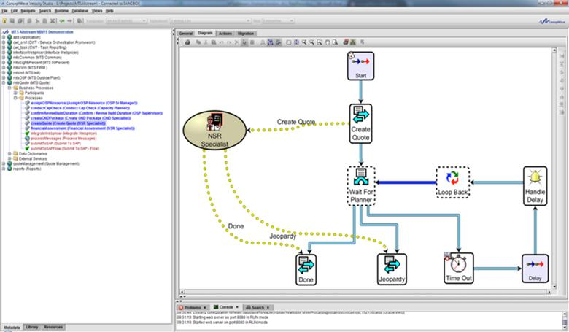

Figure 1 Create Quote micro-flow

Once the metadata for these processes have been defined through Velocity Studio, Orchestration Framework can be used by a non-IT user at runtime (with the correct permissions) to define and configure:

* Available micro-flows
* Technical Action Specifications (TASs) that are associated to each micro-flow and provide a properties layer to the micro-flows that includes a State (Active, Definition, Archived, etc.), Standard Activity Duration, and a list of key parameters that can be used to influence the behavior of the micro-flow.
* Fulfillment Plans that are tied to the sequencing of TASs (with dependencies) to complete a higher level process such as the QUOTE, 80%, or FIRM process.

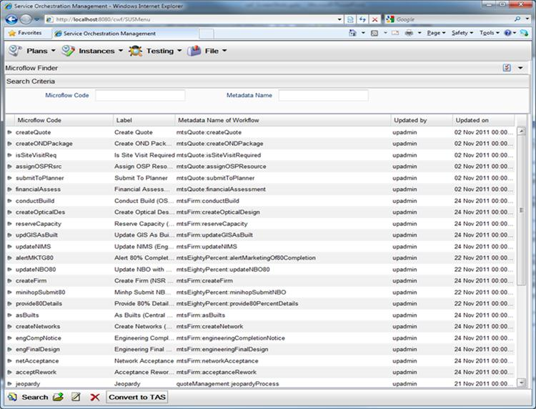

Figure 2 Micro-flows loaded into the OF module

The Micro-flows are associated to a TAS in a 1:N association. More than 1 TAS can reference a micro-flow.

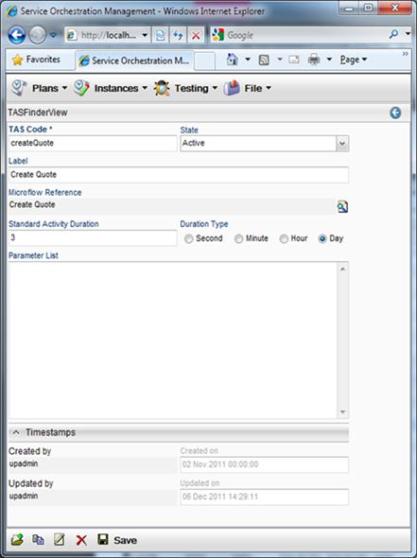

Figure 3 TAS property page

Besides defining the state and standard activity duration of a TAS, a parameter list can also be defined to influence the behavior of the micro-flow:

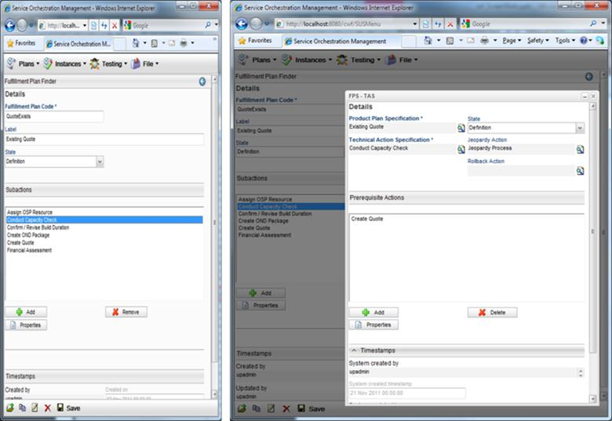

## Fulfillment Plans

Fulfillment Plans (FP) are defined to associated the TASs, and orchestrate each TAS and their prerequisite. The Quote FP process includes TASs such as Create Quote and Financial Assessment of the NBO to TASs for Capacity Planning, OND, OSP Senior Manager and the OSP Supervisor.

Definitions in the Quote FP include:

* The full list of TASs required for this FP.
* Create Quote and Create Pre-OND Package TASs have no prerequisites and are therefore triggered in parallel.
* Capacity Check TAS has the Create Quote TAS as a prerequisite and can only be instantiated if that prerequisite is met.

The advantages provided with the OF module as an orchestration engine is that the FPs can be updated in real-time with no IT involvement. New FPs can be introduced without the necessity to deploy new metadata.

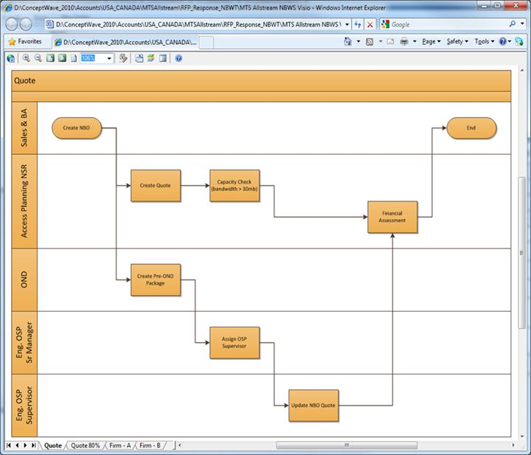

The OF module can also monitor the instantiated FPs, and display the Gantt chart and TAS details associated with each FP. The following FP details will also be attached to the NBO for visualization and editing (based on permissions) by the NS teams.

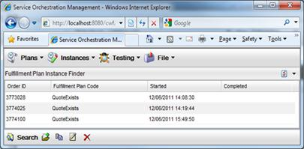

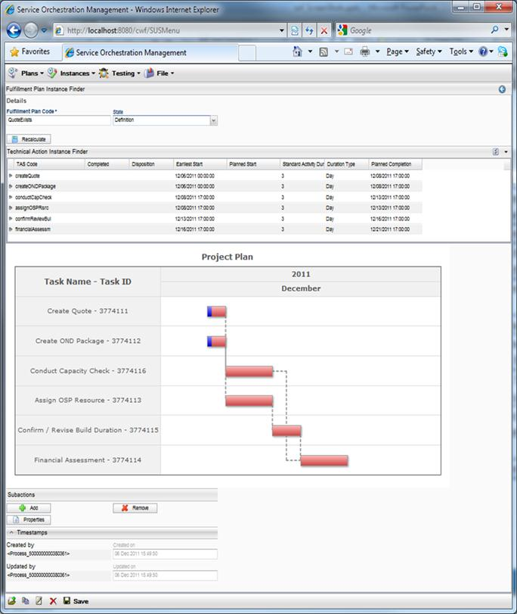

This solution provides no limits to defining and executing business processes, micro-Flows, and Fulfillment Plans. Fulfillment Plans can be reused in various flows. The flows can contain conditions that can be processed in parallel, sequential, or iteratively. The lifecycle of each flow instance can be viewed on a dashboard and allows the ability to stop, skip and resume the processing of an Order, Offer, or Request.

## Orchestration Framework Tables

SOF is a standalone template library that can be used in combination with Catalog and PLM. The following are the OF tables and their description:

* Microflow - Contains complete metadata name of process
* TAS (Technical Action Specification) - Defines microflow as technical action specification. Microflow for TAS is optional. User can create a dummy TAS with no microflow.
* FPS (Fulfillment Plan Specification)
* FPSTAS
* FPSTASPrerequisite
* FPI (Fulfillment Plan Instance) (Instance table)
* TAI (Technical Action Instance) (Instance table)
* TAIPrereq (Instance table)

# Customer Information Management (CIM)

## Overview of the CIM User Interface

The CIM user interface can be divided into these areas:

* Application layout
* Menu
* General types of user interface elements
* Understanding UI field masks

### Application Layout

The Application layout consists of the following general sections:

* Menu bar
* View options
* Search filters
* Object details
* Actions menu

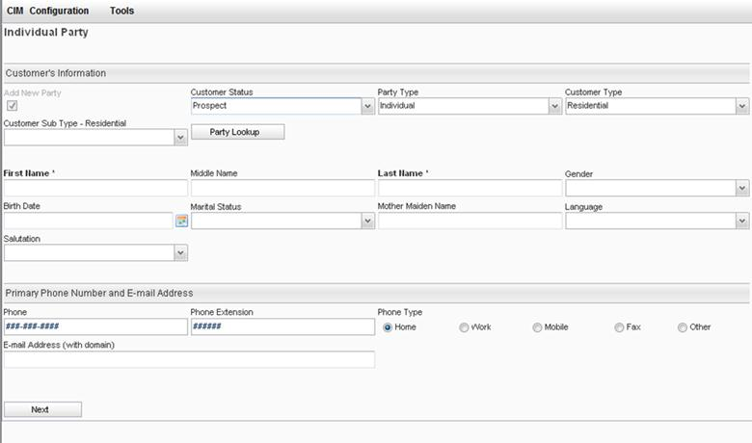

### Menus

The menu bar consists of a row of main menus near the top of the screen consisting of the following:

* CIM
* Configuration
* Tools

**CIM Menu**

The CIM menu contains the following submenu options:

* **New Customer:** Create a new customer
* **Search Individual:** Search for individuals
* **Search Organization:** Search for organizations
* **Manage Address:** Manage address information
* **Search By Site:** Search by site location
* **Manage Notes:** Manage notes information

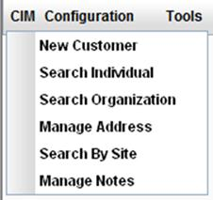

**Configuration Menu**

The Configuration menu contains the following submenu options:

* **Code Tables:** Runtime configuration of the System List box
* **CIM Config:** Configuration settings for the CIM application

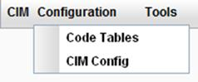

**Tools Menu**

The Tools menu contains the following submenu options:

* **Event Log:** Shows system messages
* **Information:** Displays general Frame work information
* **Select Application:** Allows you to exit CIM and enter a different application
* **Logout:** Allows you to log out of CIM and end your session
* **Change Password:** Allows you to change your password

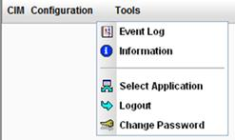

### General Types of UI Elements

The following general types of UI elements are used in the CIM module:

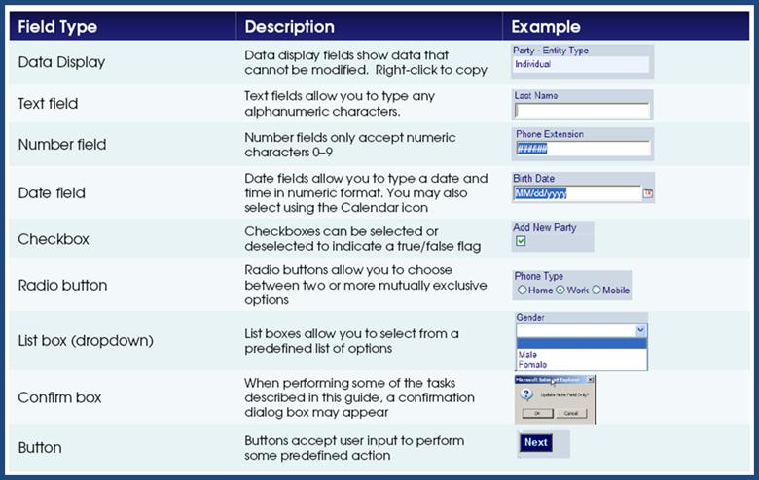

### Understanding UI Field Masks

The following illustration shows various types of UI fields, where their symbols or masks are defining formats for each field’s value.

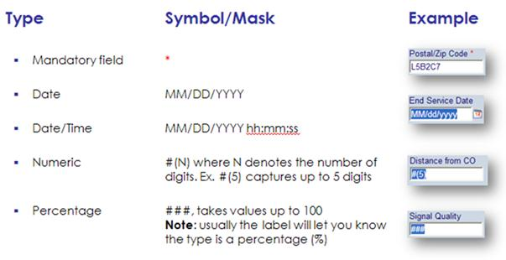

## Code Tables

Code tables drive the selection options for some list-box entities. You can add or edit these options as appropriate.

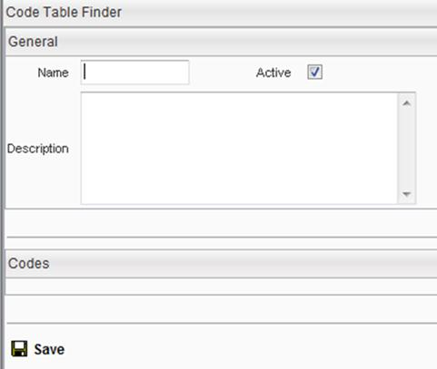

A code table contains codes and may also include codes from another code table. Code Tables in XML format can be imported using the Import option from the actions bar at the bottom of the screen.

Many system code tables that come with the core CIM installation contain “dummy” codes and require deployment-specific configuration.

### Editing Code Tables

CIM allows you to easily edit a code table and add new code, as required.

## Using CIM – Customer Management

### New Customer

You can create a new customer record using the **New Customer** option from the menu bar or by click the corresponding button within the Customer finder.

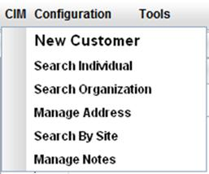

The New Customer form appears for input:

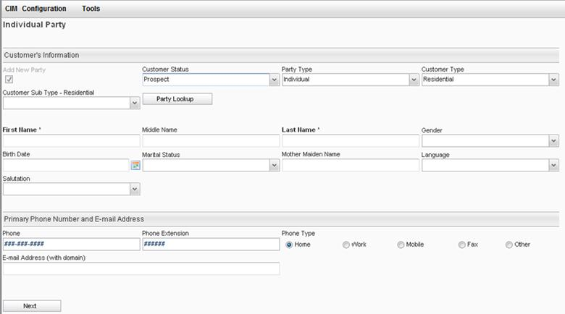

The following fields appear on the New Customer form:

**Party Type –** Choose from one of the following options:

* **Individual –** Selecting this option allows you to select either **Residential** or **Commercial** for the **Customer Type**.
* **Organization –** Selecting this option allows you to select the following:
  + The **Customer Type** as either **Residential** or **Commercial**
  + The **Customer Sub Type-Commercia**l as either **Carrier**, **Enterprise**, or **Wholesale**

The following screen displays all the necessary information:

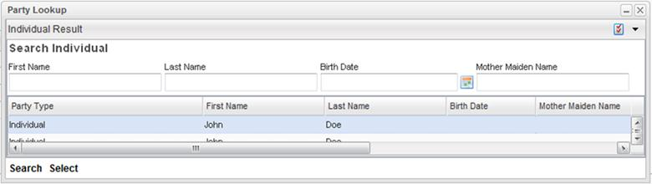

### Configure Customer’s Information for an Individual

This form can be used to fill in the customer’s information.

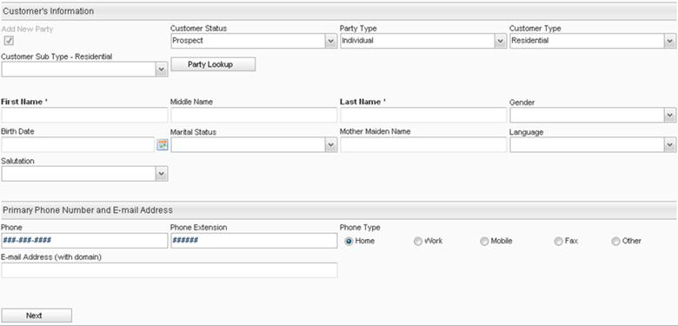

### Configure a Party – Party Master Lookup

From the Customer Information form, click **Party Lookup** to display the Reference Finder.

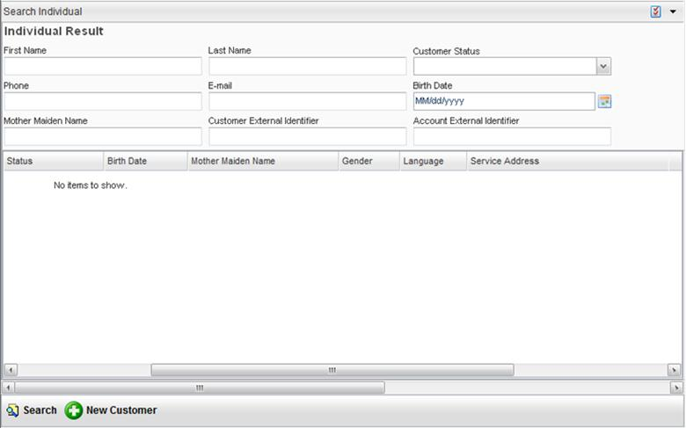

To search for a party, enter your search criteria in the available fields and click the **Search** button. Then, click the party that you want and click the **Select** button to edit the party. Otherwise, if you cannot find the party that you want, click the **New Customer** icon to create a new customer.

### Configure Contact Information – Primary Phone Number and Email Address

You can change the following contact information fields:

* **Phone –** A numeric field with an optional **Phone Extension** field. A **Phone Type** option must be selected.
* **Email Address –** This field must include domain name (for example, user@ericsson.com).

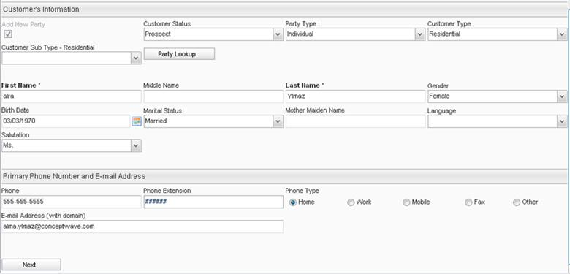

### Define an Address Using the Address Master

You can define an address in the Address Master. The Address Master is a finder that is designed to sort and search all addresses in the system. The Address Master Finder, shown below, can be used to select an existing address or new address information (see Manage Address).

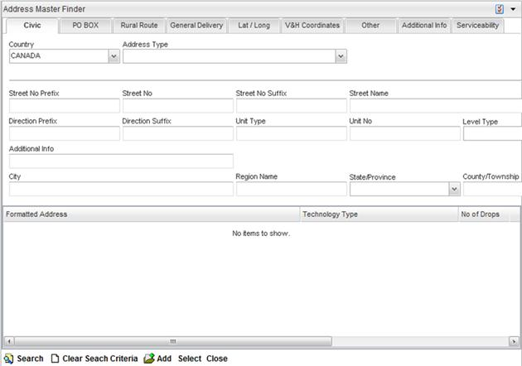

### Add, Change, and Delete a Contact

Once you have selected a customer, the node tree menu for that customer appears on the left hand side. A customer contact can be added, or an existing contact can be changed or deleted.

### Manage Address

The customer or organization address exists in the internal customer database. It may be associated with a customer, contact, site, or account, or it may exist without any association. CIM provides tools to manage an address.

#### Address Master Actions

The actions menu appears at the bottom of the Address Master finder form and has the following options:

* **Search/Find Address**  
  Initiates a search based on your filter values. Use % to perform a wildcard search.  
    
  **Note:** Unrestricted searches are not allowed, meaning you must enter at least one search filter.
* **Select**  
  Returns the Address Master for the selected row.
* **Clear Search Criteria**  
  Clears any values you have entered in the search filters on all tabs.
* **Add**  
  Opens the Add New Address popup.
* **Close**  
  Closes and finishes the session, and returns you to the main menu.

#### Address Master Finder

The Address Master is a finder that is designed to sort and search all addresses in the system.

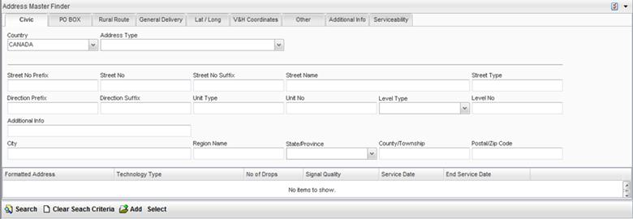

Click the tabs across the top of the finder to use the following search filters

* Civic
* P.O. Box
* Rural Route
* General Delivery
* Lat/Long (latitude and longitude)
* V&H (vertical and horizontal) Coordinates
* Other
* Additional Info
* Serviceability

All addresses, regardless of type, are stored in a single table and displayed as a **Formatted Address**.



You can enter search filters on any of the tabs and click the **Search** button from the actions bar to return your search results.

#### Add New Address

A new address can be created from the Address Master Finder. Clicking the **Add** button from the Address Master Finder launches the New Address form.

#### Address Types

There are different address types used when creating a new address. Each address type displays different address fields. This section contains the various address type forms.

**Civic Address**

The following form displays the available fields when creating a new address with a Civic address type.

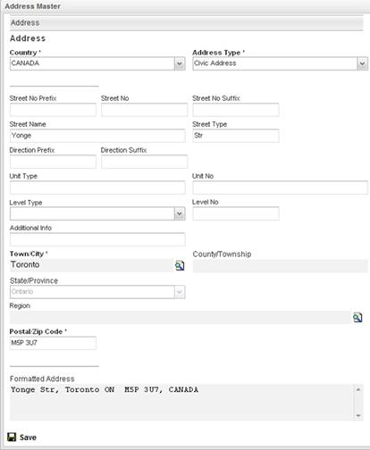

This form contains a variety of fields to capture a civic address:

* Street No
* Street No Prefix
* Street No Suffix
* Street Name
* Street Type
* Direction Prefix
* Direction Suffix
* Unit Type
* Unit No
* Level Type
* Level No
* Additional Info
* Town/City
* County/Township
* State/Province
* Region
* Postal/Zip code
* Formatted Address
  + **Show Formatted Address:** Updates Formatted Address field

**Rural Route**

This form contains the same fields as the Civic Address form, with the following additional fields:

* Rural Route Identifier
* Number
* Station Info



**PO Box**

This form contains the same fields as the Civic Address form, with the following additional fields:

* PO Box No
* Station Info



**Latitude/Longitude**

The address type is defined by:

* Latitude (N/S)
* Longitude (E/W)

In terms of:

* Degrees
* Minutes
* Seconds
* Direction

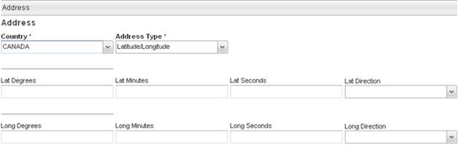

**V&H Coordinates**

The address type is defined by:

* Vertical Coordinate
* Horizontal Coordinate

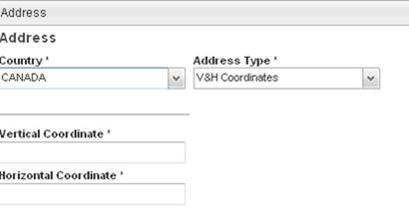

**General Delivery**

This address type is defined by:

* Station Info
* Postal/ZIP code
* Town/City
* County/Township
* State/Province

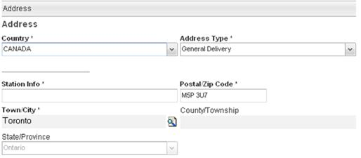

**Address Type Other**

When selecting an Address Type of Other, the system provides the following flexible address fields:

* Line 1
* Line 2
* Additional Info

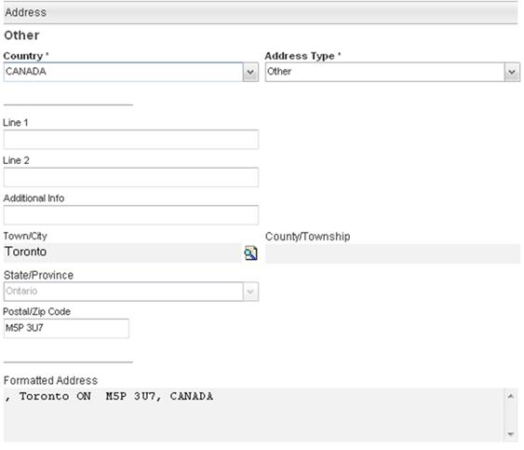

## Finder Menu Options

A finder typically has the following **View** options:

* **Toggle –** Allows you to hide or unhide the search criteria section. Only results are displayed.
* **Select Columns –** Allows you to customize the finder columns.
* **Options –** Includes Available/Unavailable, Print Results, and Download as CSV, XLS, XML.

### Toggle Search

The **Toggle** search form button hides or reveals search filters, which may free up your screen’s real estate.

### Select Result Column

The result columns feature can be used to customize the way your results table appears. You can customize the visibility of specific columns, as well as the sort order.

### Options for Output

The options include the following criteria of selections:

* **Print Results**
* Download as **CSV/XLS**
* **XML**

## Using CIM – Customer 360°

Customer 360° is a consolidated view of a customer and all of its hierarchical relationships to Accounts, Contacts, etc. Customer 360° can be integrated with the following Ericsson Order Care modules:

* Quote Management
* Order Management
* Service Registry
* … and other systems

All modules are integrated to give the true 360-degree view of a customer and all his activities. This view is intended to consolidate and manage all customer sub-entities:

* Party Name (Customer)
* Contacts (N)
  + Contact Mediums (4..N)
    - Customer Contact
    - Account Contact
  + Identifications (0..N)
* Accounts (1..N)
  + Account Number (1..N)
  + Addresses (0..N)
  + Contacts (0..N)
  + External IDs (0..N)
  + Invoice Info (0..1)
  + Service Registry (0..N)
* Sites (N)
  + Site Number (1..N)
* Quotes/Orders (0..N)
* Notes
* History

CIM allows you to easily access the 360° view of an existing customer.

### Party

#### Customer View

The Customer View screen displays detailed customer information within the left pane tree, indicating the number of accounts and different sites for this customer. The customer view always shows the site and account information separately.

#### Hierarchical Account Structure

The information that is available for the accounts can be viewed within the left pane tree, indicating the number of accounts that the customer has.

If there is more than one account associated with this customer, the previous screenshot is the screen that appears. The following screen may also appear that shows a parent account, consisting of sub-accounts denoted by a dash (-) or another level of hierarchy where a sub-account has its own sub-account.

#### Party for Individual

A party, as an entity of the customer, is either an Organization or an Individual. By definition, the party does not carry address information. The address is provided when a party plays a specific role. Each party has a role, displayed in the visual label of the party. The roles that a party can play are as follows:

* **Customer:** The party that identifies the customer (that is, the top-level). There is always only one party with the Customer role.
* **Customer Contact:** An individual who is a contact within the customer and is unrelated to any account. N contacts are allowed.
* **Account Contact:** An individual who is a contact within the Customer, related to a specific account. N contacts are allowed per account.

A Customer can have N parties, only one of which plays the Customer role. The visual label of the top node for the Customer is the party that plays the Customer role.

The following action menu options are active:

* Manage (orders)
* Jump to Site
* Add Contact
* View (select one line)
* Modify (select one line)
* Delete (select one line)

When an individual customer party lookup is selected, the search results table contains the following columns:

* First Name
* Last Name
* Status
* Birth Date
* Mother Maiden Name
* Gender
* Language
* Service Address

By selecting an appropriate customer row from the search results table, the customer profile information displays for the selected customer.

The customer profile that is displayed contains four different sections of customer information:

* Customer Info
* External IDs Reference
* Contact Mediums
* Identification Number

If the **Customer Contact** party was selected, Tab 1 contains the following contact profile fields:

* First Name
* Middle Name
* Last Name
* Gender
* Birth Date
* Marital Status
* Mother Maiden Name
* Language
* Salutation

An on-screen **Modify** button is available that allows you to change the customer information.

The four aforementioned sections allow you to click the **Add**, **Modify**, and **Delete** buttons to make changes to the information.

#### Party for Organization

A party, as an entity of the customer, is either an Organization or an Individual. By definition, the party does not carry address information. The address is provided when a party plays a specific role. Each party has a role, displayed in the visual label of the party. The roles that a party can play are as follows:

* **Customer:** The party that identifies the customer (that is, the top-level). There is always only one party with the Customer role.
* **Customer Contact:** An individual who is a contact within the customer and is unrelated to any account. N contacts are allowed.
* **Account Contact:** An individual who is a contact within the Customer, related to a specific account. N contacts are allowed per account.

When an organization customer party lookup is selected, the search results table contains the following columns:

* Party Type
* Company Name
* Company Name Type
* Registration Date
* Industry
* Type of Organization
* Revenue Range
* Logo URL

By selecting an appropriate customer row from the search results table, the customer profile information displays for the selected customer.

The Customer Profile that is displayed contains four different sections of customer information:

* Customer Info
* External IDs Reference
* Contact Mediums
* Identification Number

**Party Profile List**

CIM allows you to view all the Parties for a Customer.

#### Actions menu

The actions menu appears at the bottom of a page. The menu features the following items:

* **Manage:** Manage a new order, existing order, or copy
* **Jump To:** Select a site
* **Add Contact:** Adds a new party with Role Account or Customer Contact
* **View:** Focuses view on the correlated Party node
* **Modify:** Launches the Edit dialog
* **Delete:** Removes the party from the customer (does not apply to Party with Customer role)

#### Add Party

To add a party, you can click the **Add Contact** button from the Party Profile List’s action menu, which launches a page that allows you to create a new party.

**Party Details**

When you have selected a party, the following sections appear:

* **Contact Profile:** Customer/Contact General Info (for example, Name, Birth **Date, Language, etc.)**
* **Contact Mediums:** Methods of contact (for example, phone numbers, service and billing addresses, E-mail Address, Blackberry PIN, etc.)
* **Identification Numbers:** IDs for verification (for example, driver’s license, health card, social insurance)

**Contact Medium Tab**

A **Contact Medium** is any medium that can be used to contact a party. Some examples are as follows:

* Telephone, mobile, and facsimile numbers
* E-mail addresses
* Pagers
* URLs
* Postal addresses

Parties do not carry contact medium information directly. Instead, they carry contact mediums through their roles.

You can define contact medium types in the cwt_contactMediumType code table. If a contact medium requires specific validation, these rules can be configured as regular expressions in the cwt_contactTypeValidation table.

CIM allows you to see a summary of the contact mediums defined for a party, as well as to add a new contact medium. You can also change or delete contact medium information. When adding a contact medium, you must select a type first before the form changes to one of the generalized forms previously mentioned (for example, adding a phone number). You can optionally specify valid dates, Account ID, and other properties specific to the medium type, such as address type. You can also mark certain types as **Primary**.

**Identification Numbers**

The **Identification Numbers** tab holds identification information for the party (Individual or Organization). A party can have unlimited number of Identifications. Some examples of ID types for an Individual are Driver License, Health Card, and so on.

Identification Types for Organizations and Individuals are different, and are maintained in different code tables:

* Organizations: cwt_OrgIdentificationType
* Individuals: cwt_IndIdentificationType

**Add, Change, or Delete an Identification Number**

You can use the actions bar to add, change, or delete an Identification Number. Double-clicking an identification record will display the details of the record for updating.

When adding an Identification Number you must provide an **Identification Type** and **Identification – Number**:

* The **Identification Type** field differs, based on the **Entity Type** (Individual or Organization)
* You can optionally specify **Valid From** and **Expiry Date** fields
* A code table drives identification types

### Account

An account is an entity of the customer, which identifies a sub-component that may have its own addresses and contacts. While the account is typically a billing entity, there is a need to manage the creation and status of accounts during order entry, and within the order. The following example shows a customer having two accounts:

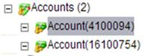

The following information holds true for accounts:

* A customer can have N accounts
* Each account can have N addresses, which come from the Address Master
* Each account can have N contacts, which come from the Party Master
* Each account can have N external system identifiers
* The visual label of top account node indicates in brackets the number of accounts (for example, **Accounts (4**) indicates there are four accounts)
* Each Account visual label has the Account ID in brackets, for ease of identification (for example, the Billing System Account ID)
* Each account contains invoice information and a link to the Service Registry for that account.

#### Parent Account ID

For a parent account, a list of the billing accounts with the following fields display in the results table:

* Account ID
* Account Name/Description
* Parent Account ID
* Billing Address
* Start of Activity Date
* End of Activity Date
* Account Status

#### Actions Menu

You can add, modify, and delete accounts. The actions menu at the bottom of the screen contains the following icons:

* **Manage:** Allows you to manage the highlighted account
* **Find:** Launches a finder to search for accounts
* **Add Account:** Adds a new row in the account list
* **View:** Focuses view on the correlated account node
* **Modify:** Allows you to change account details
* **Delete:** Deletes a highlighted account from the list

#### Add Account

Note: An **Account status** will have the following states: ***New***, ***Active***, ***Blocked*** and ***Inactive***. **Account status** is ***Active*** when a service is first activated for the customer for this account. The **Account status** becomes ***Inactive*** when all services for this account are disconnected.

A **Parent Account ID** can be assigned to an account and hierarchical billing structure is also available within accounts.

* An account can be a root or have a single parent account
* An account can have 0…N children
* There are no restrictions on level numbers
* Cyclic dependencies are restricted (child account cannot be selected as a parent for its own parent)

The **Billing Address** appears as read-only. Billing addresses can be linked to Google maps by clicking the hyperlink associated with the billing address. You can also add a billing address.

**Contact Mediums**

The contact mediums include all the necessary customer address information.

The **Add**, **Modify**, and **Delete** buttons options are available for customer account management.

When selecting an address, you can either create a **New** address or click **Address Lookup** from the Address Master Finder.

**External System IDs**

The external system and external identifier are concatenated on each line, followed by **Primary** for the primary external ID (if any). The **Add**, **Modify**, and **Delete** buttons are available for customer account management.

### Invoices

From the Account Details form, the Invoices tab contains detailed billing and invoicing information such as:

* Last Invoice Amount
* Last Invoice Date
* Last Payment Amount
* Last Payment Date
* Contract
* Invoicing Language
* Invoice Options

The following code tables drive several fields:

* cwt_custAcct_billingCurrency
* cwt_custAcct_invoiceLanguage
* cwt_custAcct_invoiceOption

### Payment Methods

The **Payment Methods** tab contains the Payment Method Finder and contains the ability to perform the following payment actions:

* Manage (orders)
* Find
* Add Payment Method
* Modify (select one line)
* Delete (select one line)

### Service Registry Tab

The **Service Registry** tab displays the Account Service List page. This page displays products that are in service for the specified customer.

The **Valid At** field allows you to specify a date. Clicking the **Query** button triggers the system to query the account’s services to display all services for the specified date. The **Account Service List** displays services, related offers, and products represented by the following fields:

* Offer Family
* Access ID
* Description
* Offer Category
* Term
* Account
* Site
* Service Start Date
* Monthly Charge

### Account Notes

The **Account Notes** tab displays the Accounts Notes List page containing all notes for the account.

The following action menu options are available:

* Manage Orders (New Order / Open an Existing Order / Copy Order)
* Jump To (Site)
* Find
* Add Note
* Modify (select one line)
* Delete (select one line)

The Account Notes List table displays account-specific notes with the following column of information:

* Note Type
* Note Sub Type
* Assigned To
* Due Date <=
* Customer ID
* Account ID
* Site ID
* Contact ID

The **Add Note** and **Modify** menu options display details of the payment method type.

### Quote/Order Folder

A customer, at any time, may have many open orders or quotes. The following example shows a Quote/Order folder with two quotes.



While CIM does not contain the order or quote data model, it does allow you to view the instances for a customer through a search-and-drill-down function. Use the Quote/Order Finder to find completed orders in the search results table.

This finder’s results table screen is overwritten by:

* Order Negotiations logic, showing the data model
* Order Management logic, showing the order state, status, or task

Orders may be associated with an address (site) or an account.

### Quote/Order Finder

Search criteria that you can use in this finder to search quotes and orders are as follows:

* Account List
* Order Number
* Order Status
* After Order Date
* Before Completed Date

The **Account List** field is a filter to display orders for a specific account. An additional column is added to show hierarchical relation of the billing accounts and others listed – **Parent Account ID** column that is available as shown on the screen that follows, along with these columns:

* Order Number
* Order Status
* Order Date
* Completed Date
* Account ID
* Parent Account ID
* Service Address

The **Search** button at the bottom of the screen allows you to perform an order search filtered by certain search criteria as shown on the screen that follows.

Drilling down on a search results row displays the detailed results of the order. The order header data appears with the following information:

* **Order Number:** User-facing number
* **Order Version:** Revision number, if any
* **Order type:** Choose from the following order types:
  + **Add**
  + **Change**
  + **Disconnect**
  + **Move-Add**
  + **Move-Disconnect**
* **Order Status:** The state of the order, such as Completed
* **Order Date:** The creation date of the order
* **Created by:** The CSR who created the order
* **Creation Date:** The date that the quote or order was created
* **Updated by:** The last CSR who updated the order, and an order In *Provisioning or Completed* state, which gives the Process ID
* **Submitted By:** CSR who submitted the order to the provisioning state
* **Completed Date:** The actual date when the order was completed
* **Account ID:** The internal account ID
* **Service Address:** Service address for the order quote
* **Dashboard button:** Click this button to display the order item status report
* **Error Message:** If an order that has entered in Error state from Provisioning is able to display a message in this field

### Order Dashboard

Due to technical reasons, two or three processes are always displayed. Each step in the Order Management process contains a colored status column that represents the state of the order:

* Completed steps are green
* A current, incomplete step is yellow
* Steps that have yet to begin are white

The Order Dashboard contains the following information:

* **Order Item:** *Process or [number] Process*. Not user information.
* **Description:** A description of the process followed by its Process ID.
* **Icons:** A series of icons that provide information or actions troubleshooting the Order Management process.
* **Folder icon:** Displays the data order, which contains the same information as the order seen in the Order UI, but in a more technical format.
* **Gear icon:** Displays the Process Manager page for the selected process. A number of additional queries are possible from this page, including querying Worklist tasks, activities, and the event log. Authorized users can also suspend, resume, terminate, or cancel the process.
* **Two gears icon:** Lists the child processes (that is, sub-processes).
* **Alert icon:** When a task has been removed due to a revised on cancelled, an alert flag displays.
* **Screen icon with check mark:** Displays the Worklist history, which is a list of manual tasks. Double-clicking a task provides additional details.
* **Due Date:** Not in use.
* **Step:** The current step or Finished for complete orders.
* **State:** The order state:
  + **PRV** = Provisioning
  + **ERR** = Error
  + **COM** = Complete

### Notes

The customer Notes section provides service and sales representatives with the ability to create and attach notes to a customer.

Notes may be associated to one of the following entities:

* Customer
* Party (such as Customer Contact)
* Site
* Account

From the Notes Finder Global form, you can search for a note, and change and delete a search results record with the following available actions:

* Find
* Modify (select one line)
* Delete (select one line)

### View Notes

The Notes menu option, available in the tree view pane, allows you to display the List of Notes finder. The available search function displays all notes that match the search criteria for the specific customer account.

From the List of Notes finder form, you can search for notes records with the following filters:

* **Note Type:** Type of notes (for example, Other)
* **Note Sub-Type:** Type of sub-type notes
* **Related Order:** Type of note related to an account
* **Related Party:** If necessary, select and reference a party
* **Due Date/Time:** Values include **Today**, **+7 days**, **+30 days**, **+6 month**, **All**, **-7 days**, **-30 days**
* **Assigned To:** Filters by user who has been assigned to this note

From the search results, you can perform the following actions:

* Manage (orders)
* Add Note
* Modify (must select one line)
* Delete

### Edit Notes

From the List of Notes search results, you can change a notes record.

The following are the display columns that contain the necessary information for each note:

* **Note Type:** Select from **Appointment**, **Email**, **Letter**, **Other**, **Phone**, **Task**
* **Note Sub-Type:** Other
* **Assigned To:** User who has been assigned the note
* **Due Date/Time:** Date until the note is valid
* **Related Account:** Whether the notes has been associated with an account
* **Site ID:** Shows site ID, if applicable
* **Contact ID:** Shows contact ID, if applicable
* **Related Party:** Party reference ID
* **Party Role:** Party role

### Sites

Select the Sites menu option from the left tree pane. The Customer Tree Site Finder displays. To add a site, click the Add Site button from the actions menu bar.

The following fields make up the site information:

* **Site Name**
* **Service Address**
* **Site State**
  + **New** (default value) for a newly created site, where no customer services have been associated yet
  + **Active** for the site where first service was activated
  + **Inactive** for the site for which all services were disconnected
* **Start of Activity Date**
* **End of Activity Date**
* **Service Address** appears as read-only

The service address is associated with Google Maps. Clicking the hyperlink displays the corresponding map.

### View a Site

The Customer Tree Site Finder page displays after you have clicked the Site menu option from the tree pane. You can use this finder to search for a site address and perform a search on the various address types (for example, Civic, Lat/long, and so on).

The search results appear in the results table with the following fields:

* Site Name
* Site Status Active (Yes/No)
* Billing Address
* Start of Activity Date
* End of Activity Date
* Service Address Information

From the Customer Tree Site Finder, you can perform the following actions through the actions menu bar:

* Manage (orders)
* Search
* Add Site
* View (must select one line)
* Jump To

By selecting a search results record and clicking the **View** button, the Site view page appears with detailed information on the selected site.

## Customer Information Management and SID

SID carries entities such as Party, Party Role, Contact Medium, PartyRoleContactMedium, and so on. Each entity has its own set of relationships.

Ericsson has rationalized these relationships into patterns:

|  |  |
| --- | --- |
| SID Entity | Ericsson Pattern |
| Customer | Party where Role = Customer |
| PartyRoleContactMedium | Party Contact Medium where Type = Address |
| Contact Medium | Party Contact Medium where Type = Address |
| Party | Customer |
| Party Name | Customer Name |
| Party Role | Individual or Organization |
| Customer Account | Account |
| AccountContactMedium | Account’s Contacts and Addresses |

# Service Registry

Service Registry is an Ericsson Order Care module. Service Registry stores information about entities such as products, services, resources, and so on, and it stores relationship information. It is a standard module that can be implemented out-of-the-box with little or no configuration. However, this generic module can be extended to fulfill end user-specific requirements.

Full CRUD (Create, Retrieve, Update, Delete) API operations are exposed for the external systems through a full SID-based interface. All changes are versioned for easy historical data retrieval. Service Registry uses the SIDCommon library.

## Logical Model

The Service Registry logical model consists of four main tables:

* Entity
* Entity Values
* Association
* Association Values

The following table describes the four main tables, a description of the data stored in each table, and keys that are used within each table.

|  |  |  |
| --- | --- | --- |
| Data Element | Description | Key |
| Entity | Stores product, service, term data, and more. | * Application Context * Entity Type * DN * Valid From Date |
| Entity Value | Stores entity characteristics as name-value pairs. | * Entity Application Context * Entity Type * Entity DN * Characteristic * Valid From Date |
| Association | Stores associations between Service Registry entities as well as associations with entities from external systems | * Application Context * Entity Type * DN * Valid From Date * Entity Key * Association Entity Key |
| Association Values | Stores association-specific characteristics such as name-value pairs. | * Association Application Context * Association Type * Association DN * Characteristic * Valid From Date |

## Active Data in Service Registry

Service Registry is expected to contain an enormous amount of data, as it keeps all customer historical data. To improve search performance, Service Registry uses separate tables for active and inactive customer services. The active data is stored in Active tables and the archive data is stored in the Service Registry’s logical model tables.

The active tables are as follows:

|  |  |
| --- | --- |
| Active Table | Related Service Registry Tables |
| CWT_SR_ENTITYACT | CWT_SR_ENTITY |
| CWT_SR_ENTITYVALUEACT | CWT_SR_ENTITYVALUE |
| CWT_SR_ASSOCIATIONACT | CWT_SR_ASSOCIATION |
| CWT_SR_ASSOCIATIONVALUEACT | CWT_SR_ASSOCIATIONVALUE |

The Service Registry module automatically redirects the request to query the Active tables for the customer’s current data, or to query the service registry tables for historical data. Active tables are not burdened with history and, as a result, performance remains stable.

The system populates these tables using **on insert** and **on update** triggers. These triggers update the Service Registry tables. All records that are currently active are populated in the Active tables. Once a record has expired (that is, the **ValidToDate** field is in the past), the record is deleted from the Active tables. A nightly batch process is then run to remove old records from the table.

# Unified Workstation

## Overview

Ericsson Order Care UWS is part of the Ericsson Rapid CRM Portfolio and provides a unified customer service desktop solution that directly integrates with Customer, Order, Quote, Inventory Management, Workforce Management, etc.

The following business challenges are addressed via UWS:

* Multiple B/OSS systems and channels, managed by different and disparate systems – lack a unified view to make key real-time, immediate business decisions and recommendations
* Ineffective CSP business decision-making and services visibility - slow delivery, poor customer impression and lack brand loyalty

UWS can simplify and automate even the most complex customer service environments by bridging disparate legacy systems and call center tools and delivering only the relevant data and process flows needed for any customer interaction.

With UWS, Customer Service Representatives (CSRs) can resolve more calls the first time, improve customer interactions, be trained more rapidly and provide a consistent experience to customers.

UWS allows the business users to concentrate on the customer interaction and process by reducing the time involved in navigation through a number of separate desktop applications (systems).

## Key Features

UWS provides the following key features

* CSR view for customer orders and customer support
* Products and Services selection and configuration for quote and customer creation
* Workforce Management scheduling integration
* Flexible User Interface
* Modular plug-in Architecture
* Workstation: Authentication, Call Handling, Desktop, Messaging, User Profiles, Searches and Dashboard
* Customer: Customer 360° view, Account, Billing, Adjustments, Payment

The following diagram shows the variety of applications that can be accessed by the CSR through Ericsson Universal Work Station.

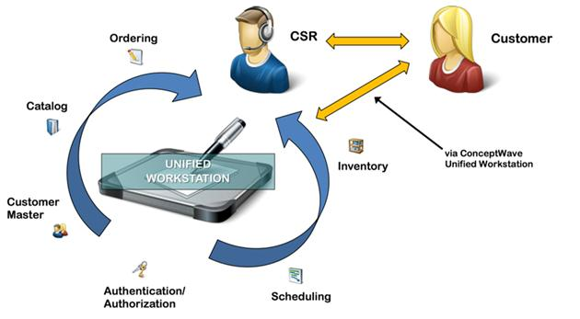

## Plug-Ins

Ericsson Universal Work Station offers a ready to go solution with out of the box Plug-ins

* Workstation
  + Authentication, Call Handling, Desktop, Messaging, User Profiles, Searches and Dashboard
* Customer
  + Customer 360° view, Account, Billing, Adjustments, Payment
* Product Catalog
  + Offers Query, Feature Query, Availability rules, offer maintenance
* Ordering
  + Ordering, Build Order, Configuration, Installation, Order review, search, Dashboard, Resource management

## UWS in the Ericsson Product Suite

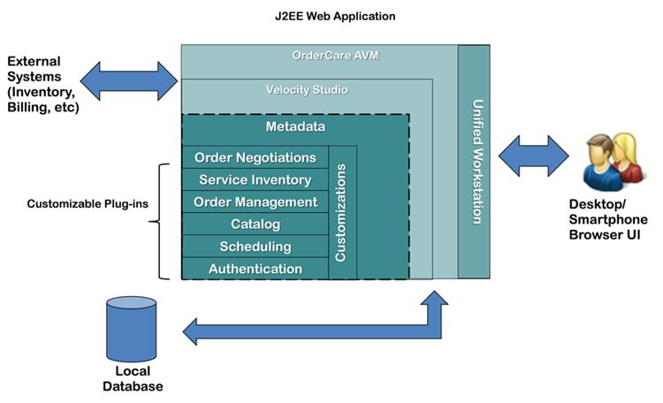

# Enterprise Self-Care

Ericsson Order Care Self-Care module exposes self-care functionality through the Communication Service Provider’s (CSP) existing Web portal. The Self-Care module provides the user interface to expose the following back-office functions (where available) to the end client via the Web:

* Customer profile inquiry / update
* Product / Offer presentation and inquiry
* Quotation
* Ordering
* Order Status inquiry
* Account / Payment Status inquiry
* Billing Inquiry (PDF invoice retrieval)

## Customization

Velocity Studio Designer may be employed to tailor the look-and-feel of the forms to meet the needs of <CLIENT>, including integration into any existing Web portal. <CLIENT> style sheets may be directly referenced by the form designer ensuring a high degree of compliance to <CLIENT>’s desired branding and presentation guidelines.

The Self-Care module provides for a wide set of use cases as depicted in the following use case model. Nevertheless, each client has a different set of back-end capabilities, and phasing of the capabilities. Velocity Studio Designer is employed to model <CLIENT> specific use cases, and to define the integrations into <CLIENT> specific back-end systems.

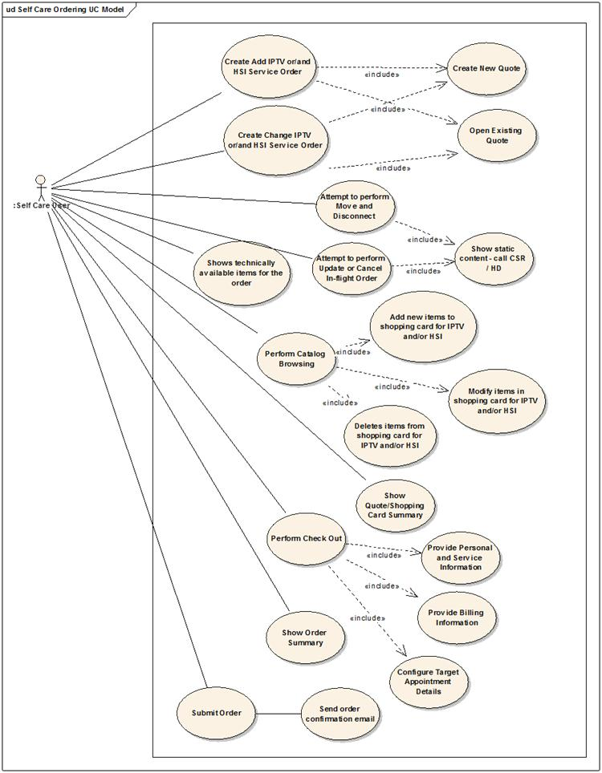

## Registration and Authentication

Self-Care provides a registration dialog for the registering of existing clients. In the event that Ericsson Order Care is providing its Customer Information Management (CIM) module, a client’s identity is authenticated against information in CIM. Where CIM is not deployed, an <CLIENT> system, typically the existing CRM or billing system, performs this role.

The User can register with the following information from CIM or ON:

* Account Number or Telephone Number
* Two of their identifications from either Credit Card, SIN, Health Card or Driver’s license
* Email Address

The User enters this information and clicks **Next**

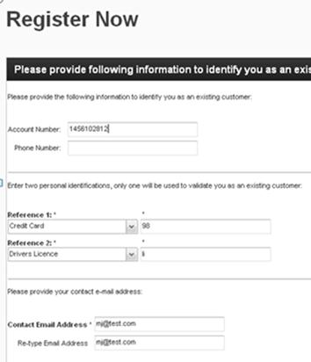

On this page the User’s information is validated from CIM and they can create their username/password and their security questions. The User fills out the following fields:

* Username
* Password
* 2 security questions

The User clicks the **Register Now button**

New clients are not initially registered but instead shop as guests until they are ready to check-out. Only limited information is collected to enable serviceability tests (typically postal code).

## Non-Ordering Pages

### Landing Page

When the User logs into Self-Care, they are immediately directed to the Landing Page. They are able to view the following information:

* Service Address
* Package Summary
* Orders
* Profile
* Contacts
* Password
* Security Questions
* Personal Identification
* Account Summary

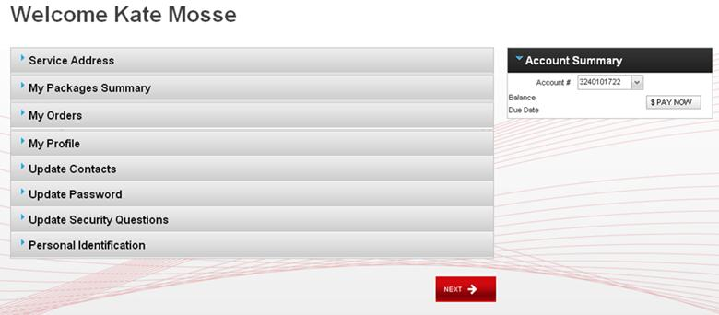

### My Packages Summary

My Packages Summary displays the User’s existing package/s.

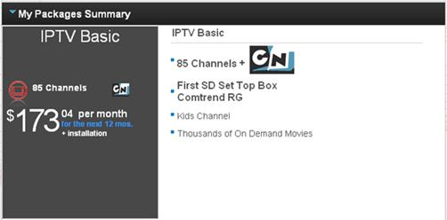

### My Orders

My Orders section, displays the list of orders that the User has in their account. The orders will display one of the following statuses Draft or Completed.

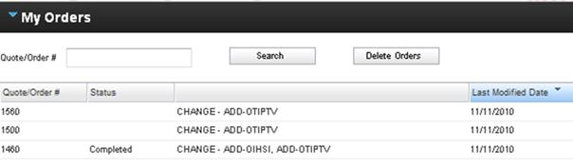

### My Profile

My Profile section displays the name of the user who is currently logged into SelfCare.



### Update Contacts

Update Contacts section displays the User’s contact information:

* Phone number – Home, Work and Mobile
* Email Address – Home and Work

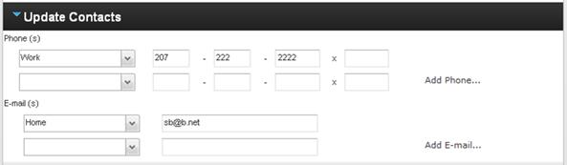

### Update Password

Update Password allows the user to update their password

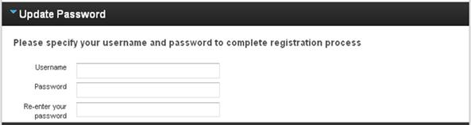

### Update Security Questions

Update Security Questions, the User can update the answers to their security questions.

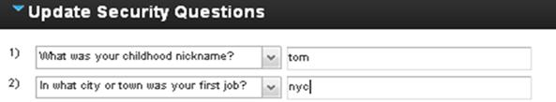

### Personal Identification

Personal Identification section, the User can update the answers to their Reference questions.

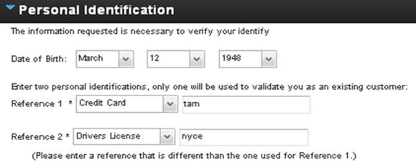

### Account Summary

This section allows the User to view the balance on their account, view the due date and allows them to make a payment on the account.

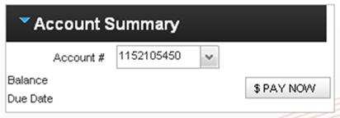

## Ordering

The following use cases are based upon IPTV and a high-speed internet (HSI) use-case.

### Select and Start Shopping

The User clicks Order on the Landing Page, they are directed to the Select and Start Shopping Page. This page allows the User to search for their offer by utilizing the filtering tool. They can search for one LOB (Line of Business) or two LOB’s at a time

On Select and Start Shopping page, the User can filter the orders by IPTV and the number of available channels or HSI and the available connection speeds.

The User selects the offer by checking the Select box and clicks **Next** to add the offer to their Shopping cart.

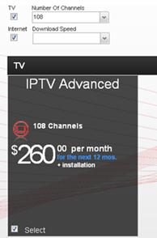

### Cart Summary Page

The Cart Summary page allows the User to view the offer/s and the offer details they add to their shopping cart. The User is given a choice of whether they want to:

* **Check Out Now –** Allows the User to bypass the customization screens and go directly to the Enter Your Information screen and continue to check out.
* **Customize Your Selection –** Allows the User to add channels and equipment to their current selections.
* **Back to Products –** Returns the User to the Select and Start Shopping page.

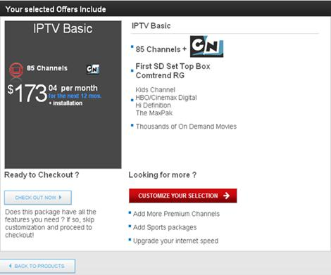

### Customizing Services

This section allows the User to customize their IPTV and HSI offers and equipment.

This page allows the User to select additional channels to add to their service. The User can select from Premium Channels and the Subscription and Seasonal Channels. They can check off a channel and add it to their shopping cart.

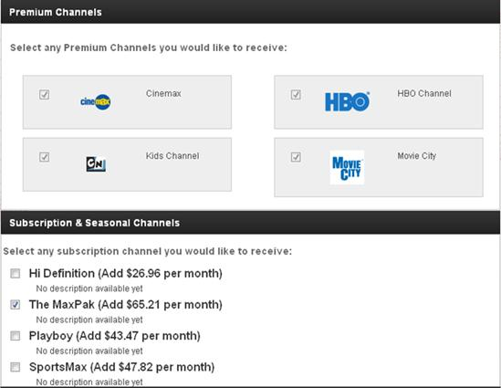

This page allows the user to select different TV equipment add additional TVs to their service.

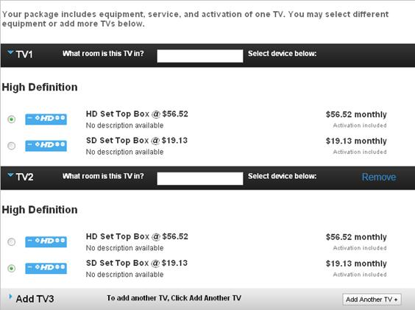

The Select Your Internet Options page allows the User to customize their HSI service. This page is made up of the following options:

* Select Optional Package
* Select and Configure Emails
* Select Equipment
* Select Term

**Select Optional Package**

This section allows to user add various options to their service and allows them to see what is included in the offer. The costs of additional items are reflected in the shopping cart.

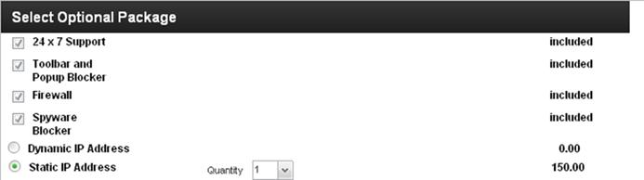

**Select and Configure Emails**

This section allows the user to add additional email addresses to their service at an additional charge which is reflected in the shopping cart.

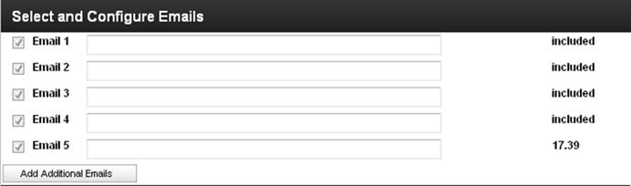

**Select Equipment**

This section allows the User to customize their modem and DSL filter quantities. When the User selects a Modem or a DSL filter, the prices are reflected in the Shopping Cart as a one-time fee.

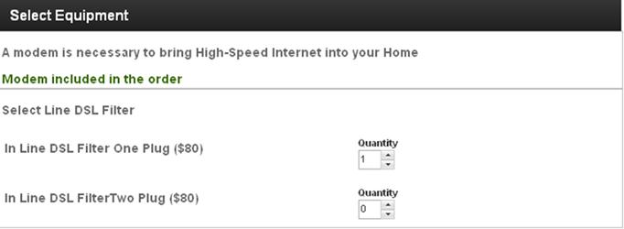

**Select Term**

This section allows the User to select their term contract and their discount. The discount is determined by the number of years the User selects the contract for. The discount is reflected in the shopping cart.

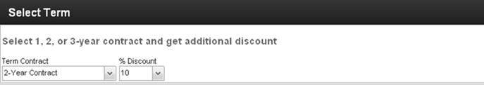

### Shopping Cart

The Shopping Cart displays the Monthly cost of the service, the One Time fees and the discounts.

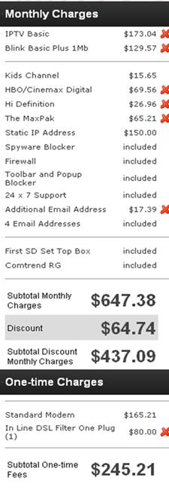

### Enter Your Information

This page allows the user to verify their information or update their information before they submit their order.

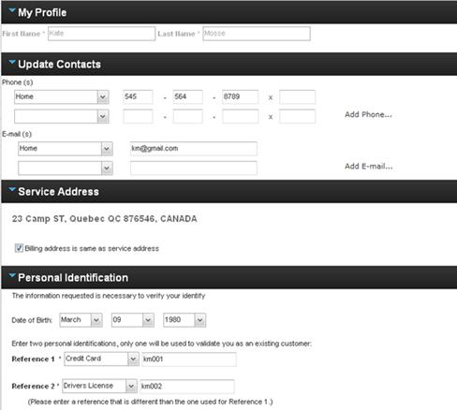

### Installation Options and Scheduling

This page displays the User’s installation options.

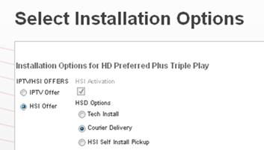

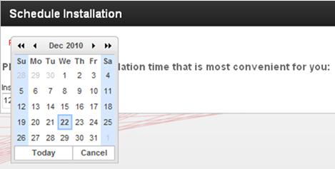

### Review and Submit Page

The Review and Submit Page is the final page before the User submits the order. The page displays the following information:

* Your Account – Contact information, Billing and Service Address
* Installation Information
* Your Order
* Year Contract
* Contract Terms

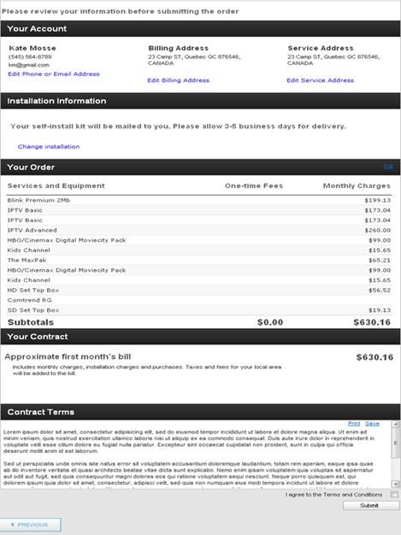

### Order Confirmation

The Order Confirmation screen informs the User that their order has been submitted. This screen displays the following:

* Email address the confirmation is sent to
* Order number
* Order ID number
* Installation details
* Account Details – Name, Phone number, email address, Service/Billing address
* Order Details

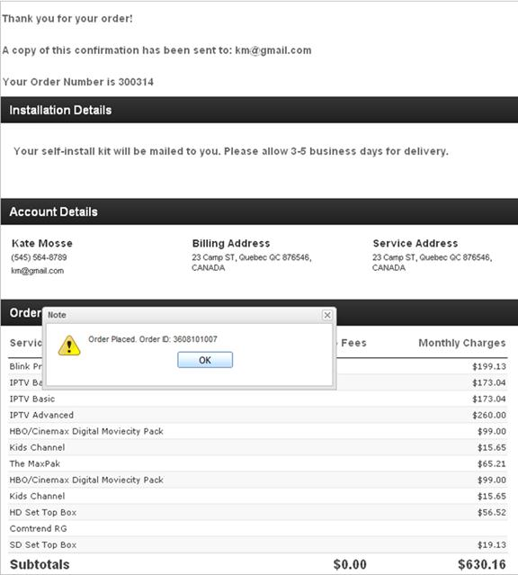

# Buy-Flow Manager

## Overview

Ericsson’s Buy-Flow Manager streamlines the order flow-through and exception management across sales channels to improve customer experience and reduce order fallout.

This product module manages the shop experience by providing business services that connect and enrich existing fine grain services.

The goal of this composite layer is to orchestrate the fine grain services and direct legacy calls to provide simple business level SOA-based Web services to be consistently used across channels. The channel interface may be either an indirect automated interface, an internal or external user interface. Additional pre-integrated products such as the Ericsson Unified Workstation (UWS) are available.

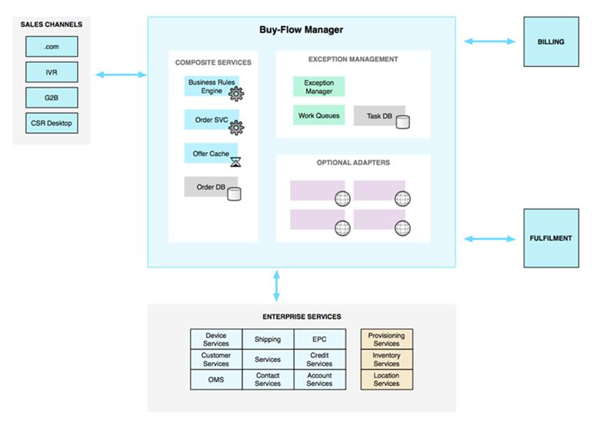

Ericsson’s Buy-Flow Manager allows you to do the following:

* Access customer information, billing, offers and bundles, account information, and more, all from one dashboard
* Improve system performance by having one-stop shopping for all of the Customer Service Representative (CSR) tasks
* There is no need to have multiple applications and tools open, which not only utilizes valuable CSR time but also system resources
* Reduce time and costs with one tool, eliminating a need for separate tools for billing, customer relationship management, troubleshooting, and so on

## Key Benefits

Ericsson’s Buy-Flow Manager module offers a number of key benefits to the customer. For example, the module:

* Enhances user productivity by focusing them on non-repetitive work that truly requires human intervention
* Enables work centers and IT resources to develop and maintain their own flows tuned for their particular services, systems and organizations
* Provides enhanced reporting on order process fallout to drive continued operations process improvement
* Easily integrates with existing customer systems to support consolidation of exceptions/fallout and necessary system interactions to speed resolution

In addition, pre-integration is available with Ericsson Order Care products, such as the Ericsson Unified Workstation (UWS).

## Functionalities

Ericsson’s Buy-Flow Manager provides the following functionalities to the customer:

* Composite services for selling, such as Offer, Query, and Validation
* Normalized ordering interface
* Regional/National rules – business rules (e.g., credit/deposit)
* Consumer standardization – discourage silo / point solutions
* Persistent order services – provide stateful order lifecycle
* Scheduling – provide real-time and pseudo scheduling
* Ancillary services – customized workflows for TPV, lidb, etc.
* Contact services – history, recommendation and other metrics
* Caching/Optimization – UI performance improvement via data caching
* Catalog-driven order entry – span multiple pocket catalogs and national offerings with a single interface
* Billing system integration providing capabilities from updating notes with shipping information to device association
* Support other channels such as full order capability for IVR Integration, DCI, and PPV

## Services

Buy-Flow Manager provides access to Web services via Simple Object Access Protocol (SOAP). The SOAP services provided by Buy-Flow Manager include the following:

### Order Service – Operations to submit and manage orders

* Add Order Note
  + Adds and stores a note with a given user id to the specified order. Returns a fault if order was not found.
* Cancel Order
  + This operation is used to cancel an order.
* Create Order
  + Returns the same order data with the autogenerated order id.
* Get Next Order
  + Gets the next available order object from all the "Active" queues, or from a single queue if queue group information is specified. Locks the order to the user making the request.
* Get Order By Key
  + Returns an order object by a given order id. Should be used to retrieve order data for "view only" purpose.
* Get Order History
  + Returns all historical events recorded for a single order.
* Get Order Task
  + Returns an order object based on its order id. Locks the order via a task to the requesting user. Should be used to acquire a "lock" for a selected order object after an order search.
* Get Queue Orders
  + Returns all orders belonging to a Single Order Queue
* Get User Order
  + Returns a single Order currently assigned and "locked" by the requesting user. Returns service fault if user does not have any orders. Should be used to immediately display the order "locked by" the user after user login.
* Query Orders
  + Searches for orders by the given search criteria filters. Returns summary information about the list of found orders.
* Query Queue Summary
  + Returns the Active and onHold lead summary queues
* Submit Order
  + This operation is used to submit an order.
* Update Order
  + Updates the entire order object with the passed in information. Requires the "full image" of the order.

### Worklist Service – Operations to create and manage tasks

* Acknowledge Alert
  + Acknowledges an alert.
* Assign Task To User
  + Assigns a task to a user.
* Create Task By Value
  + Creates a new task.
* Get Next Available Task
  + Returns the next available task of a user.
* Get Task By Key
  + Returns a task object by a given task ID.
* Perform Task Action
  + Performs an action on the passed in order task. Completes the active task and saves it the archives. Unlocks the related order.
* Query Available Tasks
  + Returns the available tasks.
* Query User Worklist
  + Returns completed and active tasks of a user. Used to query archived task history to be displayed on the landing page of an agent user.
* Return To Queue
  + "Unlocks" the given list of tasks and returns them back to the work queues.
* Set Task By Value
  + Set task by value.
* Start Work
  + This operation is used to start work.

### User Profile Service – Operations to retrieve user profile information

* Get User Profile
  + Retrieve User Profile information.

## Buy-Flow Manager Related Modules

Ericsson’s Buy-Flow Manager is related to Ericsson’s Order Management and Customer Information Management modules.

Order Management inherits orders from Order Negotiations or the communications service provider’s preferred front-end and orchestrates the entire order fulfillment lifecycle ensuring orders flow successfully while minimizing the incidence of fallout/exceptions. Order Management is Ericsson Order Care’s anchor for driving OPEX (associated with activity-based costs) out of the order fulfillment process through mechanization and is based upon a combination of template best practices and the leading edge Business Process Modeling Language (BPML).

Customer Information Management (CIM) manages customer information. CIM has been designed to allow Customer Service Representatives to quickly and efficiently associate customer information in a single centralized interface. The philosophy is to create a 360° degree view of all the necessary information to “connect” the customer and the associated services, work orders, and contact events.

# Common Platform Capabilities

## Business, Validation and Integrity Rules

Rules flexibility is a key strength of the Ericsson Order Care suite. Product specific business rules can be configured in several manners, depending upon the nature of the business rule in question:

* The Catalog Management application can be used to specify rules such as what can/cannot be ordered in conjunction with a service.
* The Catalog Management application can be used to specify the rule set applicable to each particular service.
* The Service Definition Repository (see below) metadata based rules can be coded to vary by the service type. These rules are available at the order, service request, order page, and data attribute levels.
* An external system can be called to evaluate validity, or to supplement an internal business rule.

The method selected varies based upon how dynamic the rule in question is, who “owns” and “changes” the rule, when the rule is best evaluated, the data sources/systems required to evaluate the rule, etc.

### Catalog-Based Rules

Typically, many business criteria exist in the offering of Product Catalog items. These criteria may constrain various aspects, such as accessibility of certain Products, equipment constrains, and pricing differentiation.

Rules can be defined and assigned on various objects in the Product Catalog to realize these business criteria. The following figure describes the Rules model in the Product Catalog.

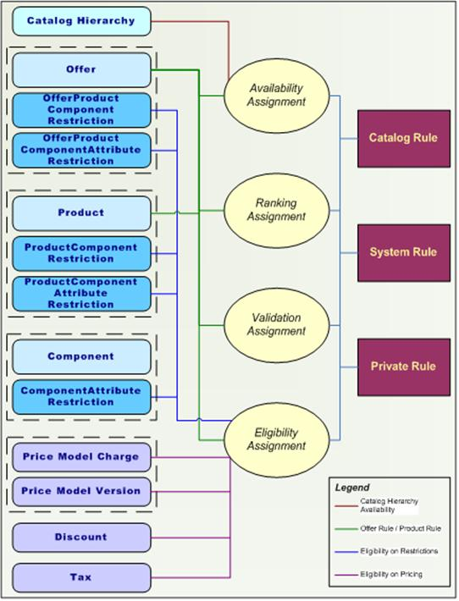

In the Product Catalog, the rules model consists of two key capabilities: Rule Definition and Rule assignment. A Rule Definition is a Boolean expression or script that evaluates to true or false. A Rule Assignment is the association of a Product Catalog object to a Rule, thus applying the Rule to the object to conditionally exert certain behavior.

For convenience, a Rule Assignment is often labeled as a “Rule” by its Rule Type:

* Availability Assignment determines whether an object is visible to the end-user during Catalog browsing. It is evaluated during display-time.
* Ranking Assignment determines the display position of the object during Catalog browsing. The assignment has a Ranking Value in addition to the Rule association
* Validation Assignment validates an item that has been added to an Order. Typical actions that trigger the execution of Validation Rules in the Order include saving or submitting an Order, or performing pricing on the Order. All Validation Rules of all items added to the Order are executed.
* Eligibility Assignment determines whether the associated object is qualified, or relevant to be applied. It asserts different functionality to the various objects that can apply Eligibility Rules:
  + Offers or Products: verifies the item can be added to the Order. In addition, a message code can be specified to display a pop-up error message if eligibility is failed.
  + Restrictions: determine whether Restrictions are to be enforced on components and attributes of Product Catalog items when they are added; see below section for details.

Multi-field and multi-form validation can be invoked on orders for complex product-based business rules, with resultant and scripted informational, warning or critical messages presented on the order entry GUI.

Messages that are generated by the system due to business rules invoked by customer input will be presented in easy-to-read and simple to understand language. Business rule validation messages are entered in the Service Designer and are configurable at any time.

### Non-Catalog-Based Rules

The Service Designer graphical tool provides the means to define and configure business rules for any document, field, and exception event or data transformation flow in the metadata.

These rules fall in the following categories:

* Mandatory/Optional; Read Only/Read Write; Hidden/Visible
* Initialization: On document/element creation
* Validation: On save or explicit execution
* Trigger: On field change
* Completion: On save

The following sample screenshots illustrate the Ericsson Order Care IDE graphical tool capabilities for configuring business, validation and integrity rules:

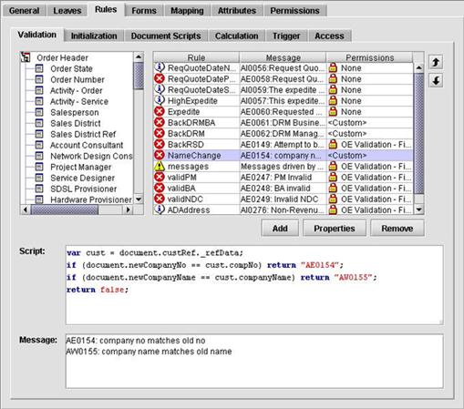

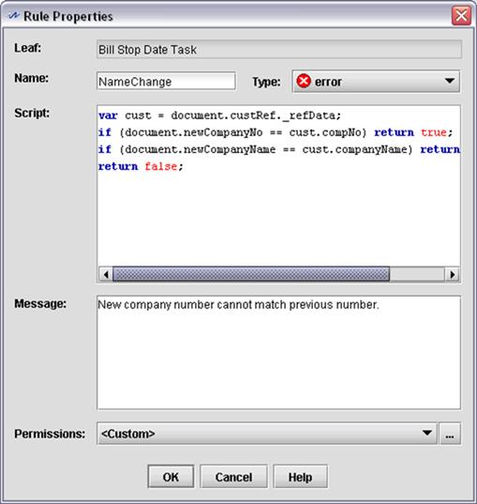

## Integration

The Ericsson Order Care solution excels at interfacing with other systems, not only in terms of the “physical” task of interfacing, but also in its design. The solution assumes that other systems exist and are the master of much of the data required within Ericsson Order Care.

Part of the Ericsson Order Care run-time framework deals with system integration. It automates the data and event flow to and from the external systems in accordance with the definition of the business process. The same framework mechanisms are used to control the data flow to and from the Ericsson Order Care business components. The integration framework automatically converts data according to the interface definitions of the external system interfaces.

The Ericsson Order Care integration framework assumes that the communication with the external systems is done through asynchronous EAI middleware or point-to-point with open APIs. Systems that have adaptors to the selected EAI products can be automatically connected to the Ericsson Order Care suite.

### Integration Approaches

A variety of models are supported:

* In Place Data Access: In this model, data is not replicated or copied into Ericsson Order Care, but accessed as it is needed, either through an API or through JDBC. In both cases, caching mechanisms are available to reduce the frequency of the physical requests for the underlying data. The cache parameters are fully configurable.
* Synchronized Data Access: In this model, the data, owned by the external system, is copied into internal data structures. In this mode:
  + Data may be pushed to Ericsson Order Care by the external system on a scheduled or as needed basis. The external system in this case determines the latency of the data (i.e. how current it is).
  + Data may be pulled by Ericsson Order Care on a scheduled and/or on-demand basis. Background processes (scheduled jobs) are invoked to manage this task within Ericsson Order Care. Ericsson Order Care determines the “latency” of the data in this case.

Ericsson Order Care can interface into applications via the GUI/HTTP:

* An application may request data from Ericsson Order Care through HTTP by appending the Ericsson URL with request specific parameters. This can be done either in a Web browser (requesting a Web page from Ericsson Order Care), or in the background via an HTTP GET.
* Similarly, Ericsson Order Care may present data from another application by opening a Web page, accessing the target system via the URL, and presenting the results in the browser. (Non-browser based HTTP Gets are supported as well, though they are modeled as with any other API, see first bullet)

### Technologies Supported

Ericsson Order Care provides WSDL (Web Services) based interface definition that supports XML, Text, CSV and parameterized data exchange over File System, FTP, HTTP, Java, JMS, LDAP, MQ, Oracle Stored Procedures, POP, SMTP, SOAP, SOCKET and Tibco. BizTalk, Vitria and WLI are supported through JMS, MQ or SOAP.

A generic Service Adaptor plug-in provides the ability to write additional adaptors for non-listed technology.

### Managing Load Over an Interface

An input channel is served by a configurable number of listeners. Each listener may either handle the request, or forward the request to a global queue. Each queue is emptied by a global process.

Interface load may be managed / throttled by:

* Allowing the product to manage the interface via its built-in processes (avoid “invoke directly” option on interfaces)
* Limiting the number of listeners using the configuration tool (inbound load)
* Configuring the listeners to place the requests on a global queue, and limiting the number of instances of global processes that process the input queue
* Limiting the number of global process instances that process an outbound interface
* Defining a throttle criteria in terms of transaction throughout on a Port in the configuration tool

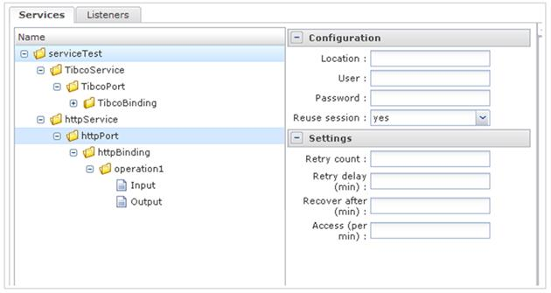

### Failover and Recovery of Interfaces

Interface robustness may be implemented by:

* Allowing the product to manage the interface via its built-in processes (avoid “invoke directly” option on interfaces)
* Defining a back-up end point / Port for a service and configuring the retry / recovery parameters within

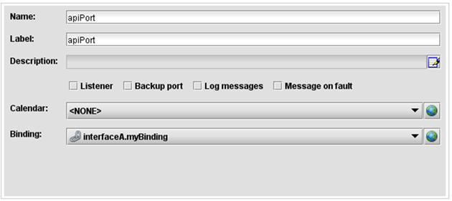

### Wizards

Several wizards are provided to speed interface modeling:

* XSD import/export to aid in the modeling of interface definitions
* WSDL import/export to aid in the modeling of interfaces
* XML import for cases where only a sample XML file is available
* Text import for cases where a sample CSV, delimited or fixed length text file is available.
* Database Stored Procedures import
* Database Schema import/export (for JDBC based interfaces)

Service Designer/Velocity Studio provides a Graphical User Interface for the end-to-end modeling of interfaces. All aspects from the message modeling, data transformation/mapping, and logical and physical interface characteristics are supported within the Designer.

### Batch Processing

Ericsson Order Care provides FTP, file reader/writer support, job scheduling and batch processing capabilities. Data files may be selected manually via a file upload facility, or dropped on a file server which is polled by the application. These files are then parsed (delimited, fixed length, XML supported natively; others via scripting) into requests and dispatched for asynchronous processing. A two-phase pass is typically employed where in the first phase, major structural errors, such as truncated files or incorrect file formats, are identified. Once the file passing the structural check, the second phase triggers the processing of individual orders.

## Language Customization

The Ericsson Order Care solution allows for easy internationalization to permit end-users to work in their language of choice.

The Ericsson Order Care application queries the browser language settings, by default, to determine the language which should be presented to the end user. This language may be overridden by a language preference stored in the user profile, or explicitly via a language selection option in the user interface.

Service Designer/Velocity Studio provides translation facilities for all labels, drop down values, error messages (system and user), etc. Double byte character sets are supported.

### Resources

The elements of the Ericsson Order Care applications that can be internationalized are called “resources”. The following resources can be translated and saved:

* The label and help of the data types, element types, documents, orders, menus and forms.
* The labels of the interfaces, operations, exceptions, signals, participants, alerts, processes, finders and decision trees.
* The messages of validation rules in the data types, element types, documents and orders.
* The enumeration code descriptions in the data types and element types.
* The labels of the leaves in the documents.
* The labels of the fields in the forms.
* The application, system and user messages.

The following screenshot is an example of the Resource Editor tool supporting a French translation of a “Force Complete Order” command:

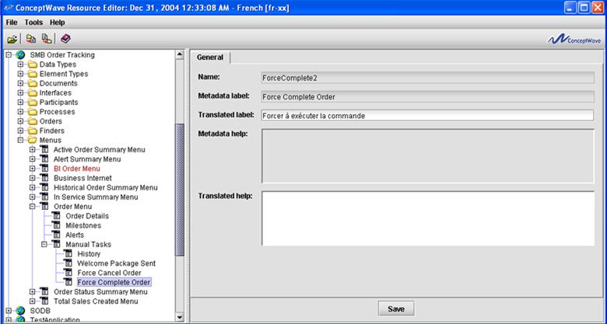

### Multilingual Help Facility

Service Designer/Velocity Studio and the Resource Editor can be used to specify help in a multi-lingual environment for each field. Since this help is restricted to text only, custom help pages are often developed. The URLs to these help pages can be varied by language.

### English-Only Back-Office Tools

Certain Java-based clients that are used to centrally administer the application will only be available in English. These tools, which are used by IT staff to set up the application, include:

* Service Designer (SD)
* Velocity Studio (VS)

It is anticipated that these functions will be performed by a small group of people that are familiar with English.

On the other hand, there are a number of administrative functions that are performed via the thin client (browser) at run-time that will be translated to the target language. Through these administrative GUIs, CSP staff are able to perform less technical administrative functions such as Worklist management, message queue management, and interface testing (to name a few) in their native language.

### Translation Approaches

While the Resource Editor is the tool recommended for maintaining translations within the product, initial translations are often performed externally. In support of this activity, the Resource Editor provides two import/export formats: MS Excel and XML. These files can be sent to auto-translation tools and the results reviewed directly, or after re-import, through the Resource Editor.

In the event that existing translations for fields exist, these translations may often be leveraged. As an example, translations from existing MS Excel based ordering forms may be auto-populated in the MS Excel output format through a macro that matches the source language labels. Again, the results may be re-imported into the Resource Editor for review.

### Business Data

Business data that is entered via reference tables, the Catalog, etc., may be translated via an online facility that provides the same capabilities as the Resource Editor.

## Change Management

Ericsson Order Care’s strength derives from its metadata driven approach. Metadata needs to be managed, from a change management perspective, in the same manner as “programming code” would be managed. In other words, mechanisms must be available to allow for:

* Version Management
* Concurrent Development

In addition, a strategy is required to address how business data, whether orders or processes, are migrated to support new versions.

Ericsson Order Care provides these mechanisms and approaches through a combination of tools and best practices.

### Metadata Versioning

Ericsson Order Care’s Service Designer (SD) and Velocity Studio (VS) tool provides the following mechanisms for versioning:

**Release 4.x**

* Metadata is versioned in the database. Each version carries a number, name and description, together with creation and update timestamps. Versions are stamped “working”, “active” or “archived”. Working versions are metadata versions in various stages of “development”. The Active version is the version used by the other Ericsson Order Care components. Archived versions are old Active versions.
* Metadata versions carry a “properties” page which provides identifies the creator, creation and update times, version number and description of the metadata.
* Metadata can further be exported as an XML document to any source code control tool, such as SVN.

**Release 5.0 and Above**

* Metadata is stored in the file system and versioned using a source code control tool such as SVN

### Managing Concurrent Change

In order to reduce the amount of concurrent changes to a version of the metadata, the Ericsson Service Designer (SD) and Velocity Studio (VS) tools provide the following facilities:

* Metadata can be “included” by reference in another metadata. In this model, each Configurator works on their own metadata, which in turn is included in the overall project metadata.
* Metadata is divided into namespaces. Each namespace typically represents a different function. Metadata can be imported/exported by namespace. In this manner work can be divided among a number of Configurators by namespace.

Where changes cannot be encapsulated using the preceding methods, the following facilities are available:

**Release 4.x**

* All metadata objects carry a last updated timestamp. A merge facility exists which takes two versions of metadata and merges the objects based upon this timestamp.
* Conflict resolution, when two people have changed the same object, is facilitated through an object comparison utility that presents the two objects and their changes side-by-side.
* Metadata is stored in an XML document that can be exported and compared and merged with another version via a text comparison utility.

**Release 5.0 and Above**

* Metadata is stored in the file system and merged using a source code control tool such as SVN.

### Workflow Versioning

Processes and orders are stamped, when created, with the version number of metadata with which they were created. With this information, two basic forms of versioning are available: Full versioning and Metadata-based versioning. The method employed will vary based upon the “lifespan” of the average workflow, the frequency of changes in versions, and the type of changes being made.

**Full Versioning**

The framework (UI) and workflow engines examine the active orders and processes, and load the version of metadata under which the order/process was created. In this manner, all existing processes/orders are grandfathered under the old version. They can be migrated to a newer version by simply updating the metadata version number to the current version.

**Metadata-Based Versioning**

As the number of active versions required increases, the memory requirement to maintain all these versions in memory becomes an issue. In this case, metadata based versioning is employed. In this model, versioning at the product level is turned-off and the metadata is responsible for defining the process versions (instead of 1 process/metadata, with the old processes retrieved by loading the old metadata, the current metadata contains all versions of all processes). Other than this, the behavior of the product remains as is.

Ericsson Order Care provides several alternatives to support the versioning of workflow:

#### Metadata Based Versioning i.e. Grandfathered Workflow

Where new orders are to use the new workflow, but existing orders need to continue with the current workflow, i.e. are to be “Grandfathered”, both workflows are in fact to be “live” at the same time and so both versions must exist in the metadata. The workflow is copied and given a unique name, typically the original name appended with a version number.

* The workflow here is, from the applications perspective, a new workflow with its own versioning.
* All menus, scripts etc. are changed to instantiate the new flow rather than the old flow.
* All workflow instances that are running on the existing version will continue to do so, i.e. they will be grandfathered.
* All new workflow instances will be instantiated on the new workflow version.

#### Catalog Driven Workflow

Ericsson Order Care Catalog Management (CM) may be employed to specify the workflow that needs to be instantiated in each situation. In this model, Catalog rules drive workflow selection by service, date, region or any other attribute.

* New workflow versions are created as in Metadata Based Versioning.
* Workflow may be future dated so that workflow may be modeled and deployed in advance, eliminating the need for tightly coordinating metadata releases and the rollout of new workflow.
* Business rules, such as the rollout schedule for a new workflow, are located in the Catalog and can therefore be adjusted dynamically as the need arises, e.g. a market rollout is delayed.
* From the perspective of the application, each workflow is independent, retains its version numbers, and may be instantiated by the application.

#### Fully Versioned Workflow

Where existing workflow instances are to be migrated to the new version of the workflow, a different approach is employed. In this case, a new workflow is not created but, instead, the existing workflow is edited in place.

* The workflow version number is automatically incremented
* Ericsson Order Care performs an automatic comparison between the existing version and the current version and presents the workflow designer with the migration analysis depicted below:

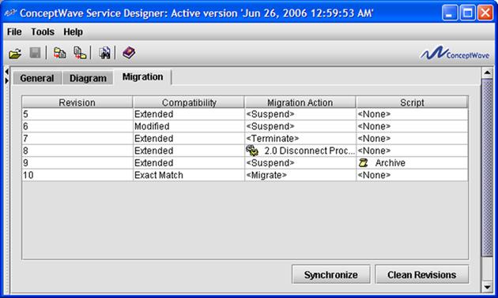

* Where the workflow is identified as an Exact Match, the workflow designer has the full range of options under Migrate Action:
  + Migrate the process to the new version
  + Suspend the process
  + Terminate the process
  + Instantiate a replacement process
* Where the workflow is identified as Extended or Modified, the Migrate option is not permitted. Typically a new process is instantiated in its place.
* A Script may also be specified to be executed. The script’s role would be to perform the data migration, prepare the new process etc. in advance of the migration action.

When employing workflow versioning, it is important to note that in order to perform the analysis of the migration requirements, Ericsson Order Care mandates that the metadata versions carrying the original version definitions be retained, so long as active processes are running in the current environment. Full validation is in place to enforce this requirement and safeguard the integrity of the versioning process.

### Catalog-Based Changes

Catalog Manager (CM) provides full import/export facilities on all Catalog defined objects. The change management process between environments typically involves the export of Catalog data into an XML file, a check-in of the XML into a change management/source code control system, the import of the XML into the target environment using the application’s user interface. There is no requirement to stop/restart the application. This activity may be performed by a Product Manager, IT Operations resource, or any other authorized resource.

As all Catalog-based data is date effective, there is no need to schedule/synchronize the upgrade process, i.e. it can be performed in advance, and it may be done mid-day.

### Deploying a Change to Production

The Ericsson Order Care IDE (Service Designer/Velocity Studio) tool generates target environment independent metadata, i.e. the metadata itself does not change as it is deployed from environment to environment. The Ericsson Order Care Configuration Tool is used to define the environment specific attributes such as server IP addresses, system accounts and passwords, logging levels, and alert addresses. This separation allows the metadata, once fully tested and approved, to be moved between environments by Change Management staff.

The activation process of the metadata, due to workflow versioning requirements, needs access to live business data, at the time the new solution is to be deployed. For example, the activation process checks to ensure that at the instant of activation, there are no unknown or unhandled versions of workflow active within the system. This may be true at time of development or user acceptance testing but may not be true at the time of actual physical deployment.

Similarly, it is not possible to pre-apply any database related changes, system configuration variable changes, etc. to the target environment in advance of the desired deployment date and time.

When the release change package is approved and scheduled, the following steps need to be undertaken (please reference product documentation for complete instructions):

Preparation:

* Repackage the WAR files with the new metadata
* Generate required DDL to affect any required changes to the database

Deployment:

* Shut-down the run-time application components
* Import the metadata to the target environment (in a “working state”)
* Import the resources to the target environment
* Apply the required DDL and SQL to the database
* Validate metadata within target environment
* “Activate” the metadata (make it the live version)
* Restart the application AVMs (workflow engines and UI servers)

Automated deployment scripts can be developed to invoke command line configuration and activation of metadata, application of require database SQL and any other deployment work required. Application server tools can be employed to distribute the WAR files.

The restart of the workflow AVMs is transparent to all users and systems since the workflow AVMs are background processes that are configured to automatically resume work-in-progress and to distribute workload.

The restart of the UI AVMs is managed through the application server and in a highly available environment, whether multiple application servers are deployed, the impact to end-users is restricted to the need to re-login.

### Deploying a New Software Release to Production

A new software release may be deployed to production by:

* Installing the new JAR and WAR files to the target environment(s)
* Updating the environment with the new Metadata templates, if any.
* Opening the existing “active” version of the metadata with the new version of the Service Designer (thereby converting the current version to the new version of metadata) and creating a new working version
* Executing the “Upgrade System” command to generate any required DDL to be applied to the database.
* Activate the working version of the metadata
* Restart the underlying components (see above)

## Migration Considerations

### Overview

Ericsson Order Care’s software design and approach reduce both the magnitude and the complexity of data migration efforts.

* The ability to leverage heritage systems reduces the need to migrate data, and associated business rules, from those systems.
* The separation between the logical (metadata definition of the document, i.e. entity or data structure) and the physical (database representation, i.e. database, table and attributes mapping) allows existing databases to be leveraged in place.
* Ericsson Order Care does not mandate a rigid data model and can therefore adapt to the data model already in use at the organization. This eliminates the need to restructure data, create relationships, etc.
* The ability to model and present “foreign” entities or data, i.e. data whose primary and foreign key structure are not managed by Ericsson Order Care, allows for data across heterogeneous databases to be accessed and/or updated seamlessly. This reduces the need to migrate (or replicate) this data within Ericsson Order Care.

Nevertheless, the migration of in-progress orders from the existing system to the new system must be addressed in any deployment where the two systems are not to be run in parallel for a significant period of time.

### Migration of Work-In-Progress Orders

The migration strategy for Work In Progress (WIP) orders is based upon the following premise – any existing orders are at a stage in their workflow where they are waiting for responses from asynchronous activities, i.e. manual activities or the response end of asynchronous interfaces, waiting for a signal and/or the completion of other processes etc.

At any other point, the workflow would be at an activity where the next step could be performed by the workflow engine immediately. Ultimately, the workflow will either complete or end-up in a “wait” state.

In addition, the following assumptions are made:

* In order to be able to support supplement/change/cancel orders on migrated WIP, it is essential to apply to full workflow model to WIP orders that would be applied to new orders. An abbreviated flow per case would not enable the compensate/rollback capabilities required in the event that the WIP order was cancelled.
* Completed orders need only retain history from a reporting perspective and need not actually create an associated workflow with all corresponding activities. Once a workflow is completed in Ericsson Order Care, the detailed process/activity related tables are archived for decision support/analysis purposes only. Operational level reports operate on “milestone” statistics only. As such, only the key milestones within the workflow need be recreated for the migration of historical orders.

With this in mind, a state-based approach is taken to the migration of WIP and historical orders:

### Open Orders

* WIP Orders are migrated as follows:
* An order is created within the new system
* A process is launched to manage the provisioning of the order
* For each unique state in which a WIP order may be found, a migration script is executed that:
  + Ignores all outbound API calls, manual activity tasking, etc. for any completed activity.
  + Mimics all external system/people responses for completed activities, by sending the appropriate message/completion notice to the process. Each message is stamped with the original message timestamp rather than the current date/time to preserve history.
* Each order is now at its original state and being managed by Ericsson Order Care.

### Historical Orders

Order history is migrated without an attempt at recreating the exact process workflow:

* An order is created in the “completed” stated for visibility purposes
* A process is not launched to manage the order
* Milestones are created directly through the migration, rather than as a result of workflow activity completion.

## Migration Sizing

The following questions will determine the size of the migration effort and the feasibility of the three “leveraging” techniques provided above:

### Size of the Data

* How many tables (or entities) exist? How many rows (or instances of the entity) exist for the key tables:
  + Customer
  + Service Address
  + Contacts
  + Billing Accounts
  + Orders
  + Open Orders (WIP)
  + Services, circuits, etc.
  + Service Catalog
* Identify how attributes for various services are captured and stored, i.e. one table for all services, n tables for n services.
* Provide a data model or indicate the number of foreign keys (relationships) within these tables.
* Indicate the storage mechanism. Relational database? Hierarchical datastore? “flat files”?

### Quality of the Data

* Has an audit of the data accuracy been performed? How recently?
* What percentage of transactions are rejected by downstream systems as a result of data integrity issues? E.g. customer does not exist!
* What percentage of orders are entered manually into the system? What percentage use some form of automated entry?
* Identify the breadth and depth of the validation applied to an order in the existing system.
* Is referential integrity managed within the application or within the database?
* Are stored procedures employed at the database level?
* Are triggers employed at the database level?
* Does system employ transactional control, i.e. updates are rolled back if transaction does not complete in its entirety?
* Do interfaces employ two-stage commits? If not, how are rejections or failures in downstream systems reflected in the order?
* List known causes of data inconsistency and/or inaccuracy and estimate their frequency, e.g. 0.1% of triggers fail but transaction not rolled back.

### Reconciliation/Data Cleansing

For each major entity listed above:

* From an operations perspective, where do the users of a system turn to for an authoritative source of service data, for example? Do they turn to the ordering system? An element management system? The network itself?
* Is any one source consistently the “authority”, or is it situational? How much of the data cleansing IP resides within rules/procedures and how much within the individual?
* Can data be extracted from these other sources for analysis/reconciliation purposes?

### Solution Design

* The design will drive the extent to which the “leveraging” techniques described above can be utilized, and therefore the extent of what can be leveraged in place versus migrated.
* Ericsson Order Care carries the ability to reference master data sources in an order rather than asking for this data to be re-keyed, e.g. select an address from an address master, or a customer from a CRM system. Where the existing system does not possess this capability, and Ericsson Order Care is to provide it, a reconciliation effort may be required to match addresses, customers etc.

### Migration Strategy

* Are active orders within the existing system to be allowed to “drain”, or are they to be migrated to Ericsson Order Care?
* Is a history of orders to be migrated to Ericsson Order Care?

### Deployment Strategy

* Will Ericsson Order Care replace all ordering functions of the existing system, in all markets and for all channels? If not, identify the roll-out strategy.
* Where strategy results in dual ownership for some entities, e.g. a service based or regional roll-out strategy for a business offering may result in a single customer having profiles in two systems, identify strategy for ongoing reconciliation or dual updates.

## Certified Environments

### Third Party Software

As of December 15th 2011, Ericsson Order Care has been certified to support the following technologies:

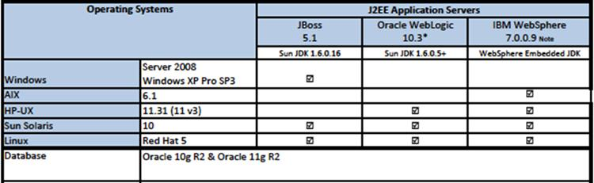

Ericsson Order Care’s software supports the following browsers:

* Firefox 3,4,5
* Microsoft Internet Explorer 6, 7, 8, 9
* Google Chrome (latest stable)
* Apple Safari 5

Ericsson Order Care endeavors to support Grade A browsers as defined by YUI’s Graded Browser Support. The current list can be found at <http://yuilibrary.com/yui/docs/tutorials/gbs/>.

### Client Hardware

The specifications for PCs are relevant for a single application use. If PCs are to be used for multiple applications and/or additional functions, then the minimal configurations will need to be increased.

| Application | Unit | Minimum Specification | Recommended Specification |
| --- | --- | --- | --- |
| End Users of Application | Any | 800 MHz Pentium III  256 MB RAM | Pentium P4 2.4 Ghz  512 MB RAM |
| IT users running IDE | PC – Standard Desktop  MS-Windows 7 and XP | 2 GHz CPU  1 GB RAM  2 GB or larger disk | Dual 2 GHz CPU  4 GB RAM  4 GB or larger disk |

## High Availability Deployment Architecture

The Ericsson Order Care product is built on top of leading industry infrastructure products – Web servers, application servers, database servers and EAI middleware. As such, high availability requirements for the Ericsson Order Care solution are largely handled via the commercial application servers and database servers that support the product. As an example, Ericsson Order Care has a large tier 1 customer that achieves high availability implementation using a BEA clustered environment with a hardware-based load balancer to support application server clustering.

### Ericsson Order Care High Availability Design Characteristics

A number of characteristics of the Ericsson Order Care design contribute to maximizing the availability of the Ericsson Order Care solution.

#### Application Servers

* Store no business data - all business and system configuration information is stored in the database.
* Can be configured to handle user interactions, API interactions and/or workflow.
* Each instance of a workflow server (a.k.a. process engine) may be allocated only a portion of the workflow load by type of process.
* Each instance of a workflow server is assigned an ID within a cluster of set size. Work is automatically distributed within the cluster using a hash scheme that ensures all activities for a process instance is handled by the same workflow server.

#### High-Availability Configuration

* Web server and/or hardware based load balancers. Perform load-balance and fail-over between applications servers.
* N-Application servers managed as an application server based cluster
  + Each user is serviced by one application server.
  + Each process is serviced by one workflow engine.
* Hardware based load balancers managing database transactions
* High availability database. E.g. Veritas clustered server solution for Oracle.

### Monitoring

Each server maintains a heartbeat interaction with the database, and via JMX, allowing for third-party tools to monitor the health of the server. The JMX based interface exposes a rich set of statistics that can be used to determine not only running/not running state, but also the performance, memory utilization, and thread utilization.

### Impact of Failed Components

#### Application Server – User Load

Sticky sessions need to be configured within the load balancer/Web server as there is no user session swapping between application servers. As a result, in the event of a failed application server, the users being served by the server will lose their connection and must re-login. All business data from the prior session will be saved/retained from the last successful interaction. Any in-progress transactions are rolled-back at the database level. The Web-servers/load balancers will automatically handle the re-direct to another application server.

#### Application Server – Workflow Server / Process Engine

Each server will attempt to remain operational in the event of a problem:

* On loss of database connection, server will immediately stop processing and attempt to reconnect periodically until the connection is restored or the system is restarted.
* On a low memory condition, alternate memory management routines are triggered, including management of system cache sizes and retention periods, and ultimately, suspending the processing of new workflow processes.
* On a non-recoverable failure, a clean-and-restart procedure is followed that will automatically reset the workflow engine to an initial state. The restart is logged so that it can be later diagnosed. No work is lost and work continues seamlessly.

Hot stand-by nodes can be configured so that a permanent failure of one “working” node, such as due to a hardware failure, can be automatically recovered by the stand-by node. This ensure an automated, seamless and immediate restoral of service. In the event of a permanent failure, any in-progress transactions are rolled-back at the database level. Upon restart, workflow is transparently resumed from the last uncommitted activity within each workflow instance.

#### Database Server

On loss of a database, servers will immediately stop processing and attempt to reconnect periodically until the connection is restored or the system is restarted.

### Typical High Availability Design

The following diagram depicts a typical high availability design in which the user and workflow load has been split into two clusters of application servers in order to isolate the impact of bursts in traffic/workload from one type of activity on the other.

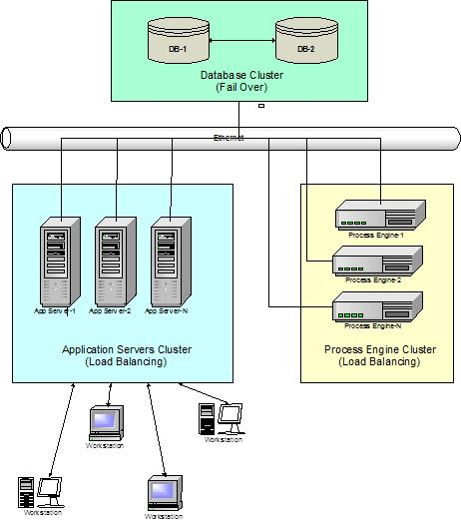

Ericsson Order Care’s highest volume deployment handles a peak volume of 40 orders/second, or 120,000 orders / hour. The following deployment architecture is for a client solution that supports over 20,000 orders per day with a community of over 10,000 users. This deployment is characterized by:

* Hardware based load balancer and SSL accelerator distributing user and API load to the application servers
* BEA WebLogic clustered application servers with selected nodes dedicated to user traffic, and others to API traffic
* Hardware based load balancer and SSL accelerator distributing load to database layer
* Active / Passive Clustered database solution (active failover)
  + Manual failover to alternate Database Server
  + SAN based storage

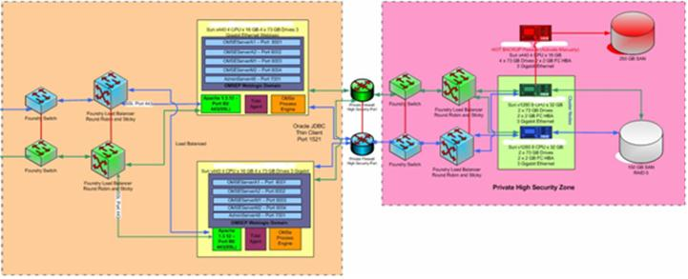

## Deployment Sizing

In general, performance sizing is largely dependent on the underlying metadata which implements an application as well as the complexity of the business processes which are being modeled. The ideal solution to sizing hardware accurately -- relies upon designing metadata and conducting initial performance testing prior to the final assignment of hardware.

### Sample Configuration

It is suggested that a single App Server Node and a single DB Server Node be implemented based on the anticipated system load expected in terms of transactions per second. With this configuration in place, a series of performance tests can be conducted to ensure that the system is responding as designed. Furthermore, depending upon the performance results, one can then determine what additional hardware/software refinements are needed to satisfy performance requirements.

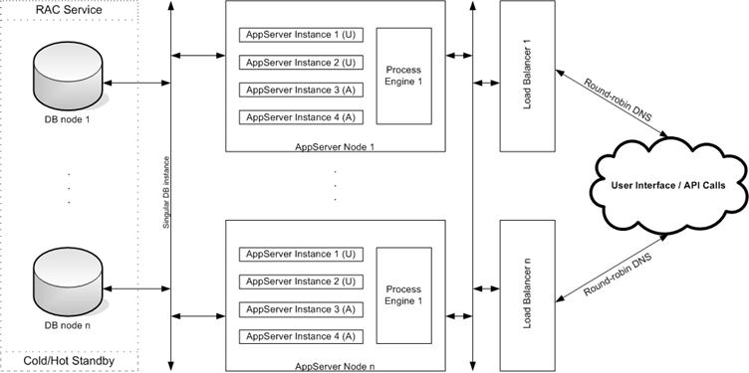

As one can see, each App Server Node has been configured to have 4 Application Server instances. This is primarily to handle the UI load of users as well API based Web Service requests to the Ericsson Order Care Framework from external systems. Additional Application Server instances can be added as WEB based traffic increases, however; care should be taken to ensure that adding instances does degrade the overall performance of the system. In such a scenario additional hardware App Sever Nodes will have to be added to the server farm.

Each App Server Node has also been configured to have one instance of the Process Engine. Process Engine instances implement the workflow engine of the Ericsson Order Care Product Suite and are responsible for moving orders along business process models. There is no direct interaction between users of the system and the Process Engines, moreover; the Process Engine spends most of its time in performing database operations. Hence, depending upon the complexity of the process models within a metadata; it may be necessary to move Process Engine instances onto separate independent hardware for greater throughput.

### Generic Hardware Sizing

Ericsson will provide guidelines regarding the hardware that is required to meet the proposed solution. Factors affecting the proposed hardware configuration include:

* Real-time demand for order creation (number of orders)
* Number of simultaneous users
* Database access requirements
* Number of processes and associated activities
* High-availability requirements

Specifically, the following metrics are collected in preparing the hardware sizing recommendation:

* Concurrent users
* Orders per month
* Business days per week
* Hours per work day
* Transactions per order
* # of busy hours per day
* Expected order life cycle duration (by type of order)
* Transactions per hour within a busy hour
* Transactions per second within a busy hour

Based upon Ericsson testing and customer experience, the following table provides a “rule-of-thumb” for determining the recommended number of servers, and their technical characteristics. This table is based on the number of orders per day, but as stated earlier a number of other drivers must be considered as well.



Ericsson recommends the required processing power, memory requirements and disk space of the underlying hardware but does not recommend a specific hardware as the final selection will be based upon many additional factors such as the availability of existing servers, pricing, and standard operating platforms.

### Additional Comments

The Web Server layer used in some architectures is not required from a Ericsson Order Care perspective.

Ericsson recommends a hardware based load balancer rather than a software based load balancer from BEA or Apache. BEA has been offering software based load balancing for some time while Tomcat has recently added this capability. While both have solutions, all of Ericsson Order Care’s customers to-date have chosen a hardware accelerated load balancer solution.

The Application Server and Process Engines do not store any business data on local (or remote) storage. All business and system configuration data is stored in the Oracle database. The local server must, however, have sufficient disk space (we have recommended 80GB or greater) to house:

* The application itself
* All third-party software, e.g. BEA WebLogic
* Application logs

Ericsson is not aware of any compatibility issues between its Ericsson Order Care software and VMWare or running under a virtualized machine. Ericsson believes the approach is viable but has no experience with customers running its software under VMWare or VM’s. Due to the size of the servers recommended, Ericsson believes that stand-alone servers may be more appropriate for Ericsson Order Care.

### SPEC Performance Benchmarks

Ericsson recommends the required processing power, memory requirements and disk space of the underlying hardware but does not recommend a specific hardware as the final selection will be based upon many additional factors such as the availability of existing servers, pricing, and standard operating platforms.

SPEC performance benchmarks are used to scale the required specifications to the desired target platform. Typically we compare the commodity (Intel) architecture employed within Ericsson benchmark tests to the client’s desired platform and scale up/down as required. An extract of dated SPEC benchmarks from 2005 follow as an example only:

|  |  |  |  |  |  |  |  |  |
| --- | --- | --- | --- | --- | --- | --- | --- | --- |
| **Tester Name** | **System Name** | **System Web Server Software** | **Script** | **CPU** | | | | **Result** |
| **Cores** | **Chips** | **Cores  per chip** | **HW Multi- threading** |
| Dell | PowerEdge 1950 | Rock Web Server v1.3.3 (x86-64), Apache Tomcat 5.5.17 | JSP | 4 | 2 | 2 | No | 9808 |
| Dell | PowerEdge 2850 | Zeus Web Server 4.2r4 (x86-64), Apache Tomcat 5.5.9 | JSP | 4 | 2 | 2 | Yes | 4850 |
| Dell | PowerEdge 2950 | Rock Web Server v1.4.0 (x86_64), Rock JSP/Servlet Container v1.2.0 (x86_64) | JSP | 4 | 2 | 2 | No | 14495 |
| Dell | PowerEdge 750 | Zeus Web Server 4.3r1 (32 bit), Apache Tomcat 5.5.9 | JSP | 1 | 1 | 1 | Yes | 848 |
| Sun Microsystems Inc. | Sun Fire T2000 | Sun Java[TM] System Web Server 6.1 SP5 64-bit, | JSP | 8 | 1 | 8 | No | 14001 |
| Sun Microsystems Inc. | Sun Fire T2000 | Sun Java[TM] System Web Server 6.1 SP5 (64 bit), | JSP | 8 | 1 | 8 | No | 16407 |
| Sun Microsystems Inc. | Sun SPARC Enterprise T2000 | Sun Java[TM] System Web Server 6.1 SP5 (64 bit), | JSP | 8 | 1 | 8 | No | 16407 |
| Sun Microsystems Inc. | Sun SPARC Enterprise T5220 | Sun Java[TM] System Web Server 7.0 Update 2, | JSP | 8 | 1 | 8 | No | 37001 |

Source: <http://www.spec.org/web2005/results/web2005.html>

### Sample Recommendations

The following are extracts from a sample hardware sizing performed for a client and provide additional insight into the factors to be considered.

#### Commodity Hardware Specifications

Ericsson recommends the following hardware specifications:

* (2) Load Balancers. Most of our customers had success with the F5 brand of load balancers.
* (2) A robust database server with at least 16 GB RAM each (or better) connected via SAN to a sufficiently sized data store with enough bandwidth exceeding the maximum anticipated throughput in terms of transactions per seconds. We estimate that 300GB should be sufficient to accommodate a couple of years of data. Data archiving and backup strategy is left to the internal corporate IT policies and procedures of the client. The IOPS figure is estimated to be around 232 KB/s. We use the following rationale to arrive to our IOPS figure:  
    
  ((4 orders / sec * 6 KB) + (50 transactions / sec * 3 KB)) * 1.33 overhead = 231.42 KB / sec.
* For each database system a typical real-life example could be a Dell PowerEdge 2900 III Server configured with (2) Quad-Core Intel Xeon Processors 5400 series (3.16GHz) starting with 16GB of RAM up to a maximum of 48GB RAM per system.
* (4) dedicated application servers systems configured with at least 4GB RAM each (or better). 8GB would be more appropriate, considering that in our rule-of-thumb generic table, we specify under the high volume scenario that the Application Server should have 4GB and the Process Engine also should have 4GB and be separate. However the load is distributed across four distinct systems. However, Ericsson recommends starting with 8GB per application server system, in order to allow scaling up to multiple (logical) instances of the BEA AppServer if the need arises over time.
* A typical real-life example could be a Dell PowerEdge 2950 III Server configured with (2) Quad-Core Intel Xeon Processors 5400 series (3.16GHz) starting with 8 GB of RAM up to a maximum of 32GB RAM per system.

Since there is a great variety of CPU architectures, with vastly differing performance and costs, the generic recommendation is to ensure that each CPU has enough processing power to sustain the anticipated load. With today’s modern processors, it is not uncommon to find 4 core processors that exceed the required performance requirements at commodity prices. However, the better the CPU, the better the overall system performance, thus CPU selection becomes an issue out of the scope of this document, better governed by available budgets and / or partnering with various hardware and / or system integrators.

But as a suggestion, going with the high-end Intel products from solid vendors such as Dell, HP or IBM may not be a bad idea. Alternatively, Sun offers very high performance products using the Sun SPARC or AMD architecture.

Each CPU, regardless of architecture, is usually complemented with 4GB of RAM for large volume of transactions. Therefore a typical (4) CPU system, would be augmented with 16GB of RAM.

### Recommendations on Development, Testing and Production Environments

There should be at a minimum a Development environment, a Performance Testing/QA/Staging environment, and finally the Production environment.

The production environment is depicted in the recommendations provided. The other environments would ideally mimic the production environment, but budgetary constraints may prevent this scenario as being realistic. However, since the non-production environments won’t be subjected to a continuous high volume of real transactions, they may be scaled down with the exception perhaps of the Performance Testing environment.

## Performance Management and Monitoring

Ericsson Order Care includes a Performance Management component that permits monitoring the system, including both system and user defined metrics and events. Included are facilities to publish these statistics to third-party systems, including a JMX based interface. Native adaptors are provided for the NT Performance Monitor and HP Open View. A generic output stream is provided and can be used by most monitoring solutions, including Tivoli.

### JMX Based Management and Monitoring

Ericsson Order Care supports JMX as a monitoring and administration protocol. Through the JMX interface, CSP's would be able to perform all monitoring functions through JConsole, or any other monitoring tool that supports JMX. Adaptors also exist for HP OpenView and the NT performance monitor. File based output is also available for monitoring tools that do not support JMX.

Item monitored include the status of the workflow engines (are they actually running), memory utilization, health of system caches (size, hit rates, overflow events), number of processes, number in error, and detailed status of each worker thread. A screen capture of a portion of the statistics available through JMX, are captured in the following screen capture.

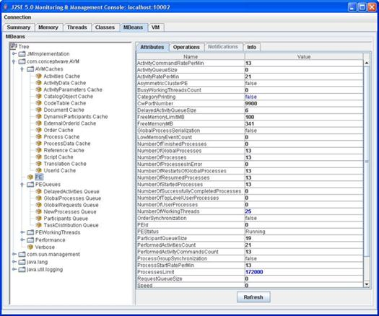

The statistics provided are provided in real time. Tools such as JConsole may then provide real-time graphical dashboards.

### User Defined Metric Definition

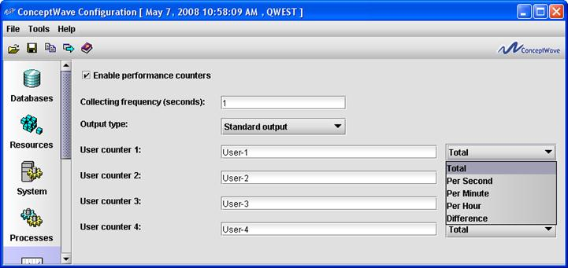

Metrics are collected based upon defined intervals and aggregated over configurable time periods. The measurement intervals for the metrics are configurable. The resulting measurements can be used to perform trending, either within third-party monitoring tools, or using the reporting capabilities described in the Order Analytics (OA) module section.

### Fault Management and Monitoring

The Ericsson Order Care application can be monitored on a regular basis using the Systems Administration Tool. As an example, staff can access the following screen to ensure that the Framework and Process Engine applications are running.

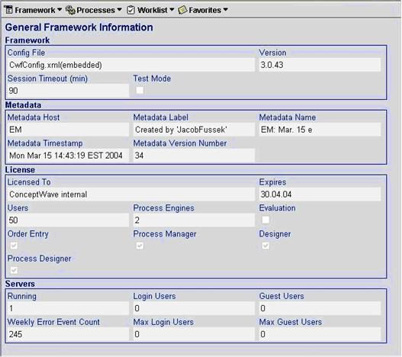

Additionally, alerts can be triggered by:

* Business flow alert activity - As part of the process flow, an alert activity can issue an alert to indicate and/or escalate a business error.
* Process abnormal termination - This alert is dispatched when a process instance terminates prior to completing all process activities. The causes for process abnormal termination include such conditions as JavaScript errors, failure to handle process exceptions, and database errors.
* Process engine abnormal termination - This alert is dispatched when the Process Management system detects a Process Engine failure. Process Engine abnormal termination can be caused by server shutdown or by Java VM (virtual machine) shutdown.

Both real and non-real-time monitoring is supported. The alerts can be delivered to an email, pager, external system, or work queue.

### Inventory Management

Ericsson Order Care software is deployed on top of a J2EE application server and hardware managed and monitored by user/customer, within its data center. Inventory management of these core components is supported within the clients existing processes.

### Server Configuration Management

Similarly, the core J2EE application server, operating system and hardware configuration is standard and typically performed by customer itself. Ericsson Order Care components are configured through the Configuration tool, which provides control over the system behavior, resource profile and performance. Configurable items include:

* Logging levels
* Archiving: frequency, duration and rules
* Caches: size, refresh intervals
* Workflow engines: number; threads; roles
* Background processes: number, servers
* Database: locations, schemas and passwords
* Interfaces: IP addresses, ports, queues, binding settings, passwords, etc.
* HTTP: port filtering, HTTPS settings

Sample screen prints follow on the next page:

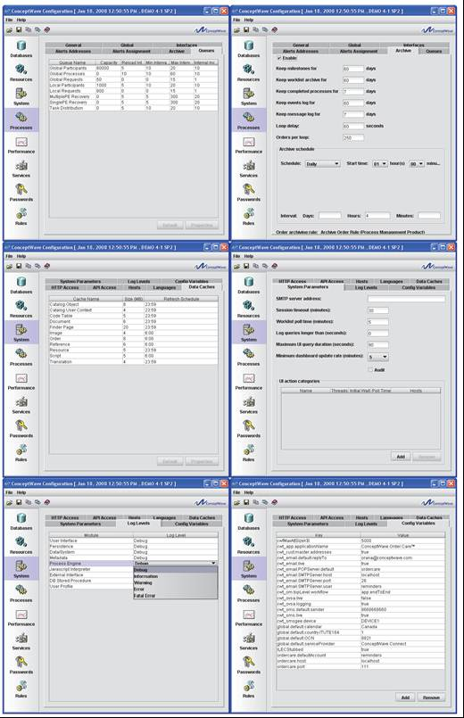

## Auditing And Event Logs

As order creation is started, the Ericsson Order Care solution audits and tracks all aspects of the order lifecycle. From the users who touch the orders to the milestones that are completed, timestamps of all activities are stored in our database for immediate retrieval. Auditing of changes is provided at the field level for those fields selected, and can be turned on/off via scripts. Audit trails are also provided on each work queue as tasks are taken/returned/reassigned/completed. Logging is provided on all errors to a database table. The severity level of errors to be logged is configured. Interface logging is also available on an individual interface level.

In addition, the Ericsson Order Care Systems Administration application includes an Event Log that displays a list of messages logged by the application. An example of the Event Log is shown below.

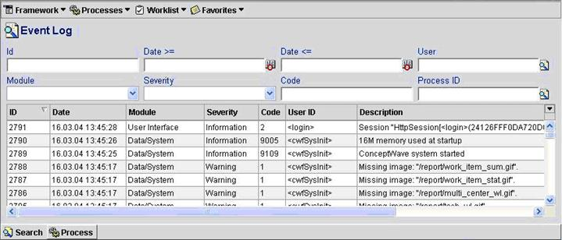

The event log finder can send manually selected log entries as XML to a default or user specified e-mail address. Filtering of messages stored in the event log can be achieved based on userID or context parameter (for example user name, context detail, etc.). A set of system configuration parameters including but not limited to debug level and event log filtering criteria can be changed on run time without restarting the system.

Event logs will continue to be collected and stored as long as enough database storage is available to support it. The archiving function of the Ericsson Order Care solution allows for retention periods to be configured for event logs.

A configurable archiving facility operates on all logs (Audit, Message and Event). The archiving function will automatically purge aged logs past the expiry time of the retention period.

The following illustrates the data captured for selected logs:

|  |  |
| --- | --- |
| **Audit Trail** | **User Defined Statistics** |
| **Change Log** | **User Counts** |
| **Logged Users** | **Change History** |
| **Interface Log** | **Event Log** |
| **Worklist Audit** |  |

## Archiving

Ericsson Order Care provides "current" and "historical" tables, with auto-archiving to history upon quote completion. Data archived to historical tables is immediately retrievable online. These capabilities cover process related tables that affect online performance:

* Worklist
* Process
* Process Activity

All other data within the system is kept indefinitely, unless Archiving is enabled within the system. The Archiving tab in the Ericsson Order Care Configuration tool provides the means to specify parameters for the removal of certain workflow and system items from the database. The Archiving GUI allows for certain types of items (DB records) to be deleted after a definable period of time using automated scheduling functions. The items that can be managed are:

* Milestones
* Worklist Archive
* Completed Processes
* Events Log

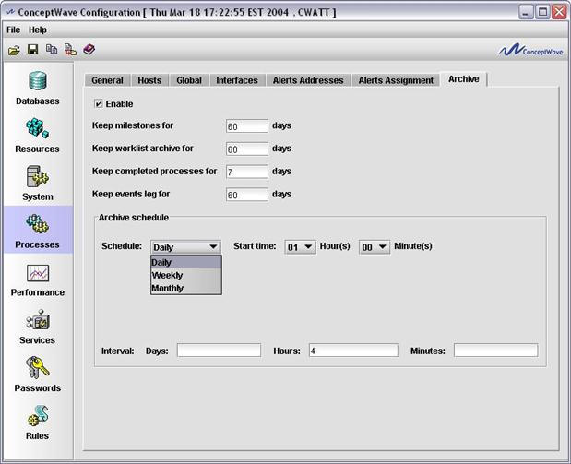

In addition, a system defined rule is available for specifically managing the archiving of orders and its associated data. By invoking this Archive Order Rule and creating an expression with conditions related to its type, age or any other factor, the resultant set of orders returned based on that rule can be forwarded to a data warehouse or data-mart environment and then subsequently deleted from the Ericsson Order Care database.

All business data is stored within Oracle and as such the backup and archiving policies are established via Oracle. Oracle table partitioning, for example by month, is fully supported.

# Single Sign-On, Authentication and Password Management

## Authentication and Password Management

The Ericsson Order Care solution performs authentication and password management functions through a security provider. Single sign-on can be achieved by having the Ericsson Order Care application securely leverage the existing authentication mechanisms that are in place at the CSP.

### Built-in Security Providers

Currently, the following security providers are supported. Additional Security Providers can be developed by Ericsson Order Care on client request and configured by the User Profile Administrator.

#### OpenID

OpenID is a free and open decentralized standard designed to enable user-centric digital authentication. OpenID is in the form of a unique URL, and is authenticated by the identity management server (such as Atlassian Crowd) used by your organization. The OpenID protocol allows you to prove that you are the owner of the URL.

By running an identity server on your site, administrators can configure settings to authenticate user’s credentials. This approach consolidates a single user's login credentials, for multiple applications, to a single username and password.

A sample identity management server to use with OpenID is Atlassian Crowd. This server supports the following directories:

* Microsoft Active Directory
* OpenLDAP
* Sun
* Novell eDirectory
* Apache Directory Server

Once you have logged in to the OpenID server, your login can be shared with several OpenID enabled applications in the same Web browser. OpenID is a flexible solution and a de facto standard for integrating disparate applications into portals in the cloud. Applications can be built using different technologies as OpenID support is not limited to Java™ application servers.

#### Kerberos

When using Kerberos SSO, once you have logged in to your LAN or Operating System account, your login and authentication is passed to the Ericsson Order Care application seamlessly. This single sign-on solution is more transparent, but is less flexible as its setup is application server-dependent. Configuration is required on the windows client (browser), and on the application server, e.g. WebLogic or WebSphere.

#### Ericsson Order Care Security Provider

The Ericsson Order Care Security Provider (effectively Oracle) has the following characteristics:

* The default security provider.
* Uses the Oracle database user accounts for authentication (performs database connection).
* When creating a new user in the User Profile Administrator Tool, a new Oracle database user account is created if one does not already exist. The Oracle database user account has the same password as the user ID.
* When deleting a user from the User Profile Administrator Tool, the corresponding Oracle database user account is deleted. If deleting an Oracle database user account automatically is not desirable, then the User Profile Manager database account (refer to the Ericsson Order Care Installation User Guide, Oracle DB Management) should not be assigned the DROP USER system privilege which allows deletion of Oracle users.
* User Profile Administrator can reset user passwords.
* Users can change passwords using the Ericsson Order Care framework.

#### Windows NT Security Provider

Windows NT security provider has the following characteristics:

* Uses Windows NT domain security for authentication.
* The Windows NT domain used by the security provider is set in the security provider Data field. This domain will be used as the default domain for user authentication.
* Can import Windows NT domain groups and users.
* Users can change passwords using the Ericsson Order Care framework.
* Can only be used on Windows machines.
* Supports multiple Windows domains.

#### JAAS (Java Authentication and Authorization Provider) Security Provider

JAAS security provider has the following characteristics:

* Uses JAAS provider for authentication.
* JAAS login module name is set in the security provider Data field.

#### LDAP (Lightweight Directory Access Protocol Provider) Security Provider

LDAP security provider has the following characteristics:

* Uses LDAP server for authentication.
* The LDAP URL and principal used by the security provider are set in the security provider Data field.

#### SMB Provider

SMB security provider has the following characteristics:

* Uses Windows NT domain security for authentication.
* The Windows NT domain and domain controller used by the security provider is set in the security provider Data field.
* The specified domain will be used as the default domain for user authentication and the specified domain controller will be used as the authentication server. The domain controller is optional, if one is not specified the domain controller is automatically detected based on the specified user domain.
* Can be used on non-Windows machines.
* Supports multiple Windows domains
* When the SMB Security Provider is selected, the Network Info menu becomes available from the main GUI. Here a user may access the Domain Controllers submenu to configure domain preferences.
* Use the Add or Search buttons to add domains to the list, and set their status by checking Active. Note that after a domain has been added, only its Active status can be changed. To rename a domain, it must be deleted and added again.

#### Other (Additional) Security Providers

Other (additional) security providers have the following characteristics:

* Can be developed and used by the User Profile Administrator Tool by selecting <other> in the security provider combo box.
* Use the Other field to give the Java class of the security provider. For example, com.conceptwave.security. Use the Data field for parameters.
* Multiple Windows Domains Support

Both Windows NT and SMB security providers support user authentication across multiple Windows domains. The Windows NT provider allows specification of the NT domain name when importing users and groups. The user domain is stored as part of the user ID in the User Profile database in the format <domain>\<user>. When creating users manually in the User Profile Administrator Tool (in the case of the SMB provider), the user ID should contain the domain name as specified above. The user domain name is also stored as a separate attribute in the User Profile document defined in the Ericsson Order Care User Profile namespace and is displayed as part of the user name.

During the logon process, the user can enter his/her user ID in full format (i.e. <domain>\<user>) or the user name only (i.e. <user>). If the user enters the user ID without including the domain, the default domain is used to authenticate the user.

## User Privilege Management

In order to allow certain functional tasks to be performed only by specific users with certain skills, Ericsson Order Care allows the assigning of user privileges to user participants. User privileges specify allowable actions in the Ericsson Order Care system. User privileges are defined and assigned to the user in the User Profile Manager.

Privileges are used in the following manners:

* To define a privilege that must be held in order to access an Ericsson Order Care application
* To define a privilege that must be held in order to view or perform a specific action
* To identify the orders, order pages, forms and fields that are visible and/or editable
* To identify membership within a “participant” or workflow actor
* To define a privilege that must be held for external systems to communicate to Ericsson Order Care via an API

The relationship between Users and the privileges they hold are defined using “Groups” so that:

* A group holds privileges
* A user may be a member of one or more groups
* The user holds the sum of all privileges held by all the groups to which he/she belongs

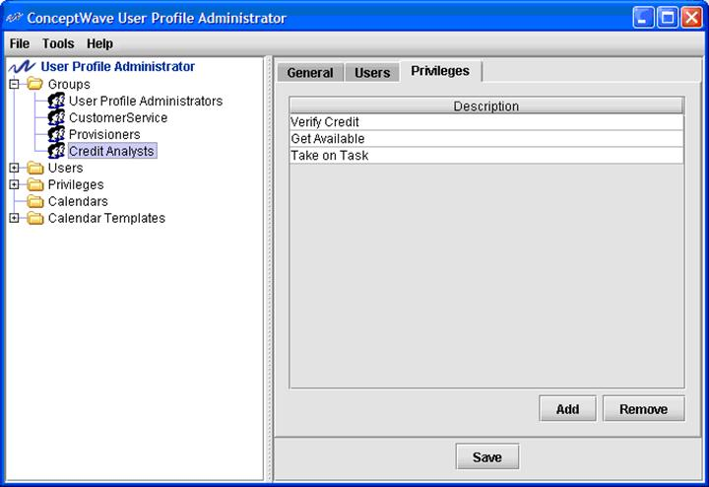

Groups do not necessarily map directly to the business functions or working groups within an organization. A single operational group may be represented by more than one User Profile Group. Examples include, but are not limited to:

Operational groups where the set of functions performed are further broken down. For example, an “Installer” and an “Expert Installer” group may be defined for the same operational group. The “Expert Installer” group may have additional privileges that allow them to deal with a special type of install, or permit them additional update privileges within the system.

Operational groups where the group operates on different Calendars, i.e. across multiple time zones, different shifts, etc. In this case, the Groups hold identical privileges but are associated with different Calendars to represent their differing availability

For this reason, there is not a direct one-to-one relationship between the User Profile Group, and the “Participant” (actor, workflow workgroup, etc.).

From a metadata/process definition standpoint, there are a few items required to be configured in the metadata to support this high level of flexibility and granularity.

* **Interfaces:** Manual/Human interfaces are defined to represent the set of interactions between the workflow and the “Participant”. Each interface is composed of a set of operations…
* **Operations:** The system needs to understand what types of operations can be assigned to or performed by each interface. For the purposes human participants there are two types of operations: one-way and notification. A one-way operation is used to assign a task to a participant. The system sends a task to a participant, but does not expect instant feedback. When the human participant performs an operation, the human participant notifies the system that he/she has done so. This type of operation is a “notification”. Each operation may optionally carry a Privilege that must be held in order to perform the action (more on this later).

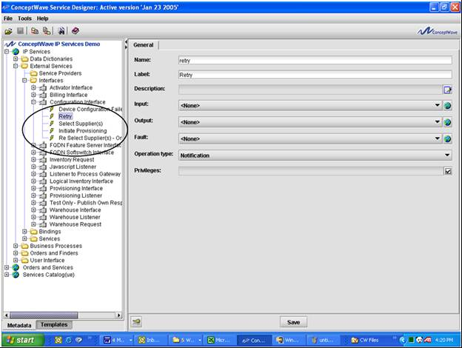

* **Participants:** ‘Actors’ that interact in the workflow are defined and assigned to an Interface definition (the set of operations to be performed). It is possible to restrict the operations within the Interface that may be performed by the participant using permissions/privileges.
* **Privilege:** A Privilege is assigned to a Participant to represent the privilege that must be held to be able to work as the Participant/Actor (to be assigned work items destined for this Participant).

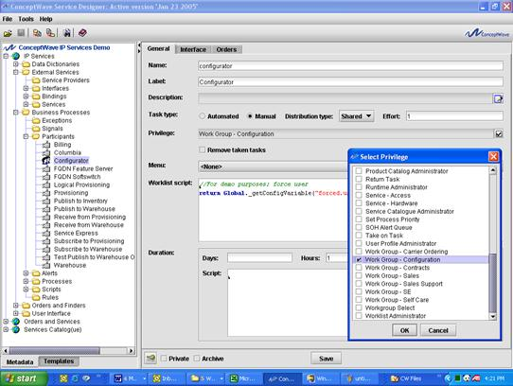

Some observations:

* Multiple Participants may be assigned to the same privilege or a unique privilege may be created for each Participant. The latter approach is recommended to maximize the flexibility to redistribute work across User Profile groups (by maximizing the granularity of the permissions).
* Certain operations may be made available for a subset of the members of a Participant by defining an additional privilege that must be held to perform the additional operations. In this case, a second User Profile Workgroup would be defined to hold the additional privilege.
* A single User Profile Group may be associated with multiple Participants by granting a set of privileges. This permits the aggregation of workflow actors into a single operational group while retaining the granularity within the workflow. This maximizes the organization’s ability to redistribute work without affecting the workflow or workflow actor definitions.
* Since users may have a number of user privileges assigned to them, users can perform any user participant task (operation) according to the privileges that he/she possesses. In addition to specifying functional tasks to users belonging to a Group skill level, the system can be configured to present only the relevant, personalized, dynamic and real-time content and information necessary to perform the tasks allocated to them.

During the metadata configuration process (via the Service Designer/Velocity Studio Tool), a "permissions" tab is available for each order, order page/document, form/view and field to specify the users that have access to that information.

# Adapters

An adapter is a layer of software that converts data from an application into a common form that can be understood and used by other applications. Adapters make it easier to integrate two different applications, without the need to understand and work with the complexities of the two applications.

## Competitive Advantage

Interface adapters allow communications service providers to successfully compete in chaotic and uncertain economic times by changing and integrating with rapidly evolving technologies.

Two of the most painful, expensive problems facing communications service providers’ Operations Support Systems (OSSs) are multivendor interoperability issues and system adaptability. These problems are often obstacles for communications service providers to successfully deploy next generation networks and to rapidly introduce new services.

Interoperability and system adaptability will become even more vital in the coming wave of consolidation among telecommunications and Internet service providers. Carriers looking to offer new services or enter new markets are opting to merge, acquire, or partner with other carriers, rather than grow organically. Such options may speed up market entry, but wreak havoc on both Business and Operations Support Systems, and on the ability to adapt and change in a chaotic world.

### Advantages of Ericsson Order Care Adapters

Adapters help communications service providers overcome these challenges and gain a competitive advantage by enabling interoperability between different systems.

With Ericsson Order Care Adapters, you can:

* Have control over your data model and business rules
* Reduce the impact of complex integration and data migration by employing adapters that enable the translation and communication of messages
* Eliminate interoperability and system adaptability issues by using custom-designed adapter solutions

Custom-designed adapters ensure that messages between Ericsson Order Care modules and your external system are translated, and are sent accurately and securely. Ericsson Order Care hides the complexity of having the calling system interpret low-level APIs that force the calling system to understand the other system’s business logic and rules, allowing the process modeler to easily model the interface and messages.

### Key Benefits:

* Have complete control over your data model and business rules, to reduce complex integration and data migration
* Eliminate interoperability and system adaptability issues by using custom-designed adapter solutions
* Quickly deploy and introduce new products

## Orga OPSC Gold Adapter

### Introduction

Ericsson Order Care provides a custom adapter for Orga OPSC Gold, which is a convergent real-time rating, charging and billing system. OPSC Gold has a modular platform architecture, which makes it a very versatile system both for adjunct rating uses cases and for end-to-end convergent billing solutions. It can either enhance existing billing systems or replace them as an independent single system.

The Orga OPSC Gold adapter exposes the functionalities provided by Orga OPSC Gold and allows other systems to effortlessly interact with Orga OPSC Gold.

### OPSC Gold System Modules

The main modules of the OPSC Gold System are:

* **Administration and Configuration Cockpit (ACC) –** Eclipse based GUI of OPSC Gold
* **Business Administration System (BAS) –** business logic for customer, account, product and tariff management. BAS includes the Operations Control Manager (OCM) component for execution of configurable business logic
* **Configuration and Operation Module (COM) –** the COM provides the basic configuration data and configuration framework of OPSC Gold
* **Payments File Processor (PFP) –** the PFP provides a batch interface in order to process incoming payment files from the Payments Interface
* **Business Intelligence Support Module (BISM) –** the BI Support Module is the central reporting framework and staging area of OPSC Gold for providing reporting data to external systems
* **Network Interface Module –** provides Unified Provisioning Interface (UPI) for transformation of provisioning requests and Post Event Converter (PEC) for conversion of usage events
* **Real-time Environment (RTE) –** real-time and post-event rating based on InCore in-memory database
* **Core Billing Framework (CBF) –** event import, bill calculation and bill extraction processing, payments and journaling

### Business Service Gateway (BSG)

OPSC Gold has a standard interface to external business support systems and to Orga Systems’ Business Service Gateway (BSG), which provides a Web Services Application Programming Interface (API) and Batch File Interface for OPSC Gold.

### Overview of the BSG Web Services API

The BSG Web Services API can be used by third-parties to integrate with BSG. The overall API is categorized into two board functional categories: Informational operations and Modification operations.

* The Informational operations are used to query the OPSC Gold to retrieve necessary data records and do not change anything in OPSC Gold.
* The Modification operations are used to change data in OPSC Gold.

### Supported BSG Functionalities

The OPSC Gold adapter provides functionalities for storing, using, and manipulating customer, account, and subscriptions data. It also has functionalities for dealing with Product Lifecycle Management (PLM) and Inventory. The following are some of the examples of the supported functionalities:

* Customer
  + Create customer
    - This operation is used to create a new customer. This creates a customer with the customer address.
* Account
  + Create top-level account
    - This operation is used to create top-level account. This means that a new account hierarchy is created for a customer. The account will be created with the life cycle state “deployed”.
  + Get account
    - This operation is used to retrieve all necessary information about the accounts and subscriptions from the database and back-ends.
  + Get account balances
    - This operation is used to retrieve information about account balances from the database and back-ends.
  + Update account
    - This operation is used to update an existing account or subscription. The service will update either a top-level or child account or subaccounts.
  + Terminate account
    - This operation is used to terminate an account.
  + Get account bills
    - This operation is used to retrieve information about the bills associated with an account.
* Subscriptions
  + Create subscription account
    - This operation is used to create a subscription account. The service appends a subaccount as a child to an existing ac-count (top-level or child). The subscription will be created with the life cycle state “deployed”.
* Billing
  + Charge one-time fee
    - This operation is used to charge a one-time fee in an account. It also allows the overwriting of the charged price.
  + Top-up account balances
    - This operation is used to top-up account balances.
    - Top-up is a feature that OPSC Gold provides natively for any balance that is available to an account.
* Products
  + Add sold products
    - This operation is used to add new sold products to the accounts.
    - The included sold components will be created with the life cycle state “deployed.” The life cycle progression will be stored as scheduled changes.
  + Deactivate multiple products
    - This operation is used to deactivate multiple products.
* Events
  + Search event records
    - This operation is used to search for all event records which fulfill the given search criteria and filters, and then return those records.

### CGS Billing Adapter Connectivity

Orga OPSC Gold Adapter Connectivity Diagram:

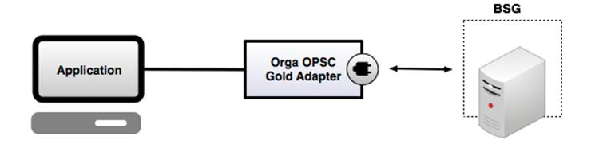

## CSG Billing Adapter

### Introduction

Ericsson Order Care provides robust, flexible, and adaptable custom-built adapters for CSG International’s Billing system. The CSG Billing system offers fully integrated modules for rating, discounting and bill production to help companies maximize their investment and optimize their business. The CSG Billing adapter exposes the functionalities provided by CSG Billing and allows other systems to effortlessly interact with CSG Billing.

### Custom-Built Adapters

Ericsson Order Care is able to provide robust custom-built adapters which allow different applications to interact with and use the CSG Billing system. The advantage of a custom approach is that we can satisfy each of our customer’s specific needs and fully comply with their particular implementation of the CSG Billing system. Having custom-built adapters ensures that the adapter only supports the functionalities that are actually being used by a particular customer; rather than being bloated with functionalities which may not be needed by the customer.

### Working with World-class Customers

Ericsson Order Care has already provided its reliable custom-built CSG Billing adapters to some of the biggest telecommunications companies from around the world, including Time Warner Cable, Comcast, and Charter.

### Supported CSG APIs

Ericsson Order Care’s custom adapters are able to support the CSG APIs needed by our customer, such as CSG’s SODI (Service Order Delivery Interface) API set.

### Supported Functionalities

The Ericsson Order Care CSG Billing adapter is able to support any functionalities required by our customer. The specific functionalities supported in a particular version of the adapter depend on the customer’s implementation of the CSG Billing system. Examples of the functionalities which can be supported by the CSG Billing adapter include the following:

* Customer
  + Create new customer
* Account
  + Add account
  + Retrieve account
* Order
  + Create order
  + Update order
  + Verify order
  + Fallout Handling
* Location
  + Find location
* Jobs
  + Get Jobs Available Schedule

### CSG Adapter Data Organization

Ericsson Order Care can define different data models to fit our customers’ needs. An example of a data model that can be implemented by the CSG Adapter is shown below.

* Keys
* Response
* Customer
* Account
* Location
* Order
* Items
* Equipment
* Jobs

### CGS Billing Adapter Connectivity

CSG Billing Adapter Connectivity Diagram:

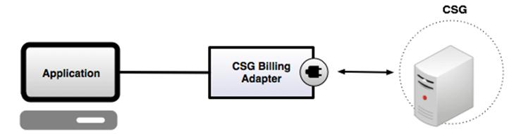

# Standards Adoption and Adherence

Ericsson Order Care’s framework is a J2EE compliant n-tier JAVA application which adopts open standards. WSDL is used for interface definition, XML for metadata repository, BPML for workflow, XSD for data definitions, CSS for Web presentation style, JDBC for data access and JavaScript for customizations and business rules. A zero footprint browser enabled client, non-reliance on any specific J2EE application server or database vendor, and a JRE enabled design time component further differentiates Ericsson Order Care as the ideal service delivery automation vehicle.

## Solution Architecture

Ericsson Order Care provides a solution that splits the presentation, processing and database tier, as well as exposing design, configuration, and administration layers.

### Presentation Tier

Ericsson Order Care provides a browser-based presentation layer. As such, it is a true “zero footprint” client with no software, no applets or plug-ins required for clients. This common interface can be used by CSP’s customers, channels and internal users responsible for creating, updating, viewing or reporting in the application. This implementation of a simple and intuitive common Web interface for all users simplifies the training requirements and eliminates the need for special training. A key strength of the solution is the auto-generation of the UI (i.e. without resorting to hand painting forms in a Web publishing tool) based upon the underlying metadata.

### Processing Tier

The Framework provides the user interface, business rules, and integration infrastructure for the application. This component is essentially the application accessed by the end-users via their browser.

The Process Engine executes the workflow in the background. Provides no user interface itself though the status of the process and the ability to suspend, resume and terminate processes is provided through the Administration Application (see below).

### Database Tier

All business and configuration data is stored within the Oracle database.

### Design

Service Designer (SD) and Velocity Studio (VS) are the primary configuration tools used to create the application. The data models, business rules, workflow, user interface, interfaces, etc. are all defined within this tool. It generates the metadata (an XML document containing the configuration information) that is used by the run-time applications.

Service Designer/Velocity Studio provides a translation facility within which all menus, forms, error messages and pick-lists are translated into the target languages. It generates language specific resource files (XML documents) that are used by the run-time applications.

### Configuration

System Configuration provides a mechanism for specifying the environment specific (Development, Integration Testing, UAT, Production etc.) attributes under which the application is to operate. Examples include logging levels, database location, schemas and passwords, server addresses of systems being interfaced with, cache sizes, polling intervals, etc.

The User Profile Administration Tool allows for the creation of users, groups, privileges and for the management of calendars (holidays, working hours, etc.).

### Administration

Run time administration tools for the framework and the process engine instances (AVMs) consist of a native browser based UIs, and a JMX based monitoring/change facility that can be accessed via any JMX enabled management platform.

A multitude of views and reports are provided including: list of AVMs running, the memory utilization, users logged in, message queue sizes, licensing information, process instance status, work queues, event logs, etc. A process administrator has the ability to suspend, resume and terminate processes from this application.

## J2EE Architecture

The Ericsson Order Care product is a J2EE compliant n-tier architecture Product. Java throughout.

* Browser enabled client. Zero footprint.
* No reliance on specific J2EE app. server
* No reliance on specific database vendor
* JRE enabled design time component

The whole Ericsson Order Care suite is developed in Java 2 and uses the services delivered by the Java 2 Enterprise Edition (J2EE). Hence, it is Operating System independent and can run on Windows, Solaris, HP-UX, AIX and Linux.

Ericsson Order Care can utilize the leading Web servers such as Apache and Microsoft IIS.

The internal database server is Oracle but the platform can communicate to any database with a JDBC driver.

End-users access the application using a browser, either MS Internet Explorer or Firefox.

## Service Oriented Architecture

Ericsson Order Care’s metadata driven approach enables clients to deploy applications that are Service Oriented Architecture (SOA) compliant[1]:

* Standardized Service Contracts
* Service Loose Coupling
* Service Abstraction
* Service Reusability
* Service Autonomy
* Service Statelessness
* Service Discoverability
* Service Composability
* Service-Orientation and Interoperability

Ericsson Order Care meets these SOA Principles through:

* Metadata driven interface definition that allows for any internal function to be exposed out through an interface.
* The provision of standard APIs (service contracts) that may be further tailored through metadata to meet the client’s needs.
* The provision of metadata driven interface modeling that allows the client to define its own reusable, autonomous and stateless services.
* Publishing WSDLs for others to auto-discover
* The adoption of Web Services Definition Language (WSDL) in interface modeling

## Web Services and Integration

Ericsson Order Care employs WSDL, an XML based standard that defines an interface in 7 layers, to model APIs.

* Systems or “services” can be defined to be supported on a variety of “ports”. Each port specifies a physical location for the service, and a “calendar” which describes hours of availability. This allows for the definition of alternate system access in the event the primary targeted system is unavailable, busy or has failed.
* A system’s interfaces, i.e. the operations it supports, and the data exchanged in each operation are defined. Support is provided for specifying the outbound, inbound (successful) and inbound (error) messages.
* Each port specifies a “binding”, which binds the port to the interface and the Service Provider (technology or protocol) to be employed.

APIs are modeled using WSDL whether they are Web services offered to others, or the definition of Web services that are to be consumed by the system.

Ericsson Order Care supports the importing of WSDL document definitions to the metadata through the Service Designer tool to create data structures (messages), interfaces with operations, bindings and external services with ports based on WSDL document definitions.

Ericsson Order Care supports the importing of XSD schema, and the creation of XSD schema from XML data, through the Service Designer tool to aid in the definition of interface messages.

SOAP messages are processed and depending on the specified business rules, generate internal events that are handled by the Ericsson Order Care solution or external events that are redirected to external bus.

## BPM/Workflow

The Ericsson Order Care workflow engine is a BPML (Business Process Modeling Language) based workflow engine. Ericsson Order Care was one of the initial members of BPMI.org before it was absorbed by the Object Management Group. Our adoption of their BPML workflow specification demonstrates Ericsson Order Care’s commitment to standards adoption.

The Workflow engine contains a rules language, JavaScript, that permits the process modeler to leverage Ericsson Order Care’s rules engine, data transformation facilities and order validation services in order to populate interface messages, process response data, define and evaluate the path to follow in scripts, define the compensate activities, activity durations, etc.

Extensions are provided via JavaScript exits that are defined for each activity.

## TeleManagement Forum: NGOSS, eTOM, TAM and SID

Ericsson is a member of the TeleManagement Forum and a strong supporter of Frameworx, NGOSS and its three cornerstones: the enhanced Telecom Operations Map (eTOM), SID, and Technology-Neutral Architecture.

Ericsson Order Care’s modules are SID-certified. For details on the SID certification and levels attained, see the following Frameworx Compliance section.

Ericsson Order Care inherently has all the building blocks to integrate within Technology Neutral Architecture (TNA). Ericsson Order Care’s approach to metadata definition of interfaces, their operations and terminations, etc. facilitates a Communications Service Provider’s adoption of a TNA strategy.

## Frameworx Compliance

### What is Frameworx

TM Forum’s Frameworx Integrated Business Architecture is a suite of industry standards that provides the blueprint for Service providers (SPs) to enable effective business operations and assess and improve performance. Frameworx uses a proven, service-oriented approach to rationalize IT operations and integration, which allows SPs to focus on growing their businesses through cost reduction and business agility improvement.

Frameworx is a result of ongoing collaboration development by TM Forum’s member companies from across the industry. Driven by SP requirements, Frameworx is constantly evolving along with market needs and changes. Frameworx has been adopted by 90% of the world’s largest SPs.

There are four key components within Frameworx which enables a service-oriented, highly automated and efficient approach to running a SP business:

1. Business Process Framework (eTOM) – the industry standard process architecture for both business and functional processes
2. Information Framework (SID) – a common reference model for enterprise information that service providers, software providers, and integrators use to describe management information
3. Application Framework (TAM) – which provides a common language between SPs and their suppliers to describe systems and their functions, as well as a common way of grouping them
4. Integration Framework – which delivers a service oriented integration approach with standardized interfaces and support tools

The key business benefits in using Frameworx are:

* Speed deployment of new services with industry-proven technologies, business services and platforms
* Reduce integration time and product costs through standard processes and interfaces
* Support new technologies and business models readily
* Reduce risk drastically with well-defined interfaces and certified compliant products
* Leverage industry concepts including SOA and ITIL to provide future-proof solutions

For more information on TM Forum and Frameworx, please visit [www.tmforum.org](http://www.tmforum.org).

*Reference: TM Forum

### Compliance and Conformance

TM Forum provides a Frameworx Conformance Certification service whereby service providers and suppliers can submit self-assessments of solutions implemented by the service providers and products developed by vendors to TM Forum for evaluation by TM Forum. Upon completion of the assessment requirements, the products (or solutions) are certified by TM Forum as being Conformant. The results are published by TM Forum on their Web site. The Frameworx conformance certification can be under the Business Process Framework (eTOM), Information Framework (SID) or both.

Ericsson, prides itself as a world-class product vendor that meets the Frameworx standards and strides to evolve its products to meet the ever-changing standards and market demands. Ericsson Order Care ensures its product and modules are compliant to standards from initial design through to development, which is a primary business objective.

Ericsson has been engaged with TM Forum for many years. It was a pioneer with the formal conformance certification program with TM Forum in 2009. Ericsson Order Care continually conducts informal self-assessment against the standards during our product management and design phase, and is fully confident that it can demonstrate the products are in compliance with Frameworx standards.

While being compliant to standards, it is important to remember that market leadership in not gained with standards alone. Ericsson Order Care has been able to excel and deliver that world-renowned product by ensuring that solutions meet customer requirements and excel beyond industry standards.

### Current Assessment

Current Ericsson Order Care Assessments can be downloaded from the TM Forum Web site:

<http://www.tmforum.org/ProductAssessmentResults/ConceptWaveOrderCare/12745/home.html>

<http://www.tmforum.org/ProductAssessmentResults/ConceptWaveCatalog/12760/home.html>

Please contact [marketing@conceptwave.com](mailto:marketing@conceptwave.com) for more information.

### Ericsson Order Care’s Frameworx Compliance

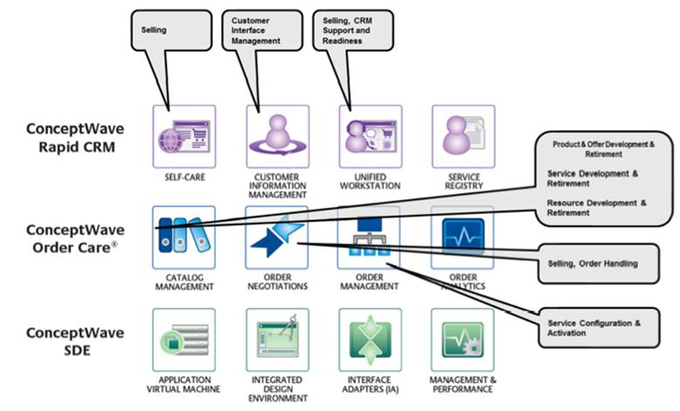

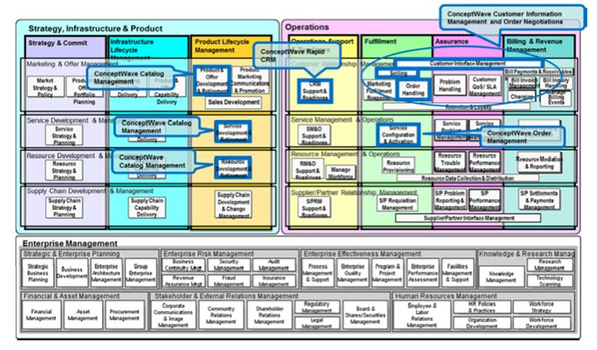

Figure 4 Release 8 of the Business Process Framework (eTOM)

Ericsson Order Care products have been designed to take full advantage of TM Forum’s Frameworx standards. Under Business Process Framework (eTOM), CW products support the following Level 2 eTOM processes:

1. 1.1.1.1-CRM Support & Readiness
2. 1.1.1.2-Customer Interface Management
3. 1.1.1.4-Selling
4. 1.1.1.5-Order Handling
5. 1.1.2.1-SM&O Support & Readiness
6. 1.1.2.2-Service Configuration & Activation
7. 1.1.3.1-RM&O Support & Readiness
8. 1.1.3.2-Resource Provisioning
9. 1.2.1.5-Product & Offer Development & Retirement
10. 1.2.1.6-Sales Development
11. 1.2.2.3-Service Development & Retirement
12. 1.2.3.3-Resource Development & Retirement

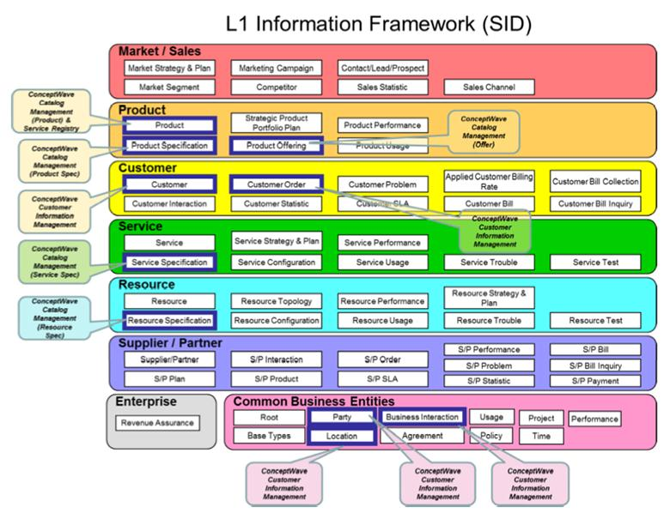

Figure 5 Release 9 of the Information Framework (SID)

### Ericsson Order Care’s Information Framework (SID) Conformance Certification 2010

Ericsson Order Care has successfully completed the TM Forum’s Information Framework (SID) Conformance Certification assessment for its Catalog Management product in 2010. This demonstrates Ericsson Order Care’s commitment to provide the best-in-class product that is also conformance to the widest recognized industry standards. Ericsson Order Care Catalog Management-5 is certified by TM Forum to meet Level 7 conformance for the following SID ABEs:

1. Product / Product / Product Order
2. Product / Product Price / Pricing
3. Product / Product Offering / Offerings
4. Product / Product Catalog / Catalog and Domains
5. Product / Product Offering Price / Pricing
6. Product / Product Specification / Products and Components

The detail of the SID conformance certification result is available at the TM Forum: (<http://www.tmforum.org/CatalogManagementVersion/8814/home.html>)

### Ericsson Order Care’s Frameworx Conformance Certification 2011

Ericsson Order Care has completed assessment of its products through the TM Forum Frameworx Product Conformance Certification program in 2011.

The scope of the assessment includes both the Business Process Framework (eTOM) and Information Framework (SID) components of the Frameworx standards. The overall program is divided in multiple phases and completion is expected before the end of 2011.

Table 1 Business Process Framework (eTOM) Scope:

| eTOM Level 3 Processes | eTOM Level 4 Processes |
| --- | --- |
| 1.1.1.1 - CRM - Support & Readiness | 1.1.1.1.1 - Support Customer Interface Management |
|  | 1.1.1.1.2 - Support Order Handling |
|  | 1.1.1.1.7 - Support Selling |
|  | 1.1.1.1.10 - Manage Customer Inventory |
|  | 1.1.1.1.11 - Manage Product Offering Inventory |
|  | 1.1.1.1.15 - Support Bill Inquiry Handling |
| 1.1.1.2 - Customer Interface Management | 1.1.1.2.1 - Manage Contact |
|  | 1.1.1.2.2 - Manage Request (Including Self Service) |
| 1.1.1.4 - Selling | 1.1.1.4.1 - Manage Prospect |
|  | 1.1.1.4.2 - Qualify Opportunity |
|  | 1.1.1.4.3 - Negotiate Sales/Contract |
|  | 1.1.1.4.4 - Acquire Customer Data |
|  | 1.1.1.4.5 - Cross/Up Selling |
| 1.1.1.5 - Order Handling | 1.1.1.5.1 - Determine Customer Order Feasibility |
|  | 1.1.1.5.2 - Authorize Credit |
|  | 1.1.1.5.4 - Track & Manage Customer Order Handling |
|  | 1.1.1.5.5 - Complete Customer Order |
|  | 1.1.1.5.6 - Issue Customer Orders |
|  | 1.1.1.5.7 - Report Customer Order Handling |
|  | 1.1.1.5.8 - Close Customer Order |
| 1.1.2.1 - SM&O Support & Readiness | 1.1.2.1.1 - Manage Service Inventory |
|  | 1.1.2.1.2 - Enable Service Configuration & Activation |
| 1.1.2.2 - Service Configuration & Activation | 1.1.2.2.3 - Track & Manage Service Provisioning |
|  | 1.1.2.2.4 - Implement, Configure & Activate Service |
|  | 1.1.2.2.7 - Issue Service Orders |
|  | 1.1.2.2.8 - Report Service Provisioning |
|  | 1.1.2.2.9 - Close Service Order |
| 1.2.1.5 - Product & Offer Development & Retirement | 1.2.1.5.5 - Develop Detailed Product Specifications |
|  | 1.2.1.5.6 - Manage Product Development |
|  | 1.2.1.5.7 - Launch New Products |
| 1.2.2.3 - Service Development & Retirement | 1.2.2.3.4 - Develop Detailed Service Specifications |
| 1.2.3.3 - Resource Development & Retirement | 1.2.3.3.4 - Develop Detailed Resource Specifications |

Table 2 Information Framework (SID) Scope:

| SID Domain | SID ABE |
| --- | --- |
| Common Business Entity | Location/Geographic Place/Geographic Place |
|  | Party/Party |
|  | Party/Contact |
|  | Party/Identification |
|  | Party/Roles |
| Customer | Customer |
| *Product | *Product/Product |
|  | *Product/Product Price |
|  | *Product Offering |
|  | *Product Offering/Product Catalog |
|  | *Product Offering/Product Offering Price |
|  | *Product Specification |
| Common Business Entity | Business Interaction |
|  | Root Business Entities |
| Customer | Customer Order |
| Service | Service Specification |
|  | Service Specification/CustomerFacing ServiceSpec |
|  | Service Specification/CustomerFacing ServiceSpec/CustomerFacing ServiceSpec Role |
|  | Service Specification/CustomerFacing ServiceSpec/Service Package |
|  | Service Specification/ResourceFacing ServiceSpec |
|  | Service Specification/ResourceFacing ServiceSpec/ResourceFacing ServiceSpec Role |
|  | Service Specification/ResourceFacing ServiceSpec/Service Bundle |
| Resource | Resource Specification |
|  | Resource Specification/CompoundResource Specification |
|  | Resource Specification/LogicalResource Specification |
|  | Resource Specification/LogicalResource Specification/Logical Role Specification |
|  | Resource Specification/Physical Resource Specification |
|  | Resource Specification/PhysicalResource Specification/Physical Role Specification |

List of processes and ABEs subjected to changes without notice.

### CASE STUDY: TM Forum Frameworx Used to Re-engineer and Transform Türk Telekom’s Business

Türk Telekom’s solution was submitted and was selected as the TM Forum Solution Excellence Award Finalist 2011. Detail of the submission is available at the TM Forum: (<http://www.tmforum.org/ConceptWaveOrderCare/10627/home.html>)

Türk Telekom undertook a major business transformation program called Program Bir to create a customer-centric business, which consists of Customer Relationship Management (CRM) and Service and Resource Management (SRM). They used a new architectural approach and leveraged TM Forum’s Frameworx. Türk Telekom used Ericsson Order Care products to transform their quote-to-cash business process fulfillment and order management requirements.

Ericsson Order Care’s SID-based Catalog Management and eTOM-based Order Management solution enabled Türk Telekom to:

* Rapidly deploy Ericsson Order Care’s solution that unified all services and subsidiaries
* Automate customer and order lifecycle management
* Improve customer experience through fast and accurate order negotiation and completion
* Deliver quick time-to-market for current and new products and services
* Reduce overall operational costs
* Speed integration between new and legacy systems

# Product Management

## Software Release Strategy

Ericsson Order Care regularly enhances its products to ensure continuous quality improvements and inject new features and technologies into the core platform. Ericsson is available to help you plan and rollout upgrades quickly, effectively and seamlessly.

There are several types of releases:

* **Major Releases:** Ericsson updates and enhances its Ericsson Order Care product portfolio on a continual basis and delivers these enhancements via scheduled GA (major) product releases twice within a rolling 12 month cycle. Selected major releases warrant longer lead times. Major releases are labeled #.#.0.0, e.g. 4.2.0.0
* **Service Packs:** Service Packs typically contain new features deemed useful in support of active customers and projects. These changes are limited in scope but are of sufficient business benefit to our clients that they warrant releases in advance of the next major release. Service Packs also contain minor product fixes that had workarounds and therefore were not included in an EBF (below). Service Packs are targeted for every 6-8 weeks. Service Packs are labeled #.#.#.0, e.g. 5.1.9.0
* **Emergency Bug Fixes (EBF):** EBFs contain product fixes to issues of sufficient importance that they warrant immediate attention. EBFs are labeled #.#.#.#, e.g. 5.1.0.6.

Software upgrades are provided as part of Software Support Services. Ericsson will work with you to determine how to proceed with a software upgrade. Releases need to be implemented within a reasonable time frame after their release, in accordance with the standard Software Support Services terms.

## End-Of-Life Policy

Products reach their end-of-life for many reasons. Ericsson understands that planning for a product end-of-life milestone is an important part of any organization. Ericsson provides this policy, to help customers plan for end-of-life and end-of-sale milestones, and migration options to other Ericsson Order Care product versions or technology.

The general guidelines are:

1. An end-of-life decision will be made after two subsequent major releases have been issued.
2. A 6 month notice will be provided for end-of-sale and end-of-life products. This notice will be sent to customers, partners, and will be posted on the Ericsson Order Care support portal.
3. Access to Ericsson Order Care Support will be available as per the contracted support terms until the end-of-life milestone for the product in question.
4. Customers need to ensure that they have a current and fully paid support contract with Ericsson. Please contact your Account Representative or Ericsson Support for details about your support status.

Ericsson frequently supports clients on releases that have been formally declared to be End-of-Life. This support is provided on a case-by-case basis and is provided on a paid service basis.

**Terms Used**

**End of Product Lifecycle:** A process that contains a series of technical and business milestones and activities, that is associated with the Software Product Management Lifecycle. Once this process is completed, the product becomes obsolete, i.e. the product is not sold, manufactured, repaired, maintained or supported.

**End-of-Sale Date:** The date when the product is no longer available for sale through Ericsson Sales Channels.

**Software Maintenance Support:** Ericsson during this timeframe may release software Service Packs or Emergency Bug Fixes to the software products. After this date, Ericsson Order Care Engineering will no longer develop, repair, maintain, or test the software products.

**End-of-Life Date:** This is a milestone used to indicate that a product in at the end of its lifecycle, and Ericsson Order Care will no longer be marketing, selling or promoting the particular product, product version, product model or service. The end-of-life product may have a replacement product, product version, or product model.

## Documentation

Ericsson Order Care offers a complete set of documentation included with the solution in electronic format.

During the project implementation, there will be a number of project documents to ensure that the requirements have been properly gathered and the appropriate testing and implementation plans are in place.

Also, at the end of the project implementation, Ericsson will deliver the following documents:

* **Functional Specification document.** This document has a high-level functional breakdown of the solution, a description of the user interface, metadata configuration parameters, etc.
* **Systems Administration document.** This document covers things like a description of the software environment that was delivered (e.g. versions of application servers, operating system, etc.), topology diagrams, and instructions for installing new versions, etc.

The following user guides are also delivered electronically with the product:

* Service Designer Tool User Guide
* Systems Administration Application User Guide
* Resource Editing Tool User guide
* Process Monitor Tool User Guide
* JavaScript Debugger Tool User Guide
* Configuration Tool User Guide
* Installer User Guide
* User Profile Administration Tool User Guide

In addition, a facility exists within the Service Designer to (at any time) auto-generate documentation representing the customer’s actual metadata configuration.

# Software Support Services

## Introduction

Software Support Services include rights to receive all software updates and fixes made Generally Available during the term, along with help desk support for the term of the Support Services Agreement.

Ericsson provides high quality software support via a team of expert support staff. The hours of coverage is determined by the software support level subscribed.

## Scope of Services

Payment of the annual maintenance fees will entitle the customer to the following software support services, in accordance with the level of support ordered:

* Remote support for problem determination, analysis and response;
* Remote maintenance to supply fixes (or work-around or third-party solutions) to solve errors and malfunctions in the software;
* Remote development associated with change requests; and delivery of an electronic copy of all new releases to the software, including fixes, upgrades to the software, new product releases, and any related documentation, which may include release notes and migration scripts.
* The customer is responsible for installation of all new releases to the software.

## Software Warranty

Upon Customer Acceptance of the Licensed Software, Ericsson offers a 90 day warranty period during which software support services are delivered at no additional charge.

## Software Support Services

Ericsson Order Care software support services are divided into 2 levels to suit the needs of the individual customers:

### Level 1 – Premium Software Support Services

* Premium support provides an account prime, but no dedicated support personnel.
* Account prime will liaise with the customer on a regular basis, serve as the point of contact for the resolution of issues, and be responsible for keeping the customer informed of new releases and patches as they become available.
* Account prime will work closely with the assigned support personnel to ensure that issues are resolved on time.
* Third party issues, once identified, are coordinated with the parties involved to achieve resolution.
* Support is provided around the clock on a 24x7x365 basis.

### Level 2 – Standard Software Support Services

* Same quality of attention as provided in higher levels (levels 1 and 2) but no account prime or dedicated personnel assigned
* Support is provided Monday to Friday, from 9:00 AM to 5:00 PM Eastern time.
* For issues identified as third party related, the Ericsson Order Care team will inform the customer, and coordinate resolution on a time and materials cost basis to the customer, if requested.

### On-Demand Services

Additional support required outside the Software Support Services Agreement is available on a time and materials basis, based upon a signed Statement of Work or Change Request.

Interaction with the Customer Service center is handled via a 1-800 number to work directly with a Customer Support Agent to resolve any identified product issues.

## Terms

The following terms are applicable for all Software Support Services offered by Ericsson Order Care:

* Software Support Services are applicable to the Ericsson Order Care licensed software only.
* Application support (i.e. for the Developed Software) is also available at additional fees.
* All Software Support Services contracts are offered on a year by year renewable basis.
* Software Support Services commence upon the expiration of the warranty period.
* Software Support Services fees are payable annually in advance. Support services are renewed each year, unless the customer advises in writing 60 days in advance.

# ConceptWave Integration with Ericsson: New Product Names

In September 2012, ConceptWave Software Inc. became a wholly owned subsidiary of Ericsson (NASDAQ:ERIC). As part of the integration of ConceptWave with Ericsson, the following products have been renamed:

|  |  |
| --- | --- |
| ConceptWave Name | Ericsson Name |
| ConceptWave® Order Management | Ericsson Order Care |
| ConceptWave® Catalog Management | Ericsson Catalog Manager |

Going forward, you will begin to see the new product names in proposals and contracts. Ericsson products continue to provide global leadership in the development of mobile, broadband and enterprise communications software and services. These new product names reflect our commitment to these products that our valued customers have come to depend upon. Our solutions enable the Networked Society with efficient real-time solutions that allow us to study, work and live our lives more freely, in sustainable societies. Our offerings comprise services, software and infrastructure within Information and Communications Technology for telecom operators and other industries. Ericsson operates in 180 countries and employs more than 100,000 people. Ericsson is listed on NASDAQ OMX, Stockholm and NASDAQ, New York stock exchanges.

# Trademarks

Ericsson, the Ericsson logo and the Globemark are trademarks of Ericsson.

Ericsson is a recognized leader in delivering communications capabilities that enhance the human experience, ignite and power global commerce, and secure and protect the world’s most critical information. Serving both service provider and enterprise Customers, Ericsson delivers innovative technology solutions encompassing end-to-end broadband, Voice over IP, multimedia services and applications, and wireless broadband designed to help people solve the world’s greatest challenges. Ericsson does business in more than 150 countries. For more information, visit Ericsson on the Web at www.Ericsson.com.

# Disclaimer

This document may contain statements about a number of possible benefits that Ericsson believes may be achieved by working with Ericsson. These might include such things as improved productivity, benefits to end users or cost savings. Obviously, these can only be estimates. Gains might be qualitative and hard to assess or dependent on factors beyond Ericsson’s control. Any proposed savings are speculative and may not reflect actual value saved. Statements about future market or industry developments are also speculative.

Statements regarding performance, functionality, or capacity are based on standard operating assumptions, do not constitute warranties as to fitness for a particular purpose, and are subject to change without notice.

This document contains Ericsson’s proprietary, confidential information and may not be transmitted, reproduced, disclosed, or used otherwise in whole or in part without the express written authorization of Ericsson.

1. Source: www.soaprinciples.com